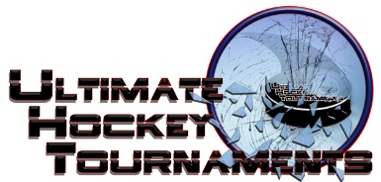
Ice Blast Tournament, St. Louis, 1.17-19, 2020

PW B

Tournament Format

There are 4 teams and every team plays each other once in the preliminary round. At the end of the preliminary round,

1st place plays 2nd place for the Championship, 3rd plays 4th for the consolation.
Standings
Team | Points Gm1 | Points Gm2 | Points Gm3 | Total Points | Tiebreakers
Affton Americans (Parks) | 0 | 0 | 0 | 0
St. Jude Knights | 2 | 2 | 2 | 6
St. Peters Spirit (Zucol) | 2 | 0 | 0 | 2
Chiefs Hockey 3 | 0 | 2 | 2 | 4
Game Results
Fri | 6:20 | Pm |  | All American Rink |  | Affton (parks) |  |  |  | 0 | vs. |  | Knights |  | 5
Sat | 8:10 |  | Am | All American Rink |  | Knights |  |  |  | 2 | vs. |  | Chiefs |  | 1
Sat | 8:30 |  | Am | St. Peters Rec Plex-Rink A |  | Spirit (zucol) |  |  |  | 3 | vs. |  | Affton (parks) |  | 1
Sat | 2:45 |  | Pm | St. Peters Rec Plex-North |  | Spirit (zucol) |  |  |  | 1 | vs. |  | Knights |  | 6
Sat | 7:00 |  | Pm | All American Rink |  | Chiefs |  |  |  | 4 | vs. |  | Affton (parks) |  | 3
Sun | 8:10 |  | Am | All American Rink |  | Chiefs |  |  |  | 5 | vs. |  | Spirit (zucol) |  | 0
 |  |  |  |  |  |  |  | HOME TEAM |  |  |  |  |  | AWAY TEAM
Sunday | 1:00 |  | Pm | All American Rink | 3rd Place |  | Spirit 3-2 |  |  |  |  | 4th Place |  | Affton Consolation
Sunday | 1:00 |  | Pm | Affton Rink | 1st Place |  | Knights 7-2 |  |  |  |  | 2nd Place |  | Chiefs Championship

