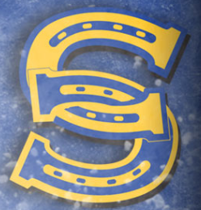
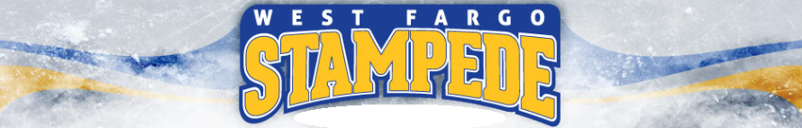

Go Get Em’ Jacob

Keep your stick on the ice, head up and skate hard!

A good hockey player plays where the puck is. A great hockey player plays where the puck is going to be. – Wayne Gretzky

Go Get Em’ Ashton

Keep your stick on the ice, head up and skate hard!

A good hockey player plays where the puck is. A great hockey player plays where the puck is going to be. – Wayne Gretzky

Go Get Em’ Jackson

Keep your stick on the ice, head up and skate hard!

A good hockey player plays where the puck is. A great hockey player plays where the puck is going to be. – Wayne Gretzky

Go Get Em’ Ethan

Keep your stick on the ice, head up and skate hard!

A good hockey player plays where the puck is. A great hockey player plays where the puck is going to be. – Wayne Gretzky

Go Get Em’ Jack

Keep your stick on the ice, head up and skate hard!

A good hockey player plays where the puck is. A great hockey player plays where the puck is going to be. – Wayne Gretzky

Go Get Em’
Ben

Keep your stick on the ice, head up and skate hard!

A good hockey player plays where the puck is. A great hockey player plays where the puck is going to be. – Wayne Gretzky

Go Get Em’ Alex

Keep your stick on the ice, head up and skate hard!

A good hockey player plays where the puck is. A great hockey player plays where the puck is going to be. – Wayne Gretzky

Go Get Em’ Brody

Keep your stick on the ice, head up and skate hard!

A good hockey player plays where the puck is. A great hockey player plays where the puck is going to be. – Wayne Gretzky

Go Get Em’ Kaeden

Keep your stick on the ice, head up and skate hard!

A good hockey player plays where the puck is. A great hockey player plays where the puck is going to be. – Wayne Gretzky

Go Get Em’ COle

Keep your stick on the ice, head up and skate hard!

A good hockey player plays where the puck is. A great hockey player plays where the puck is going to be. – Wayne Gretzky

Go Get Em’ Oakley

Keep your stick on the ice, head up and skate hard!

A good hockey player plays where the puck is. A great hockey player plays where the puck is going to be. – Wayne Gretzky

Go Get Em’ Tate

Keep your stick on the ice, head up and skate hard!

A good hockey player plays where the puck is. A great hockey player plays where the puck is going to be. – Wayne Gretzky

Go Get Em’ Jackson

Keep your stick on the ice, head up and skate hard!

A good hockey player plays where the puck is. A great hockey player plays where the puck is going to be. – Wayne Gretzky

Go Get Em’ Mason

Keep your stick on the ice, head up and skate hard!

A good hockey player plays where the puck is. A great hockey player plays where the puck is going to be. – Wayne Gretzky

Go Get Em’ Coach Addison

Success is the Sum of Small Efforts, Repeated Day In and Day Out.
Shout Praise. Whisper Criticism.

Every child deserves a champion -- an adult who will never give up on them, who understands the power of connection and insists that they become the best that they can possibly be. – Rita F. Pierson

Go Get Em’ Coach Warren

Success is the Sum of Small Efforts, Repeated Day In and Day Out.
Shout Praise. Whisper Criticism.

Every child deserves a champion -- an adult who will never give up on them, who understands the power of connection and insists that they become the best that they can possibly be. – Rita F. Pierson

Go Get Em’ Coach
Lance

Success is the Sum of Small Efforts, Repeated Day In and Day Out.
Shout Praise. Whisper Criticism.

Every child deserves a champion -- an adult who will never give up on them, who understands the power of connection and insists that they become the best that they can possibly be. – Rita F. Pierson

