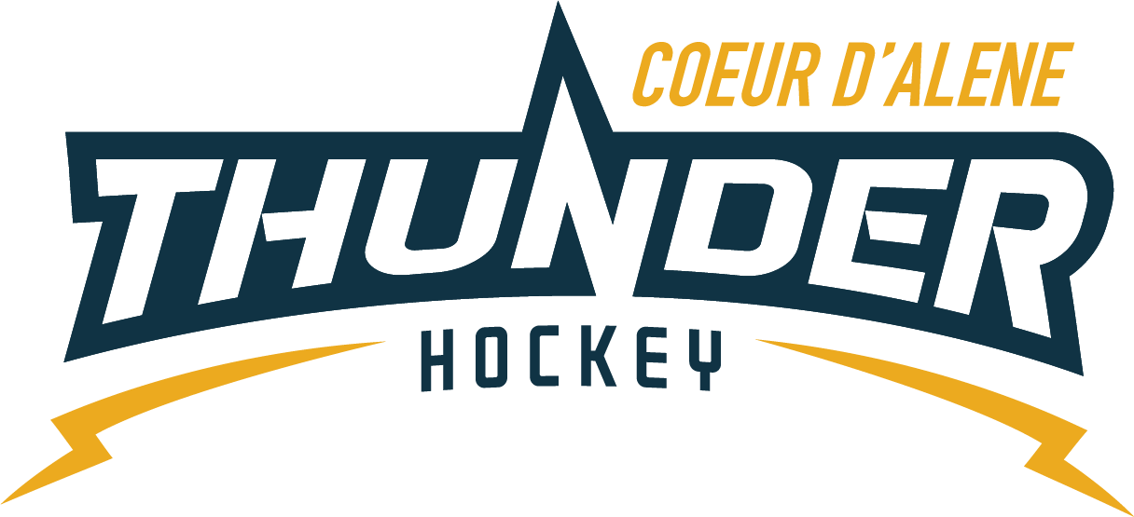

CDAHA

Meeting minutes
Location: Frontier Date: April 8, 2021
Attendees: Bob Nelson, April Hocking, Meghan Smith, Bart Barrett, Jarrod Hansen, Matt Fisher, Josh Leppert, Matt Creighton, Matt Crieghton, Will Higgins, Elliot Taub, Katie Lovitt
Time: 7:00PM
- Call to order
Bob Nelson, President called meeting to order 2/04/21 7:03PM
- Roll call
Torsten Langely absent
- Approval of minutes from last meeting
Minutes read and passed
Today’s agenda only for new members and and voting open to for anyone to join but closed agenda
- Open issues
Welcome New Board of Directors
    - Bob issued farewell speech and thank you’s to exiting members.
    - State Meeting to be discussed and new Director and Alternate to be chosen
    - Meeting Cadence to be discussed
      - Urge new members to follow and handle how their meetings will be ran. Suggestion was made to have all outside matters dealt with in their committees and brought to Board for approval/voting to have time management.
      - Table issues with a timeline but do not let their time line expire.
      - President runs the meetings and can set the time limit of the items listed on the agenda.
      - We will blast committees and what’s available, each BOD will be required to chair a committee to also be at meetings.
      - Coaching Committee/Coach in Chief/Financing/Fundraising.
- New Seats
  - President-Matt Creighton
  - VP- Meghan Smith
  - Secretary – Elliot Taub
  - Treasurer – Katie Lovitt
    - The board set motions in place to appoint the above seats in place, they were 2nd and passed unanimously, no discussions
- Appointed Seats
  - Registrar – April Hocking
  - Scheduler – Kami Winfrey
  - Equipment Manager – Emily Cook
  - Team Manager Coordinator – Jennifer Frame
  - Referee Scheduler – Bart Barrett
    - The board set motions in place to appoint the above seats in place, they were 2nd and passed unanimously, no discussions
- Bylaw
  - Elliot motioned to amend Bylaw 6:7 to add line g. for Team Manager Coordinator.
    - 2nd/passed

- Adjournment
8:14PM
Minutes submitted by: April Hocking
Minutes approved by: CDAHA BOD
- Next Meeting
  - April 29, 2021 6:30PM

