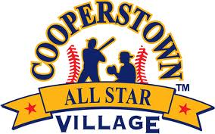

Cooperstown All-Star Village
Skills Competition
FINALISTS
Week 4

Fastest Person in Camp Finalists

Player Name: Troy Smith
Team Name: Michigan Dawgs
Time: 12.81

Player Name: Freddy Beyer
Team Name: Warriors Baseball Club
Time: 12.65

Fastest Double Play Finalists

Team Name: Novi Heat Gold
Time: 2.08 (WINNER)

Team Name: Scottsdale Dirtbags
Time: 2.26

Team Name: Texas Outlaws
Time: 2.29

Home Run Derby Finalists

Player Name: Chase Golding
Team Name: Deerfield Red, IL
Number of Home Runs:12 (WINNER)

Player Name: Ayden Wagner
Team Name: Warriors baseball Club of Michigan, MI
Number of Home Runs:9

Player Name: Dominic Swanson
Team Name: XL Delray Baseball, FL
Number of Home Runs:7

Player Name: Albin Miller
Team Name: Sierra Valley Thunder, CA
Number of Home Runs: 4

Player Name: Jackson Schlott
Team Name: Illinois Dynasty, IL
Number of Home Runs: 6

Team Relay Finalists

Team Name: New Cannan Rams
Time: 20.01 ( WINNER)

Team Name: Baltimore Redbirds
Time: 28.58

Team Name: Gurnee Travelers
Time: 20.85

