INSTRUCTIONS FOR GETTING STARTED WITH RANK ONE
YOUR STUDENT ATHLETE IS NOT ELIGIBLE TO CONDITION, TRYOUT, PRACTICE, OR COMPETE IN ANY SPORT UNTIL ALL CONSENT FORMS ARE SIGNED AND A CURRENT PHYSICAL HAS BEEN UPLOADED FOR APPROVAL

GO TO: https://www.rankone.com

SELECT: Parents Click Here

SELECT: Go to Forms / Georgia / Gwinnett County Schools – Athletics
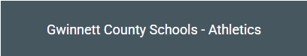
YOU DO NOT WANT TO SELECT 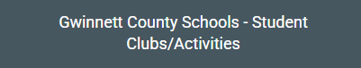
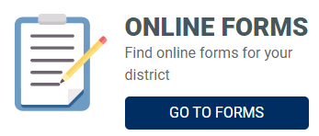

REVIEW INSTRUCTIONS THEN SELECT: Proceed to Online Forms (For assistance, click: How to Create a Parent Account Guide)
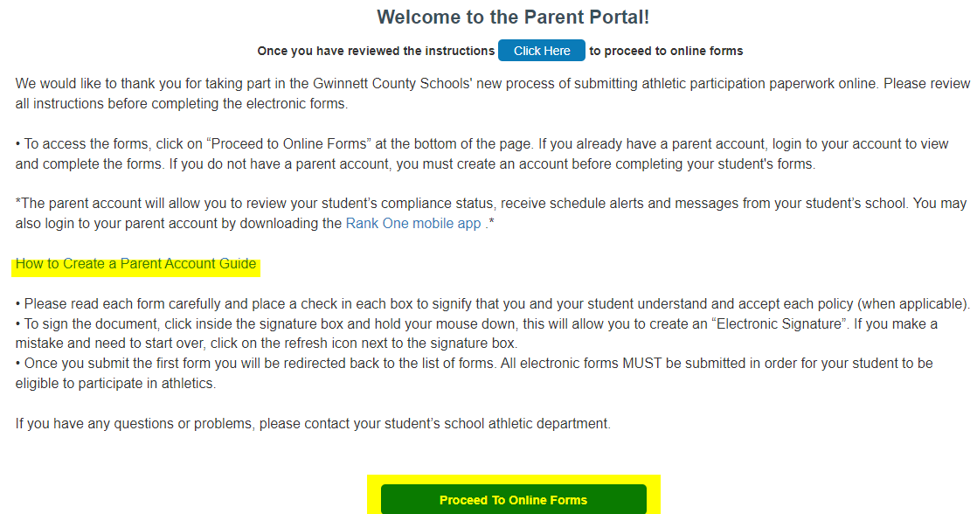
You’ll get a confirmation e-mail that your account has been created. Once the account is set up you can download the app for further updates to your child’s account.
 (This is the app icon)
CONSENT FORMS
IF USING A COMPUTER: Click View and a list of the forms that need to be completed will appear. As you complete each form successfully, it will change from incomplete.
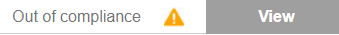
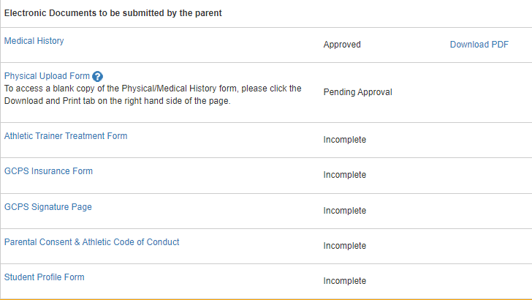

IF USING THE RANK ONE APP: Click your child’s name and then click Forms. A list of the forms that need to be completed will appear. As you complete each form successfully, the incomplete will change, and you will see a green check mark. **
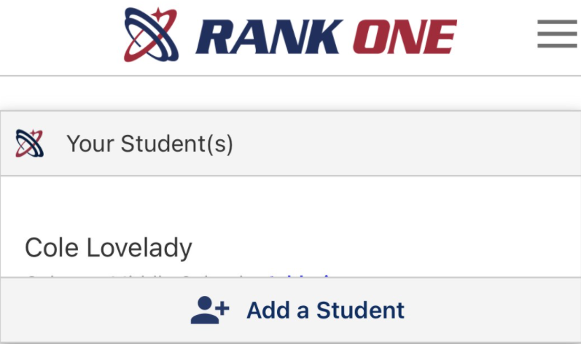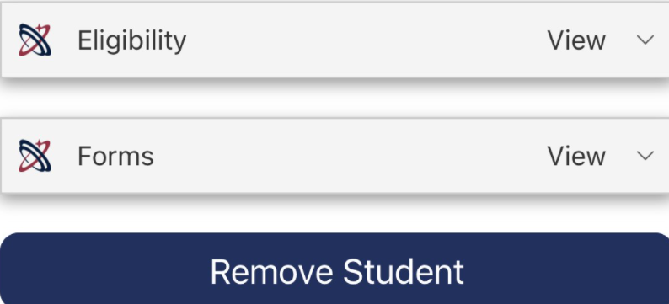
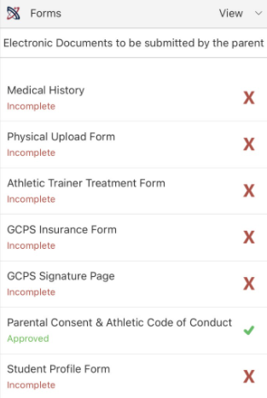

For the GCPS Signature Page, you must open each link and read the form before checking the boxes and signing off. If the links are not opened, the form will not be approved.
PHYSICAL
If you have not obtained a copy of the updated GCPS physical, download and print one from Rank One.
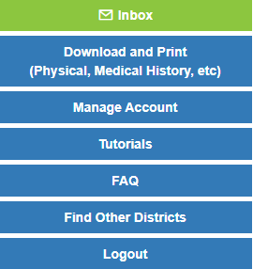

Complete Pages 1 & 2 of the medical history prior to your appointment.

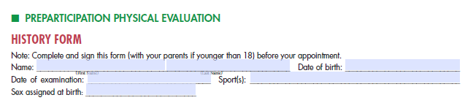

Your doctor will complete Pages 3 & 4. Please be sure your child’s name is on both pages, that both forms are signed and dated by the doctor, and that the eligibility status is clearly marked. (If the doctor’s office places a stamp on the bottom of the forms, please ask them not to stamp over the date of exam.) All four pages of the physical will need to be uploaded.

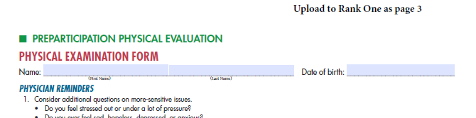

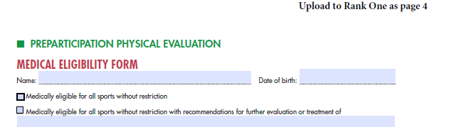

UPLOADING PHYSICAL TO RANK ONE
SELECT PHYSICAL UPLOAD FORM
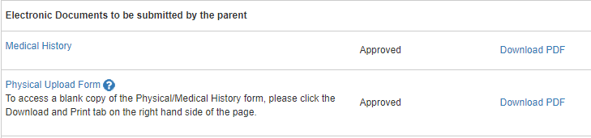

SELECT HOW YOU WILL UPLOAD THE FORMS
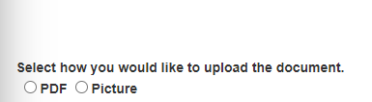

UPLOAD EACH PAGE INDIVIDUALLY, SIGN OFF, AND SUBMIT
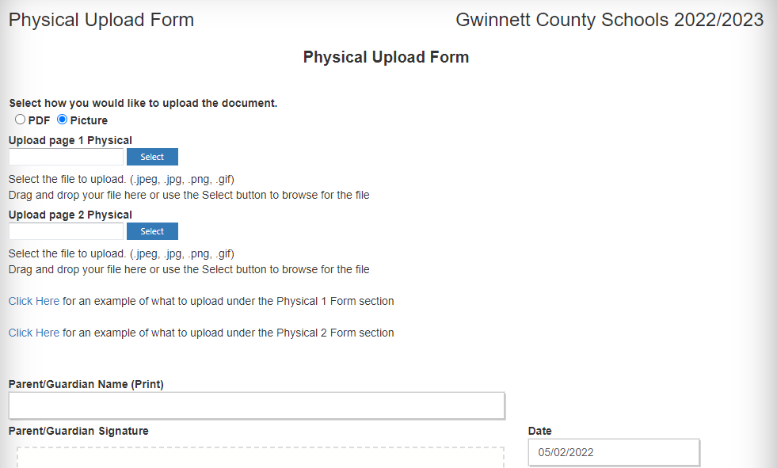

Once successfully uploaded, you will see a notation that the physical is pending approval.

