SLPYHA Board Meeting Agenda
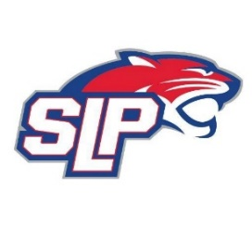
Date: 10/26/21
Bricks
7:00pm

Attendees: Scott Lichter, Michelle Rice, Mike Mliner, Corey Piekarski, Jason Shipman, Adam Kiedrowski, Bob Roloff, Jeremy Flaten

Guests: Matt St. Martin and Connor Gagnon

- President Report: Scott Lichter
- Call to order: 7:00pm
- Approve agenda
- Approve minutes from 8/30/2021 meeting, motion: Lichter, move: Mliner
- Latest D10 updates
- Pictures
- Game Sheets
- iPads
- Covid Update
- Vice President Report: Michelle Rice/John Pitzl
  - Hockey Lab/MAP/FHIT
  - Panther Classic Tournament
  - SKATE Program
- Treasurer Report/Gambling Report: Mike Mliner
  - Mliner motioned to approve expenses for the month, approved by the board
- Secretary Report: Corey Piekarski
- Traveling Director Report: Jason Shipman/Adam Kiedrowski
  - Bantam B2 (collect money/tournaments)
  - Squirt transfer?
- Girls Traveling Director Report: Kevin Mitties
- Mite Director Report: Mike Fitzpatrick
  - Mite updates
- Coaching Director Report: Jeremy Flaten/Bob Roloff
  - Mandatory coaches/manager meetings
- New/ongoing Business:
- Motion to dismiss: 9:26pm, motion: Piekarski, move: Shipman

