4-4-2

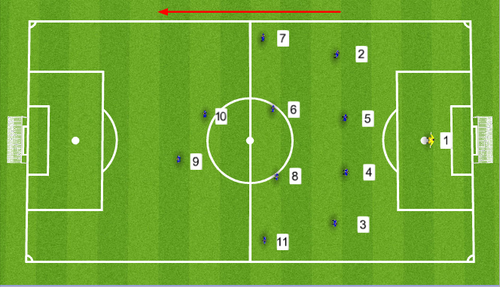

4-4-2 is the most classic 11v11 formation. In recent years, many teams have transitioned away from using the 4-4-2 formation for more offensive or defensive formations. Once the staple formation of most teams, the move away from it has often been to accommodate a talented No. 10, attempt a more complex formation, or strengthen the midfield by sacrificing an attacking player for another midfielder.

More variation occurs based on the players on the team. Some fullbacks are more defensive while others are very attacking. Some wingers hug the touchline while others come inside to influence the play. You can play two physical strikers, one little and large, or even a couple of speed merchants. It all depends on what players are at your disposal.

While other formations rely more on ball-playing Nos. 4 & 5 (central defenders), their main priority is to win everything in the air, be strong in the tackle, and close down the attackers before they get a shot off.

Although the Nos. 2 & 3’s (fullbacks) priorities are to defend, the modern game does dictate that these players are now involved in the attack more. Their position has evolved into one of the key positions on the field and a good No. 2 & 3 can make all the difference to a team.

In a flat four, the players are spread across the midfield. On the outside are the Nos. 7 & 11 (left and right midfielders) who provide the team with pace, creativity, and width in attack. They are responsible for getting crosses into the box and providing the strikers with service.

In the middle, the Nos. 6 & 8 (central midfielders). They are typically very good on the ball and have a lot of stamina to run up and down the pitch to support both the defense and attack. In a 4-4-2 formation, they have a lot of responsibility as they have to create chances, control the play, and need to be disciplined in terms of the positions they take up.

The Nos. 9 & 10 (forwards) have to be able to hold up the ball, bring others into play, and disrupt the opposition’s defense into mistakes.

To work well, the 4-4-2 formation needs disciplined players who attack and defend as a team, are creative in the confines of the formation, and know what is expected of them in their position.

PLAYERS/SKILLS REQUIRED

- Midfielders must be comfortable on the ball
- Nos. 2, 3, 7 & 11 (wing players) must be extremely fit
- Wing players who do not get drawn to the middle
- Forwards who can hold the ball up.
- Defenders who do not create too big of a gap between themselves

PROS

- It is simple to use
- Balance and width
- 2 forwards offer greater opportunity to score
- Players are interchangeable

CONS

- ​A lack of passing options and angles
- Midfielders and one forward must defend
- With flat 4’s across the midfield and defense passing lanes are easily created to beat it

