This form must be used for all award requests.
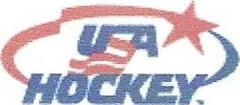 Awards Request Form 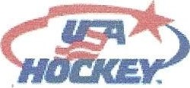
MN Hockey District: Association Name:
(i.e. Anoka Hockey Assoc not AHA)
Team Level/Classification:

(i.e. Bantam A, PeeWee B, Squirt B, Girls IOUA, Girls 12UB, etc.)
Zero Award: For a goalkeeper playing a complete game without allowing a goal.
Hat Trick Award: For a player scoring three goals in one game.
Playmaker Award: For a player registering three assists in one game.
Player awards are distributed under the following conditions:
1 . The recipient is a registered and rostered player.
- The game was in league competition (not scrimmage or exhibition), a sanctioned tournament or a MN Hockey playoff involving only USA Hockey registered teams.
- The game was officiated by registered USA Hockey referees and they have signed the score sheet.
- Eligible player categories: All players Squirt/10U and above.
- A readable, unaltered copy of the score sheet with the players listed is required with the application.
- A copy of the official signed roster must be included with each request.
- Limit of ONE of each award per player per season - i.e. one Hat Trick, one Playmaker and one Zero
Please allow 10 to 14 days for processing. | Coach/Manaqer - this is where the awards will be
We do not mail patches to individual | mailed
players. | Name:
Mail Requests to: | Street:
Rich Rakness | City, State, Zip Code
222 Dale St E | Email:
- Please batch your requests and send them in 2 or 3 times per season — not every time an individual has earned a patch.
 |  |  |  | Game | Game | Zero | Hat | Pla -
 | Pla ers Name | O | onent | Date | Score | Award | Trick | maker
1
2
3
4
5
6
7
8
9
10
South St Paul, MN 55075
AWARDS ARE NOT AVAILABLE TO BE PICKED UP - THEY ALL ARE MAILED.
