College Bound Student Athletes
Helping Our Youth Achieve Success
2023 AAU SEASON
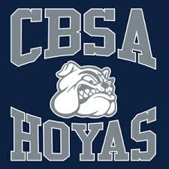

CBSA HOYAS 2023 Tryouts/Registration Schedule
Boys Teams 10U-17U

March 13-19
Location(s) and Time(s)-TBD

