SET UP
- Turn on Score Board (Switch by Sink + Under South Board)  - Turn on Console Panel  - Press & hold   - Select “Scoreboard” by pressing  - USE LAST SETUP - Press 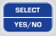 until “No” displays & then   - ENTER SCOREBOARD IDs -  - SELECT YOUR SPORT – Press for Hockey  - CHANGE GAME SETUP? Press until “Yes” displays & then  - NEW GAME? Press until “No” displays & then  - Set Brightness – Press  &  - Enter Period Time – Example: 12:00 minutes would be    - Enter Number of PERIODS -  - Enter TIMEOUT Length -  - Enter TIMEOUTS ALLOWED - | - Enter MINOR PENALTY LENGTH - Example 1:30 minutes would be  - Enter MAJOR PENALTY LENGTH – Example 2:00 minutes would be  - Enter AUTO HORN? Press until “Yes” displays & then  - Enter LAST MIN TENTHS? Press until “Yes” displays & then  - Enter TIME OF DAY? Press to skip  - NEW GAME? Press until “Yes” displays & then  - SET AS DEFAULTS? Press until “Yes” displays & then  - Note: If South board does not sync, turn switch off & on at box again  - After setup is complete - Press   - Make sure the “P” is on the console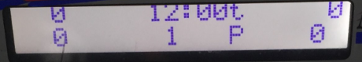. If not, press  until the “P” is displayed.
PREGAME
To enter warmup time, Press  & enter time followed by – Example 4 minutes would be
After Horn, Select
DURING GAME
GOALS (Add)  - For Guest, Press 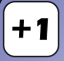  - For Home, Press 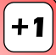  GOALS (Remove)  - For Guest, Press 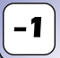  - For Home, Press 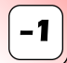  PENALTY (Adding)  - For Guest, Press 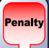 & enter Player # followed by & select MINOR by pressing or MAJOR by pressing  - For Home, Press 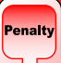 & enter Player # followed by & select MINOR by pressing or MAJOR by pressing | PENALTY (Removing)  - For Guest, Press  & press number of applicable penalty to delete (typically ). Select “Yes” to confirm.  - For Home, Press  & press number of applicable penalty to delete (typically ). Select “Yes” to confirm.  START CLOCK at whistle, Press   STOP CLOCK at whistle, Press  REF ATTENTION, Press 
INTERMISSION (Note: This does not run penalty time, if it exists)
Press  & enter time (typically 1 minute, ) When Intermission is complete, press followed by 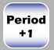 to select next period (keep selecting if you advanced past the correct period)

