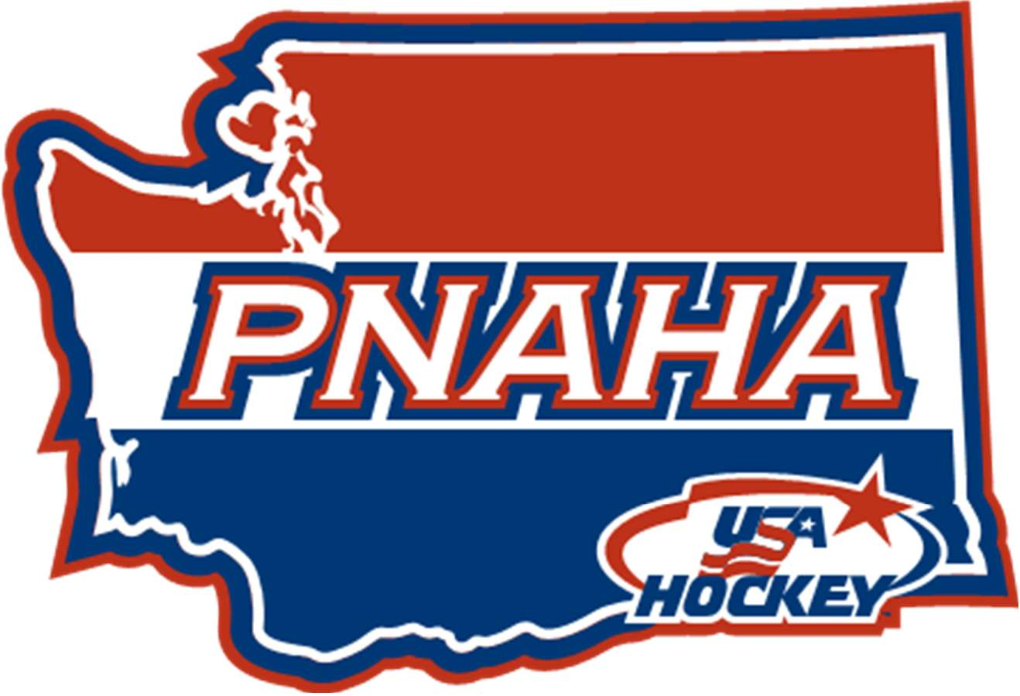PNAHA GENERAL FALL MEETING
SATURDAY, SEPTEMBER 9, 2017 MINUTES

Wenatchee convention center
201 North Wenatchee, Wenatchee, WA 98801

Committee Round tables covering Coaching, Safesport and Registrars was held from 9:00 am until 11:15 am.
Dru Hammond, PNAHA President called the meeting to order at 11:15 a.m.
- Sign-In
- Sign-in sheets distributed and are an official record with these minutes. Voting delegate sign-in sheet completed with the following delegates present:
  - President – Dru Hammond; 1st Vice President – Robby Kaufman; 2nd Vice President – Rob Azevedo; Secretary/Treasurer – Debbie Didzerekis
  - Member Organizations Present: EYH – Gary Gusinsky; IEAHA – Dave Nieuwenhuis; KVHA – Les Grauer; SKAHA – Doug Kirton; SAYHA – Brad Moon; PSAHA – Chuck Zimmer; TCAHA – Kris Waltze; VYHA – Ben Triplett; WAHA – Travis Fetzer; WSHC – Penny Delbarto and WWFHA – Kelly Goscinski
  - Member Organization not represented - MLYHA, SJHA, WCAHA and YAHA
- Introductions - Personal introductions made by the PNAHA Board of Directors, PNAHA Appointed Directors and special guests, at total of 30 people were present for the meeting.
- Minutes of last meeting
- Minutes from June 24, 2017 PNAHA Summer/Spring meeting were presented to the board, Dru Hammond noted a correction to the title, replace Winter with Summer/Spring. Gary Gusinsky (EYH) motion [to approve the minutes with noted correction to title], 2nd by Brad Moon (SAYHA), motion passed.
- Treasurer Report – Debbie Didzerekis
- Debbie Didzerekis (PNAHA Secretary/Treasurer) presented copies and reviewed the July 2017 – August 2017 Treasurer Report. Ending balance as of August 31, 2017 is $98,629.78. Treasurer report accepted as presented. Associations were reminded that if any anytime they have questions or wish to see the PNAHA records they can do that, Debbie will show them the QuickBooks online, or she can send them a financial detailed report. Gary Gusinsky (EYH) motion [to approve the treasurer report as present], 2nd by Brad Moon (SAYHA), motion passed.
- Proposed Budget for 2017-2018 presented to the board, a review of increases in directors and cost of events such as showcase high school teams, incurs a deficit for the coming budget year. Discussion of money reserves that are held by PNAHA for operating expenses in case of necessary coverage will more than cover any budget deficit that is incurred. Gary Gusinsky (EYH) motion [to approve the proposed budget], 2nd by Brad Moon (SAYHA), motion passed.
- Special Guests
- Donna Kaufman, Pacific District Director –
- Youth Council topics
- USPHAL no longer part of USA Hockey, created their own league
- No tryout dates to be scheduled until 48 hours after nationals, Prep schools do recruite in January
- USHL Signed agreement with USA Hockey
- National tournament topics
- Must stay at host hotels and they must be booked through tournament host
- 12 minute rest time up on clock for national tournaments while Zamboni is on ice
- quarter finals coming back which will add 1 day to Tier I tournament
- backup goaltender language added “or extenuating circumstances”
- Tie breaker language change - added most regulation wins
- Note on 4 hours between games is from end of game to beginning of next game
- Stronger EMT language authority at tournaments, tournament EMT has authority
- Affiliate Tier II state tournaments should be ran like national tournaments
- Declarations for Women’s Tier II/Tier I is still Oct 1
- Some general house cleaning on the Guidebook
- Pacific District meeting will be in Portland in October
- Hawaii will be holding an Adult Tournament
- Steve Stevens, Pacific District Referee In Chief – The State of Hawaii has one sheet of ice in Maui, there is talk of another sheet but nothing confirmed. Hawaii currently has 22 officials. Las Vegas team will only cause officiating numbers to grow in that area. On the District side, there were two women officials from
- Wendy Goldstein, Pacific District Registrar – Wendy wanted to introduce everyone to Jeremy McCann, the new PNAHA Registrar. She wanted to thank everyone for all their hard work and patience during this transition.
- Player release must go to PNAHA President not registrar
- Credential book should only have Roster, ALL SCORE Sheets (it can include any return to play release for players that had been out for medical reasons/concussions).
- NEW RULE: at Tier I teams must have 15 players, they are not nationally bound until they have the 15 player minimum.
- Tier II encouraged to have 15 players, they can no longer have 12 year old playing on nationally bound team.
- Travel Permits – only with official roster.
- Please note that players playing on teams back east who have competed for a national bid at their state level tournaments and did not succeed, may have players return to the west and possibly play for a west team that has not competed for national bid yet. Players can only compete for nationals once, so if those players return to teams in west they cannot be on the roster for a nationally bound team.
- Officer's Reports
- GOALIE DIRECTOR – Mike Landry
- Mike has a work commitment and he must leave the meeting early, we moved his report to the top of the officer reports. Mike hosted in Tri-Cities a one day Goalie Symposium on July 29, 2017. Darrin Campbell, Kyle Knudsen and Brian Moreno assisted with the 2 ice times and video feed back to the goalies. They had a Vaughn Rep on site who brought goalie equipment for players to try and assisted them in getting sized for gear. In addition they also had a yoga instructor that to lead the players in a yoga class to help them work on flexibility, stretching and overall player health. There will be an article on the symposium in the USA Hockey magazine, Mike will let everyone know when it is coming out. Mike is hoping to expand the Goalie Symposium next year to a Friday – Sunday event. One side note that Mike wanted to share with everyone was when you are training goalies be sure to use inclusive language. He found that because it is co-ed it used “she” and “her” interchanged with “him” and “he” when talking to the group, it engaged the female goalies a bit more instead of just using male language. Just a little something that everyone should try and do.
- Mike has been working with Rob on a plan for goalie evaluation for the Development Camp. Mike is working on a written proposal to make it more transparent and possibly include an East/West evaluation camp. More information to come as he and Rob work out the details. Cindy Dayley, Female Director, would like to use the same process they develop to identify the female goalies for the Female Development camp. Mike expressed how hard it is to get around the entire state to evaluate goalies for development camp, Rob Kaufman (PSAHA) and Gary Gusinsky (EYH) both volunteered ice times for goalie evaluations on the west side.
- Mike shared a fundraiser targeted to goalies called “October Saves” which is a Cancer Fundraiser for 8U to NCAA, where goalies get pledges based on how many saves they will make in the month of October. The website for more information is www.octobersaves.org. Mike will work with Jeremy McCann, PNAHA Registrar to get information out to goalies.
- Mike is still working with affiliates to setup their own goalie development programs. Please reach to him to schedule time for him to visit your association. He can work with your goalies and/or your coaches. His email is goalielab@gmail.com.
- SUPERVISOR OF OFFICIALS – Ben Staehr (Dan Boelens)
- Ben was unable to attend the meeting, in his place he sent Dan Boelens, the West Side Supervisor of Officials.
- Dan shared that there are lots of seminars being held throughout the state. So make sure anyone interested in officiating is attending one of those seminars.
- Rule Change Year – 14U and under can no longer ice the puck when short handed. Using the 9-dot face off locations, beyond those 2 there is nothing notable.
- Officials will not be monitoring or focusing on Helmet dates that is something parents and coaches should be paying attention to.
- DISABLED SUPERVISOR OF OFFICIALS – Tony Milles (No Report)
- Coaching Director – Rob Kaufman
- Player Development Camp – January 28-29, 2017 in Wenatchee at Town Toyota Center, please communicate this as a black out weekend for teams, so players can attend if selected.
- During coaching breakouts, discussed the amount of information out there to coaches and the importance of being present at the practices as well as being positive. Don’t be on automatic pilot, make it fun and be energetic. Dryland before or after a practice/game and it can also be on a separate night and a different location. Important to remember we are training athletes not just hockey players. Remember your ABC’s of performance training which are agility, balance and coordination which will help ensure a well-rounded athlete.
- ADM – while watching football games they have the ADM logo on the TV, working at removing contact at the younger ages and following an ADM model for development to reduce concussions because of contact.
- 10U ½ ice process, is good for kids, helps with day to day game management, and teams should be smaller.
- CEP Training
- Level 4 in Seattle/Bellevue on 9/22/17 to 9/24/2017
- Level 1 & 2 in Bellevue on 9/23/17
- Level 1,2 & 3 Late October
- Level 1,2 & 3 in Tacoma
- Mid December, Rob will need list of players from directors for development camp
- Pacific District youth camp will be May 3-6, 2018, evaluators from PNAHA Development camp will have ice times with those player in order to better prepare them for the District Camp.
- GIRLS/WOMEN DIRECTOR – Cindy Dayley
- State Female Development planning is well under way. This year Shawna Davidson will be on the ice with the females during the camp. Emily West, USA Hockey ADM Manager for female hockey has also committed to attend the camp this year. Camp dates are January 20-21, 2018; location is still to be determined. Just a reminder this is an Olympic year, which always helps, grow the game of hockey across the country.
- Dru Hammond, PNAHA President discussed that the female camp started about 10 years ago and there use to be younger girls who would attend the camp in order to fill it out. This year no younger girls were allowed to attend because we had the numbers with those who are qualified to attend, it has grown greatly over the 10 years since Shirley Williamson started the camp. Dru is looking to use any profits form development camps to help fun bringing in folks from USA hockey to make it a useful camp. Those profits if any can also be used to send players on to the next level if help is needed.
- Another aspect this year is adding the Female high school showcase along with the Youth high school showcase. As of August there were 65 Jr/Sr females registered in PNAHA who would be eligible to participate. This is a focus for those under scouted areas through out USA hockey.
- Cindy offered as a side note to everyone that NCAA Division I and II coaches are identifying 12 and 13 year olds and making verbal commitments to those younger girls.
- REGISTRAR/RISK MANAGER – Wendy Goldstein/Jeremy McCann–
- Everyone welcomed the new PNAHA Registrar Jeremy McCann to the position. Jeremy discussed that he already had in some tournament applications and asked about 10U tournaments are they going to be ½ ice.
- LEAGUE COMMISSIONER – Vacant (TBD)
  - Team Declarations
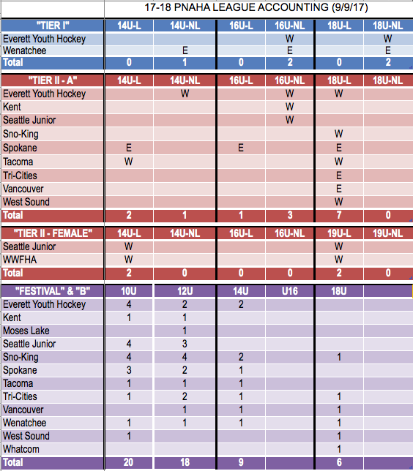
Please note at Festival -12U SAYHA indicated they could have a 3rd team, at B-14U PSAHA is a maybe, and at B-18U Whatcom is an 18U made up of mostly 16U and is not sure if they would participate.
For 10U Festival, teams are not interested in League play, but would like to see some PNAHA super weekends so that the competition committee can make team comparisons for State Festival rankings.
- League commissioner was elected from the 18U teams participating in league. The teams elected Cassidy Hudkins to be the 17-18 League Commissioner. You can reach him at commish@pnaha.com or (360) 479-7465.
- Rules committee was previously present with a recommended rule update from Dru Hammond (PNAHA President) to amend the Festival Operations 12U and 10U, section 12U C and 10U G. Proposal presented: If for any reason a PNAHA League Division at 10U or 12U is not formed for any season, an “open” Festival will be held for PNAHA teams only. Each PNAHA association in good standing will be contacted for a team participation count no later than 2 weeks following the PNAHA Annual Fall meeting. Each association will be limited to a maximum of 4 teams to participate in the Festival. Once the preliminary count has been made it cannot be increased. At the January Winter meeting a final team count will be made. Associations may reduce the team count participation at this time. This final count is binding. Robby Kaufman (PNAHA 1st VP) motion to accept rules committee recommendation to have a Festival without a league. 2nd Debbie Didzerekis (PNAHA Secretary/Treasurer). All in favor, motion passed.
  - 2017-2018 Tournament Bids
    - State B – to be hosted by West Sound – March 16-18, 2018
    - Tier II - to be hosted by TCAHA – March 2-4, 2018
    - 10U - to be hosted by PSAHA – March 23 – 25, 2018
    - 12U – to be hosted by SKAHA – March 23-25, 2018
  - District Tournament Dates
    - From the Pacific District Guidebook
      - Youth Tier I/Girls Tier I – March 8-11, 2018 – San Jose, CA
      - Girls Tier II – March 8-11, 2018 – San Jose, CA
      - Youth Tier II – No District Tier II tournaments, Affiliate State Champions Win Direct byes to Nationals.
      - Women C & B Divisions – March 2-4, 2018 – San Jose, CA
  - National Tournament Dates
    - From USA Hockey website
      - Tier I – April 5-9, 2018
        - 14U Charlotte, NC
        - 15 Only Plymouth, MI
        - 16U & 18U Philadelphia, PA
      - Tier II – April 509, 2018
        - 14U Amherst, NY
        - 16U Wayne, NJ
        - 18U Green Bay, WI
      - Girls/Women – April 5-9, 2018
        - Tier I & II Marlborough, MA
        - Women’s (A/B/C) Bedford, MA
      - High School All – March 22-26, 2018 – Plymouth, MN
      - Disabled all at West Dundee, IL
        - Blind, Deaf, Special Hockey & Warrior – April 5-8, 2018
        - Sled – April 12-15, 2018
- safesport DIRECTOR – Doug Ross
  - Screening process is currently not functioning correctly; Doug is working through the problems with Sports Engine. Doug will be sending information and updates to the Safesport coordinators.
- adm director west side – Doug Kirton
Here is a link that was sent to me by our ADM Regional Manager Joe Bonnett. The current effort is led by former player Pat Lafontaine in conjunction with the NHL. It is an effort to grow our game at all levels.
https://www.usatoday.com/story/sports/nhl/2017/09/06/hockey-organizations-unveil-declaration-of-principles/105321180/
https://www.nhl.com/info/nhl-declaration-of-principles
Joe will be visiting the Seattle area on Monday, September 11th and 12th and all area coaches are welcome to attend.

USA Hockey ADM Coach/Player and Parent Meeting
Sno-King Hockey Association continues to work closely with USA Hockey as an American Development Model Club. Our players and coaches always receive the latest ADM developments and training techniques. Regional Manager Joe Bonnett will be present at
- Sno-King Renton Monday, September 11th @ 6:00 PM
- Sno-King Kirkland Tuesday, September 12th @ 6:00 PM

This will be an excellent opportunity for our players, coaches and parents to learn all aspects of the American Development Model. How it started, where it is now and what the future holds.
Meeting Agenda
· ADM practices and better ice utilization
· Importance of decision making drills and small area games
· Benefits of 10U half ice
· Parents and coaches the Q and A
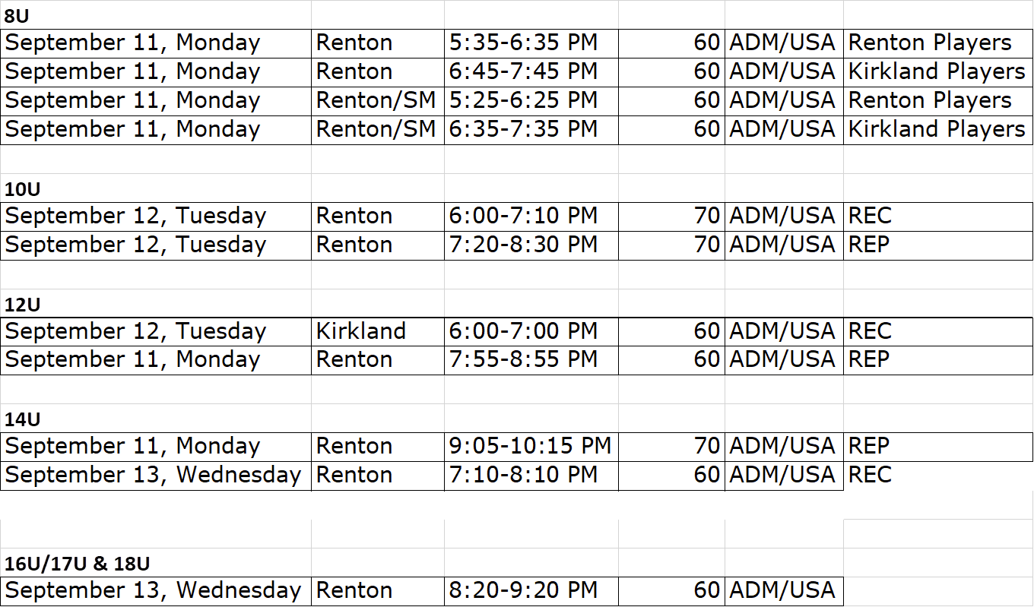

- adm director east SIDE – Herman Cho – nothing to add
- DISABLED HOCKEY DIRECTOR – Tami English (No Report)
1st Vice President – Robby Kaufman (No Report)
- 2nd Vice-President – Rob Azevedo (No Report)
- president – Dru Hammond
- Just wanted to remind everyone that for proposals/rule changes the 30 day notice is a curiosity not a rule. Per Roberts Rules if a practice is in place and followed for a period of time that can become a rule of the society. It is good practice to get proposals in 30 day sin advance but there will be times that we can’t meet that. Standing process will be to maintain two (2) weeks prior to the meeting. Members are to submit items for the agenda 3 weeks in advance to the PNAHA President and Secretary.
- Dru thanked everyone for submitting tournament requests to host.
- State B – to be hosted by West Sound – March 16-18, 2018
- Tier II - to be hosted by TCAHA – March 2-4, 2018
- 10U - to be hosted by PSAHA – March 23 – 25, 2018
- 12U – to be hosted by SKAHA – March 23-25, 2018
- Old Business
- TIER I – Rules committee reviewed their submission of the Certification form in assisting with defining Tier II/Tier I teams. Form is attached.
- INVESTIGATIVE TASK TEAM – Doug Kirton had no report on this item.
- NEW BUSINESS
- RULE 14 AMMENDMENT – Discussion regarding that in June 2017, Rule 14 was to go away per the previous meeting where it was set to expire at that meeting and the Rules Committee were to come back with a replacement process for certifying at Tier I/Tier II. That did not happen so there was discussion that it was not appropriate to simply vote to renew the rule. A group discussion was had regarding this issue and that the board can hold a vote which it did to renew the standing rule.
  - A motion by Brad Moon (SAYHA) to accept [Rule 14 as presented], 2nd by Ben Triplett (VYHA). See proposal attached. Discussion about versions of issues that this can help address or prevent. Question was called. Motion passed (7 yes, 4 no, 1 abstained).
- LEAGUE WEEKEND PROPOSAL – Robby Kaufman (PNAHA 1st VP) reviewed the rules committee proposal for wording to be added to 10U/12U Festival operations to allow for an end of year festival in the absence of a league. Robby Kaufman (PNAHA 1st VP) motion [Accept Proposal for Festival Operations as presented], 2nd by Brad Moon (SAYHA), motion passed.
- High School Hockey Implementation – SKAHA presented information on the program they are starting to implement High School hockey league through PNAHA that would be nationally bound. They will be rolling theirs out this year and would like to have others participate. They anticipate capturing players that want to play at that higher level with an opportunity to attend Nationals. Discussion regarding players going back and forth between the high school teams and their regular season teams and that communication would need to be had between associations. Also discussion around if players can participate on 2 nationally bound teams. From the information that was acquired it appears they can be on a High School and a Youth team nationally bound. More information to come, SKAHA will share their documents they have created with the rest of the group.
- Winter MEETING
- The PNAHA Winter meeting will be held on Saturday, January 6, 2018 at the Wenatchee Convention Center. Room reservations can be made by calling (509) 662-4411 as for PNAHA Winter Meeting rate.
- ADJOURNMENT– Les Grauer (KVHA) motion [to adjourn at 3:48 pm], 2nd by Gary Gusinsky (EYH), all in favor, meeting adjourned.

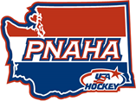

 | PNAHA Treasurer Report
 | As of August 31, 2017
Balance as of May 31, 2017 |  |  | $ 109,956.72
Income
 | Discounts/Refunds (Bank Cash Back Bonus) | 27.71
 | Misc Income
 | Donation | 175.00
 | Player Fees | $ 11,118.00
 | Total Income | $ 11,320.71
 |  |  | $ 121,277.43
Expenses
 | ADM Director, PNAHA | 511.52
 | Coaching Director, PNAHA | 539.58
 | Goalie Director, PNAHA | 921.97
 | Meetings-Motels
 | Food | 1,838.82
 | Misc Expenses
 | Bank Charges | 10.50
 | Clothing | 108.58
 | Gift | 150.00
 | Legal & Professional | 1,999.67
 | Office/General Administrative Expenses | 209.88
 | Printing | 46.92
 | Pacific District Player Fees (2016-2017) | 8,153.00
 | PNAHA Development Camp
 | Motel/Hotel | 1,020.91
 | PNAHA Travel | 1,397.40
 | Referee Expenses | 123.08
 | Safesport, PNAHA | 952.15
 | Tournament Expenses
 | B State Tournament | 665.59
 | Festival 10U/12U | 287.29
 | Tier II Tournament | 485.78
 | Travel-USA-Seminars | 3,225.01
 | Total Expenses | $ 22,647.65
Balance as of August 31, 2017 |  |  | $ 98,629.78

PNAHA
BOARD OF DIRECTORS MEETINGS
CONSTITUTION, BYLAW & RULES PROPOSAL SUBMISSION FORM

NAME OF CHANGED DOCUMENT: | PNAHA Rules & Regulations
MAIN HEADING: | ARTICLE IV – ELIGIBILITY
REGULATION (Heading):
BY-LAW (Heading):
Section: | 14
Reference (sub-section):
Paragraph / Page no(s): | /84

CURRENT WORDING:
14. Tier II National Tournament Bound teams shall not include on its roster more than 5 players from outside that Member Organization/Member Team's membership from the prior year. For the purpose of this rule the following will apply: A new Member Organization or Member Team will be on probation during the first year of membership and will not participate in the PNAHA State tournament. All teams that are national bound and which include more than five (5) players from outside that Member Organization or Member Team’s membership from the prior year must submit a roster to the Competition Committee Chair. In certifying a team’s roster for the Tier II National Bound Tournament, PNAHA shall exclude players who move their legal residency into PNAHA and players moving to a new organization or team from an association that no longer exists. Effective for the 2016/2107 season only, expires at the next June meeting.

RED-LINE WORDING OF PROPOSAL: (as it should appear with new wording-underlined, Deletions-strikethrough)
14. Tier II National Tournament Bound teams shall not include on its roster more than 5 players from outside that Member Organization/Member Team's membership from the prior year. For the purpose of this rule the following will apply: A new Member Organization or Member Team will be on probation during the first year of membership and will not participate in the PNAHA State tournament. All teams that are national bound and which include more than five (5) players from outside that Member Organization or Member Team’s membership from the prior year must submit a roster to the Competition Committee Chair. must submit a roster with players' previous year team to the Certification Committee Chair by October 1. In certifying a team’s roster for the Tier II National Bound Tournament, PNAHA shall exclude the following players from the 5 outside player limit: who move their legal residency into PNAHA and players moving to a new organization or team from an association that no longer exists. Effective for the 2016/2107 season only, expires at the next June meeting.
*Players who move their legal residency and register at the nearest organization in proximity with a Tier II team.
*Players that did not play for a PNAHA member organization the prior year.
*Players moving to a new organization or team from an association that no longer exists.
*Players moving to a new organization that does not offer a Tier II team.
*Players moving back to their home association within two years after playing for a Tier I team. A player’s home association is the organization he/she played for prior to playing Tier I.
There will be no waivers or exceptions to this rule.

CLEAN WORDING OF PROPOSAL: (For ease of reading)
14. Tier II National Tournament Bound teams shall not include on its roster more than 5 players from outside that Member Organization / Member Team's membership from the prior year.
For the purpose of this rule the following will apply: A new Member Organization or Member Team will be on probation during the first year of membership and will not participate in the PNAHA State tournament.
All teams that are National Tournament Bound must submit a roster with players' previous year team to the Certification Committee Chair by October 1. In certifying a team’s roster for the Tier II National Tournament Bound team, PNAHA shall exclude the following players from the 5 outside player limit:
*Players who move their legal residency and register at the nearest organization in proximity with a Tier II team.
*Players that did not play for a PNAHA member organization the prior year.
*Players moving to a new organization or team from an association that no longer exists.
*Players moving to a new organization that does not offer a Tier II team.

*Players moving back to their home association within two years after playing for a Tier I team. A player’s home association is the organization he/she played for prior to playing Tier I.
There will be no waivers or exceptions to this rule.

INTENTION OF PROPOSAL:
Submitter: BRAD MOON

PNAHA
BOARD OF DIRECTORS MEETINGS
CONSTITUTION, BYLAW & RULES PROPOSAL SUBMISSION FORM

NAME OF CHANGED DOCUMENT:
MAIN HEADING: | Festival Operations 12U and 10U
REGULATION (Heading):
BY-LAW (Heading):
Section: | 12U C./10U G
Reference (sub-section):
Paragraph / Page no(s):

CURRENT WORDING:
N/A

RED-LINE WORDING OF PROPOSAL: (as it should appear with new wording-underlined, Deletions-strikethrough

CLEAN WORDING OF PROPOSAL: (For ease of reading)
If for any reason a PNAHA League Division at 10U or 12U is not formed for any season, an “open” Festival will be held for PNAHA teams only. Each PNAHA association in good standing will be contacted for a team participation count no later than 2 weeks following the PNAHA Annual Fall meeting. Each association will be limited to a maximum of 4 teams to participate in the Festival. Once the preliminary count has been made it cannot be increased.

At the January Winter meeting a final team count will be made. Association may reduce the team count participation at this time. This final count is binding.

INTENTION OF PROPOSAL:
To allow all PNAHA 10U and 2U teams the opportunity to participate in an end of the year Festival despite the failure of a 10U or 12U PNAHA League to form for any given season.

Submitter: DRU HAMMOND

