- 0-5 minutes – Welcome (Introduce yourself/Goals for the season: 1) Fun 2) Everyone getting 1% better each practice)
- 5-20 minutes – Dribbling Fundamentals
  - How to Dribble - https://www.youtube.com/watch?v=BnvGa0I8bMc&list=PLmPIogZWH3R4xiAiSfYtc0fAoRoUYiUSk&index=48
  - Seated Dribble Drill – All participant seated on butts with legs out. Participants start by dribbling as low to the ground as possible on the right side of body (stress using wrist and finger tips). Switch to left hand
  - 3-3-3 Drill - https://www.youtube.com/watch?v=v1Et3nW1IQ8&list=PLmPIogZWH3R4xiAiSfYtc0fAoRoUYiUSk&index=57
  - Zig Zag Drill - https://www.youtube.com/watch?v=HI3uylRp1OY&list=PLmPIogZWH3R4xiAiSfYtc0fAoRoUYiUSk&index=64
- WATER
- 25-40 minutes – Shooting Fundamentals
  - How to shoot - https://www.youtube.com/watch?v=t7ciq_x4138&list=PLmPIogZWH3R59Dr1P0aWjSPbYVO206PYe&index=33
  - Perfect Shot - https://www.youtube.com/watch?v=ihKEQGn3KNo&list=PLmPIogZWH3R59Dr1P0aWjSPbYVO206PYe&index=37&t=3s
  - Form Shooting - https://www.youtube.com/watch?v=lIezoHBdF-k&list=PLmPIogZWH3R59Dr1P0aWjSPbYVO206PYe&index=40
  - Jump Stop Shooting Drill - https://www.youtube.com/watch?v=AueLd1-H1V8&list=PLmPIogZWH3R59Dr1P0aWjSPbYVO206PYe&index=26
- WATER
- 45-55 minutes – Defensive Technique
  - Fundamentals of Defense (teach how to play defense)
  - Closeout. Slide, Backpedal Drill (https://www.youtube.com/watch?v=aSvFDJcIzys&list=PLmPIogZWH3R49KmlPCeyzY8XyQSprfg_Q&index=23)
- WATER
- 60-70 minutes – League Rules
  - Go over league rules including:
    - Taking ball back on a defensive possession
    - Checking the ball
    - Scoring
- 70-90 minutes – SCRIMMAGE
  - Run the “Cone Scrimmage” game https://www.youtube.com/watch?v=ImLdkaheVAY&t=372s (8:06 mark)
- 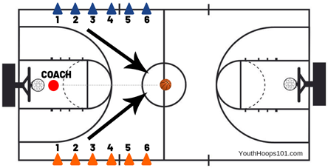
- Line players up from youngest to oldest in your group so that they are competing against the same skill level.

