2024 Men’s 16u Duals Team IN
The Men’s 16u National Team traveled to Herriman, Utah for the National Duals was very successful for Team IN. Teams included in tournament this year were: CA, ILL, IA, MN, KS, NE, UT, FL, TX, SD, ND, OR, ID, WY, IN
Team IN Gold finished 4rd in the Nation Overall. Winning the A pool, then going 2-2 in the Gold Pool (4th out of 35 teams).

Below listed are the members of 16u Team Indiana who made the trip.

88 Cameron Schofield 6-2
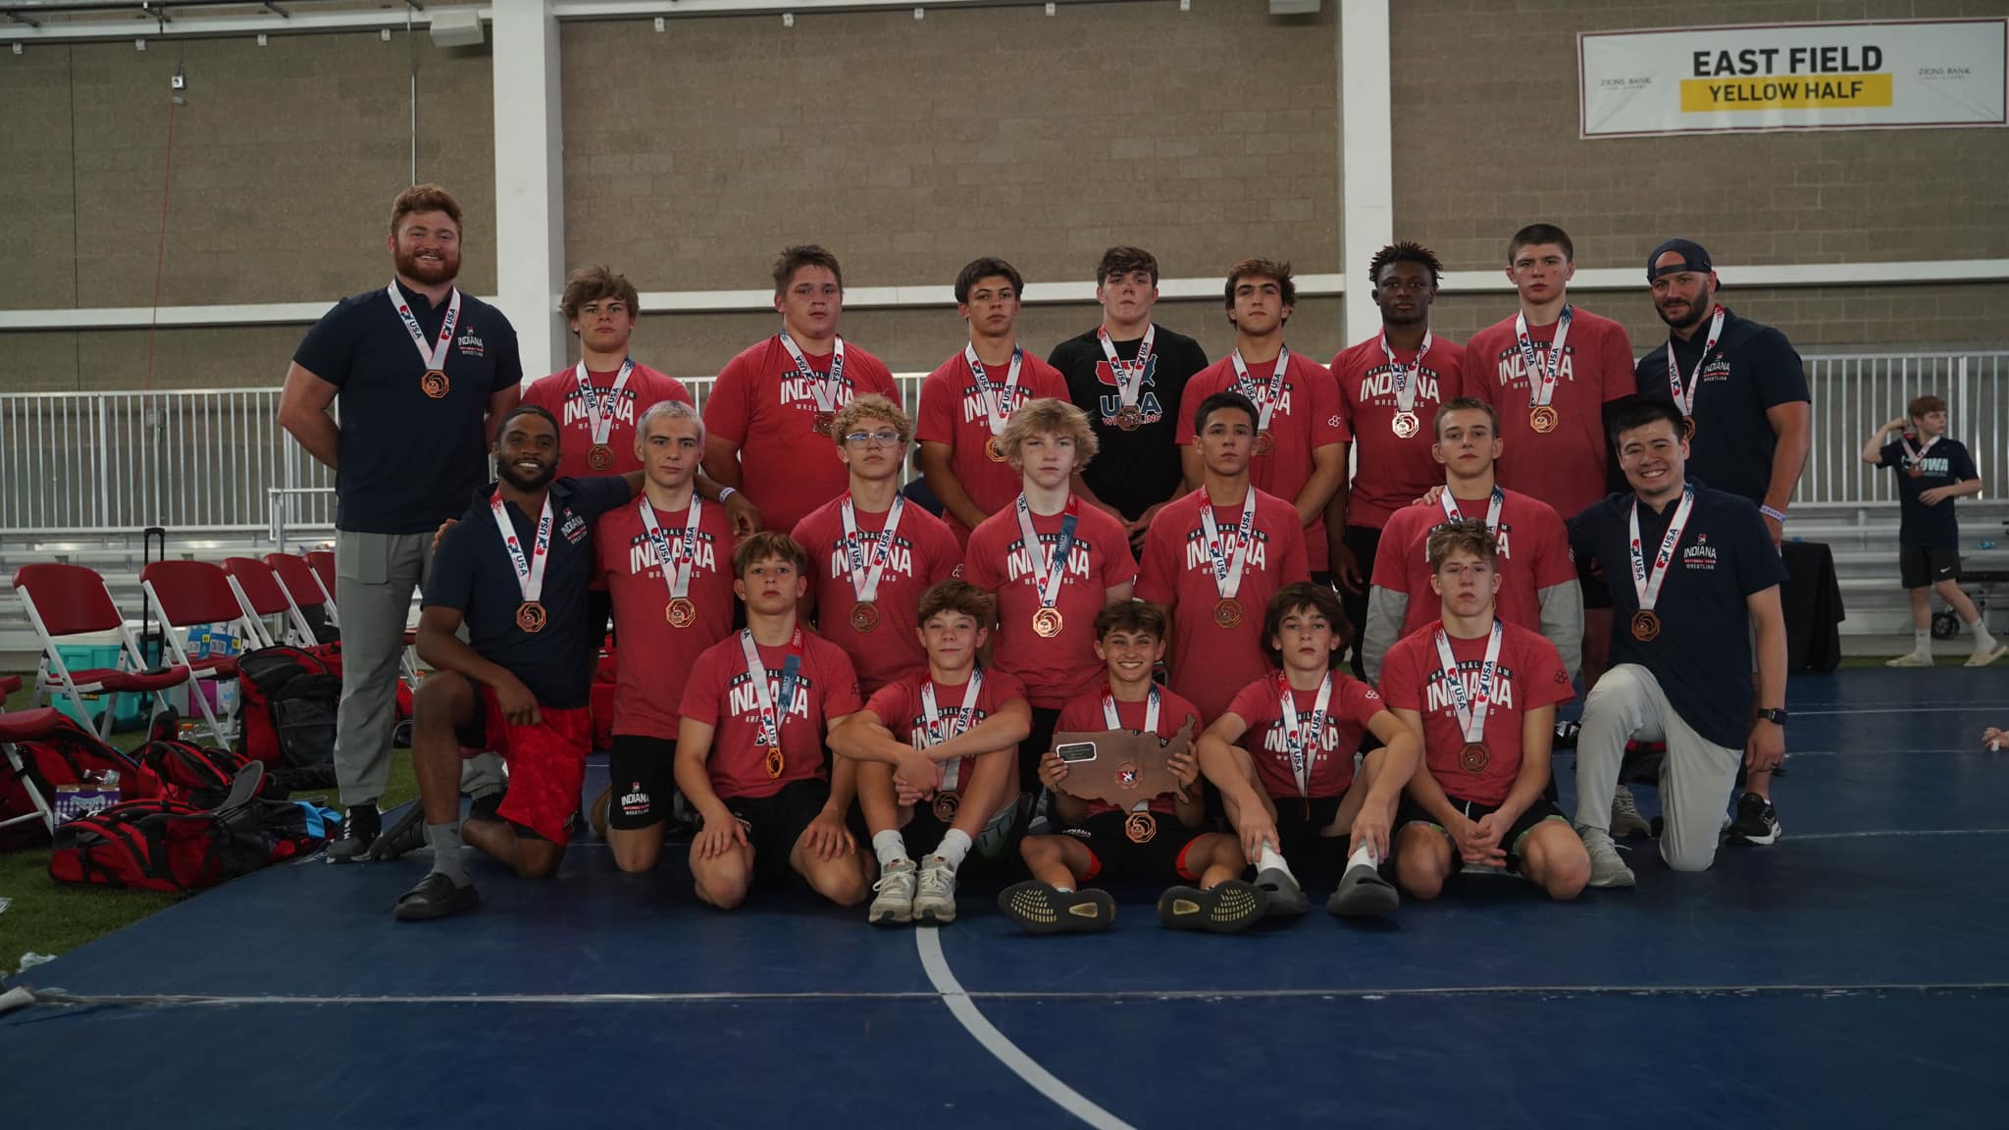
94 Kellen Schoeff 4-4
100 Case Bridge 7-1
106 Case Bell 7-1
113 Jensen Boyd 8-0*
120 Colin Strayer 5-3
126 Gavin Lewis 5-2
132 Braylon Reynolds 2-2
138 Clinton Shepard 7-1
144 Peyton Hornsby 5-3
150 Tommy Gibbs 7-1
157 Matthew Staples 7-1
165 Lucas Boe 7-1
175 Michael White 6-2
190 Conner Hoar 2-6
215 Kellen Fellure 4-4
285 Hayden Smith 6-2

Team Leader: Ryan Parrish
Coaches: Cameron Diep, Chad Red Jr, Draven Rasler

* Jensen Boyd was named to the all tournament team.

