CAMP APPLICATION
Name:__________________________
Address:________________________
Shirt Size: Youth _____ or Adult_____
Age: ______ Grade Fall '25_________
Email: _________________________
Parent Name:____________________
Day Phone #:____________________
Emergency Contact:_______________
Release and Liability Waiver
In and for consideration of my child's participation in the Flower Mound Baseball Camp (a/k/a as "Jaguar Baseball Camp"), I, for myself, my spouse, my child, and on behalf of our heirs, assigns, personal representatives and next of kin, HEREBY RELEASE AND PROMISE TO INDEMNIFY AND HOLD HARMLESS (including expenses and attorneys' fees) Danny Wallace and all persons under his direction or supervision at the Flower Mound Baseball Camp (each a "Released Party") from any and all liabilities, injuries, damages or other claims of any kind related to or arising out of my child's participation in the Flower Mound Baseball Camp. This release complies with the express negligence doctrine and applies EVEN IF THE CLAIM(S) ARISE(S) FROM THE RELEASED PARTY'S OWN NEGLIGENCE.

Signature: ____________________________

Danny Wallace
JAGUAR BASEBALL CAMP
3227 Walnut Grove Place
Flower Mound, TX 75022
Phone (469)401-9994
Wallacedt@lisd.net

www.FlowerMoundBaseballCamps.com

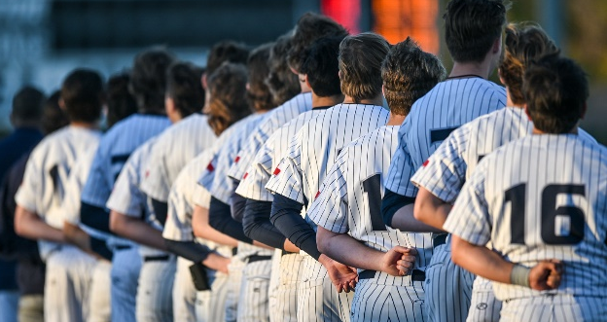

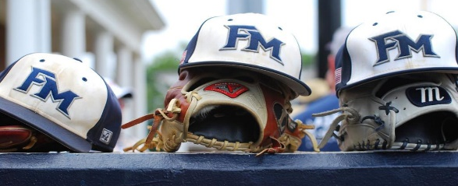

JAGUAR BASEBALL CAMP
May 26th - May 29th, 2025
Day 1 is Memorial Day
SESSION I: 8:30AM-11:00AM
Age 5 - Incoming 6th grades
SESSION II: 12:00 PM-2:30PM
Incoming 7th -9th grades

CAMP INFORMATION AND APPLICATION


CAMP STAFF AND FORMAT
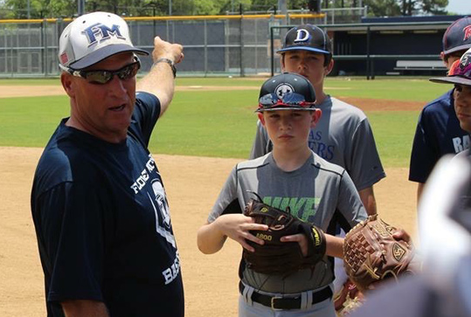
Staff: Head Coach Danny Wallace, FMHS assistant coaches and former players at Flower Mound High School will instruct during the camp.

Philosophy: The camps are designed to teach fundamentals of baseball, individual skills, and team skills.

Format: Campers will be taught the fundamentals of play at different positions. Each camper will be grouped with players of equal ability in order to promote safety and confidence. There will be instruction in infield, outfield, catching, pitching and hitting. During each day of camp, we will end the day with a game to teach team play.

INCOMING 9TH GRADERS

This camp will be used to teach fundamentals and team skills but will also be used to prepare the athletes for high school baseball. Coming to this camp gives players a chance to meet the high school coaches and get instruction before their freshman year. It is a terrific opportunity for young players to prepare for the future.

Camp Fees
The Camp Fees are $105 per participant.

FAQ's
Q: What do I need to bring?
A: Campers will need to bring a glove and are encouraged to have baseball pants and a hat. Bringing your own bat or other playing gear is also strongly encouraged.
Q: Will there be water breaks and concessions?
A: There will be water breaks – please, bring your own snack and water.
Q: How do I sign up for camp?
A: Use the Camp Application in this brochure. Please, mail your completed application and check made payable to "Danny Wallace" to:
Danny Wallace
3227 Walnut Grove Place
Flower Mound, TX 75022
or
Register on-line at:
www.FlowerMoundBaseballCamps.com

