Michigan Senior Women’s Hockey League Meeting Minutes
Thursday, October 8th, 2020 7:00-9:00pm

Attendees: BOD: Lauren Murphy, Tina Butler, Sara Lane, Alix Wright, and Alyssa Laforge Absent Sarah Mason and Maria Farris. Members: Laurie Golden, Renee Leblanc, Lauren Histed

- Call to order: Lauren Murphy: 7:04 Second Alyssa Laforge

- Prior Meeting Minutes: Approval of September meetings Via Slack

Financial
  - Treasury Report:
    - Comerica: Balance as of $5,720.36 as of 10/8/2020
    - 13 teams have paid for the season

Old Business:
  - None

New Business:
  - Sam Jenkins has resigned from the board this year due to injuries and not rostering as a coach or player per handbooks rules
  - The Michigan health department has reinstated the use of masks MAHA will continue to uphold their policies on wearing masks while in the rink and playing.
  - All appeals approved for this season will need to be reappealed next season
  - 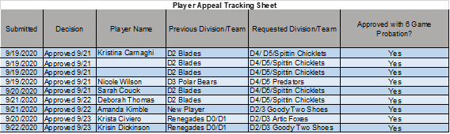
  - Recap on rostering players, uploading master schedules
  - Reminder that USA hockey is short on ref’s this season, but the board has not heard that any teams are having issues finding refs
  - Need to re-evaluate and publish goalie sub list and rule for this season.

Meeting called to close by Lauren Murphy at 7:40pm. Second by Alyssa Laforge

Next Board Meetings: 2nd Thursday every month -7:00-9:00pm

2020 | 2021
November 12, 2020 | January 14, 2021
December 10, 2020 | February 11, 2021
 | March 11, 2021
 | April 08, 2021

