Agility Training
Should be done on Mondays!
Agility Training
- “Jump” Drills
  - Jump rope 3x1-minute
  - Line hops 3x30 seconds each way (forward/back & side/side; double leg & single leg)
  - Vertical jumps:
-Double leg 3x5-stick the landing
-Single leg 1x5-stick the landing; 2x5-rapid fire
  - Standing broad jumps 5x10 jumps-stick the landing; 5x10 jumps-rapid fire
  - Finisher! “skaters” (Rapid fire) 3x1-min, 20 seconds rest

- T-Drill x20 reps (10 Left, 10 Right) Full recovery
  - Start, finish and numbers represent cones
  - Follow numbered pattern from start, return to 1 then finish
  - Athlete should keep back to start/finish throughout drill
  - Sprint up to center cone, shuffle left, shuffle right past center cone, shuffle back to center, backpedal through the starting line.

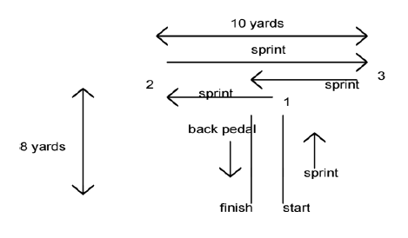
- “Square of Joy”/Box Drill
  - Make a 10x10-yard box; Begin in an athletic stance (knees bent, on the balls of your feet)
  - Go around the box changing speed and method of movement (shuffle, backpedal, carioca, broad jump, etc.); any time you change direction, squat down and touch the ground with both hands.
  - This is for time: 3x1-minute rounds with 30-seconds rest to begin; work up to 5x2 minute rounds
  - “Circle of Joy” can be done using center circle.

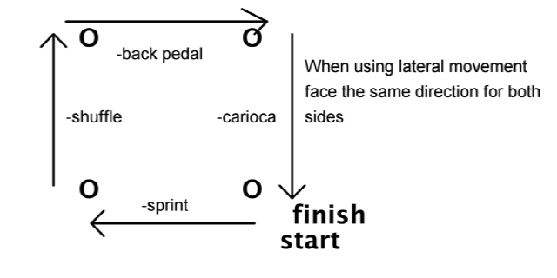

- Figure 8 (x8-15 total reps; full recovery)
  - Drop the hips at the corners
  - Keep the feet moving at the corners
  - Break down at each corner
  - Full acceleration out of each corner

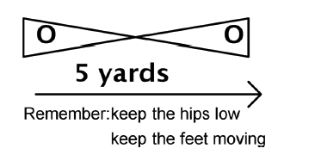
- M-W Drill
  - Set up the drill as represented by the diagram (use 10x10-yards)
  - Emphasize cuts; Keep feet moving
  - Drop the hips at the corners
  - Slow down going into the corner and full acceleration out of the corner; push off hard when changing direction.
  - Complete 5 reps each direction for 10 total. Add 2 reps each time you do this drill until you can successfully complete 10 reps each direction with maximum efficiency.
