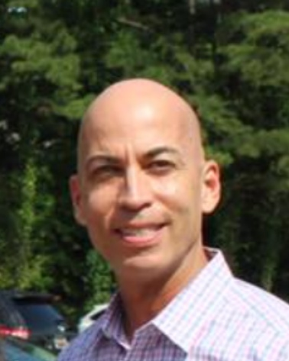

Luis Martinez
Candidate for Re-Election – Palmetto Region Board of Directors

Professional Summary
I am a retired U.S. Army officer with 23 years of distinguished service to our nation, bringing a unique combination of discipline, financial acumen, and leadership experience to the Palmetto Region Volleyball Association.
My background as both a Combat Engineer and a Finance Officer has shaped my approach to decision-making grounded in integrity, accountability, and mission-focused execution.
As the current Palmetto Region Officials Chair and an active Board Member, I have had the privilege of serving the region for the past four years. During this time, I have been deeply committed to ensuring that our operations are transparent, fiscally responsible, and aligned with the best interests of our members and the sport.

Key Accomplishments and Contributions
- Established the Region’s First Formal Budget: Led the effort to implement a structured budgeting process, improving transparency and financial oversight.
- Contract Review for Accountability: Initiated and coordinated an attorney-led review of the CEO’s contract to ensure fairness and protection for both the CEO and the Region.
- Financial Oversight: Facilitated the first accounting review in several years, ensuring compliance and the responsible use of regional funds.
- Commitment to Integrity and Service: Championed open communication and ethical governance to build trust among officials, board members, and the volleyball community.

Diversity and Leadership
As a Hispanic veteran and lifelong servant leader, I bring diversity of thought, background, and experience to the Board. My leadership style emphasizes teamwork, respect, and inclusion values essential for representing the wide range of athletes, coaches, and officials that make our region thrive.

Vision for Continued Service
- Strengthening financial transparency and operational efficiency.
- Promoting diversity, equity, and inclusion within all levels of the region.
- Enhancing training, support, and opportunities for officials and members.
- Upholding the highest standards of professionalism and integrity in every decision.

Closing Statement
I take great pride in the progress we’ve made as a Board and greater pride in the people who make the Palmetto Region what it is.
It would be an honor to continue serving as a member of the Board of Directors. I respectfully ask for your support in continuing this mission to make our region stronger and volleyball better for everyone.

Respectfully,
Luis Martinez
Palmetto Region Officials Chair
Board Member
Retired U.S. Army Officer

