Scoring in the APP
- Download the Sports Engine App
- Open Sports Engine APP – Your team should be listed
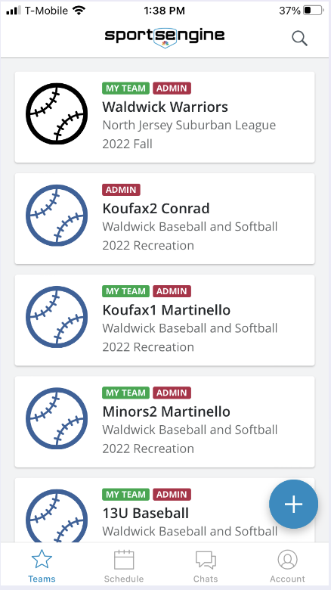
- Once your team is open click on the Schedule Icon
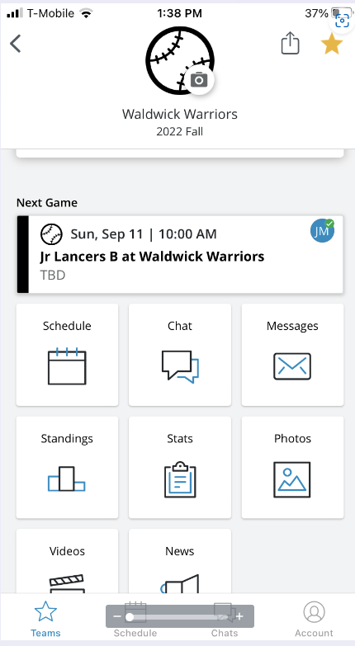
- Your schedule will be displayed. Click on the game to score.
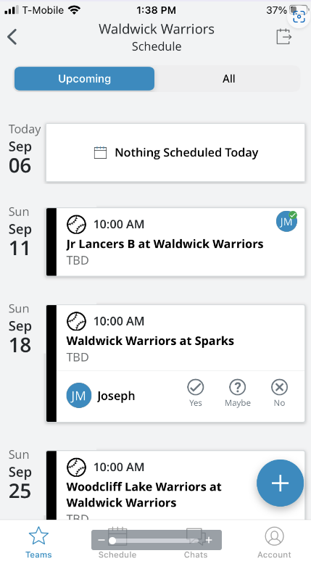

- Game Details will be displayed. Click on the Pencil Icon at the lower right
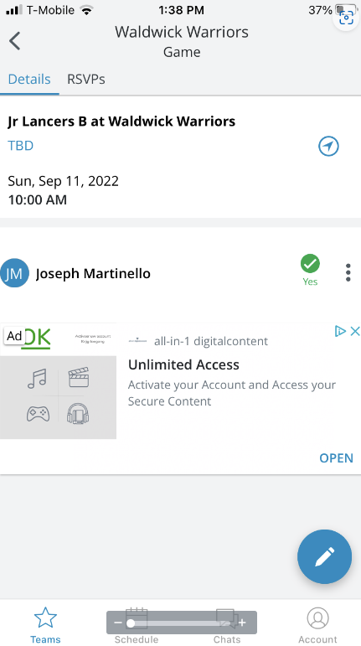
- Click Score Game
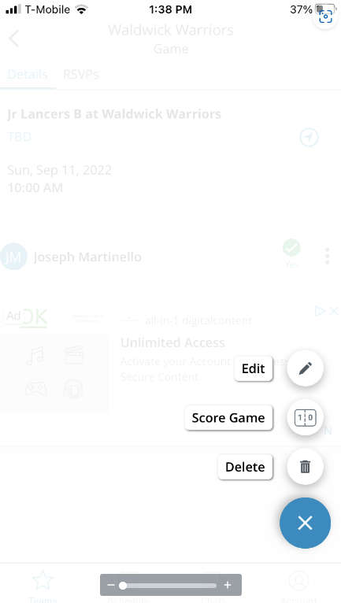

- Update Score and Save. Make sure to change to Final!
