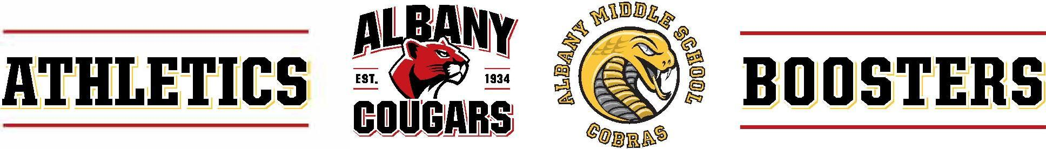
Athletics Boosters Board Meeting Agenda, December 16, 2025, 6:30 – 7:15 PM
General Meeting 7:15 – 8:00 PM
603 KEY ROUTE BLVD · ALBANY · CA · 94706
*Zoom
- In attendance:
  - Garth Schultz, President, Communications, AMS Liaison
  - Yvonne Gallegos, AUSD Athletic Department, Captain’s Council, Website, AMS Track & Field, AHS XC
  - Sarah Roberts, Treasurer, AMS Liaison
  - Diandra Sam, Secretary
- Winter Sports Teams Fundraising Status Update
  - Most AHS winter teams are starting off in great positions – board members to follow up with girls’ soccer need to determine method of crowd funding
  - Girls’ basketball and boys soccer are not currently on track to meet ETC
- AAB Financial / Budget Update
  - Unanimous vote to approve 3 B coaches for boys’ basketball ($2,734.98/coach, $8,204.94 total), 1 JV coach for girls’ soccer ($1,338.39), total of $9,543.33, not to exceed $10,000
- AHS Spring / AMS Winter B Fundraising Planning
  - Parent night will be held January 12
  - Spring registration to open soon, with a February 2 end date, parent night will be held February 16
- Discussion on AUSD Coaching Consideration
  - Transparency, community trust, avoiding potential conflicts of interest.
- Start 2026-27 AAB Board Recruitment Process
  - Board members will reach out to potential candidates for folks who could be a good fit for board roles
- Future Meetings
  - January: AMS / "Intramural" / Development Team ETC Analysis and Policy Discussion - Meant to have this month, time permitting
  - February: Review bylaws
  - March: Potential bylaw updates
  - April: Draft 2026-27 Budget and AAB Board Slate, Draft Bylaw Updates
  - May: Adopt 2026-27 Budget, Elect AAB Board Slate, Adopt Bylaw Updates
7:15 General Meeting
- Introductions
- AUSD Athletic Directors' Update
  - Athletic trainer has been present for about a month and is becoming better acquainted with coaches and students
  - New softball coach was recently hired
  - AMS girls’ basketball and AMS boys’ soccer seasons are wrapping up
  - Winter sports begin in January
- AHS Spirit and Athletic Commissioners' Update
  - Students have asked about letterman jackets, Yvonne will look into pricing and budget. Students may have to fundraise for the jackets.
- Team Updates
  - Successful crowdfunding efforts are being reported from soccer
  - AHS girls’ basketball is using Schoolfundr and has exceeded their fundraising goal.
  - AHS girls’ basketball is in need of more parent drivers and busses
  - AHS girls’ volleyball recently went on a trip
  - There is less participation in swim, there is a need or involving parents for more team participation
- Winter Sports Teams Fundraising Updates
  - Girls’ soccer is not currently on target to meet fundraising goal
  - Triathlon was a fundraising success

