CGAA Trusted Coaches Walk Through
Trusted Coaches Website – Login or register for a new account
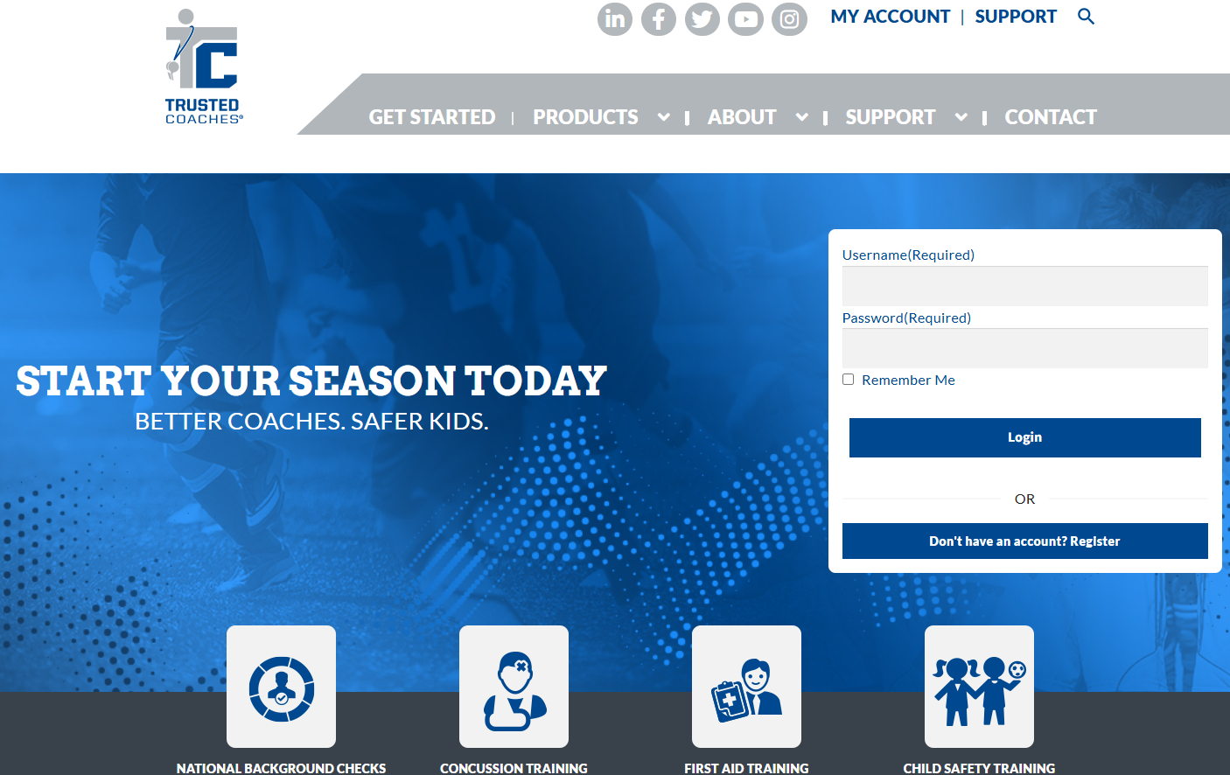
The next screen will show you the Dashboard. As a coach or board member who is not an administrator, they will see the Coach/Parent Links. They will claim a role/join a season. If they are sent out an invite to join, the invite will have the link, name of the season they are joining and access key to get everything completed and the easiest way to handle.

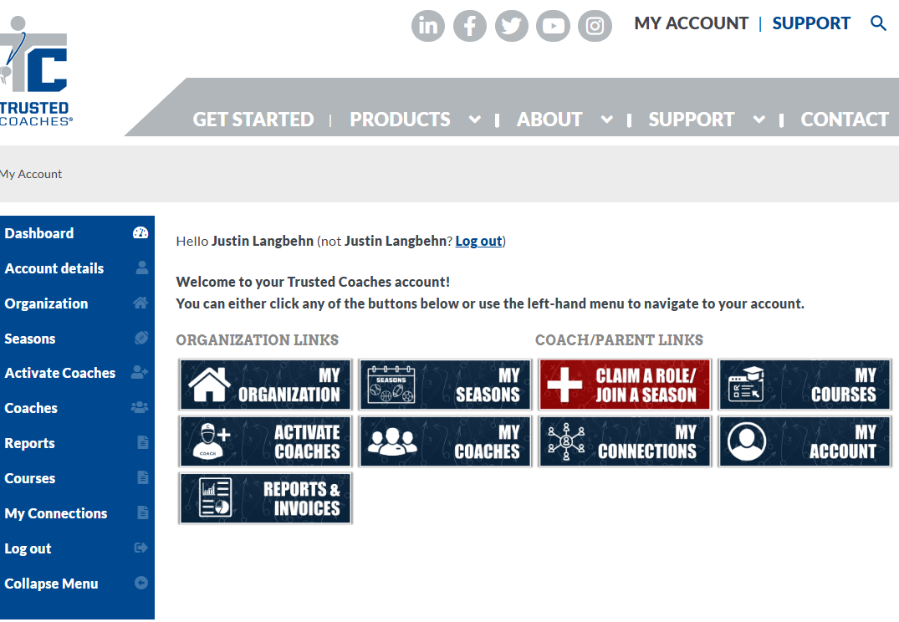

For CGAA Divisional Administrators, you can either create a new season along with the season name, access key and required training or request through vicepresident@cgaa.us. Currently we are requiring background checks, concussion training and child safety training every two years. Trusted Coaches will track the coaches even if they are involved with other divisions. If they have already completed those requirements, they will not have to complete for a different CGAA division.
If you would like to go with every year for the requirements, you will either create the season with those requirements or request the requirements to be set at that interval.
There are tutorials on how to navigate the website and the different pages.
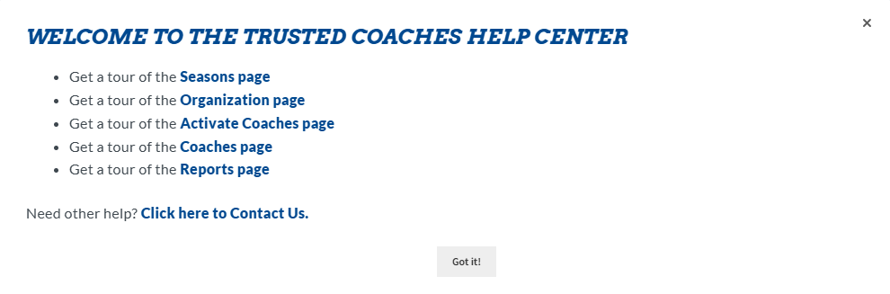
The “Seasons” tab is where you will navigate if you are going to create a new season for your division. This is where the season is programmed for what is required, at what frequency and how many coaches/board members should be set up for each role.
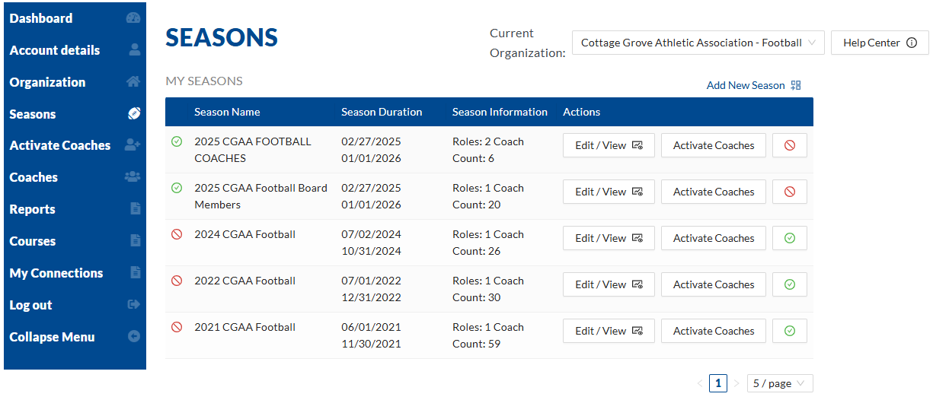

By clicking on the “Activate Coaches” button for the season you are in, it will pop up the below window where you can decide to tell your coaches to go to the website and claim a role. You can send them an email invite that will have a template already created or you can copy the link and past into your own email template to send to all coaches. You can also upload your coaches via CSV file.
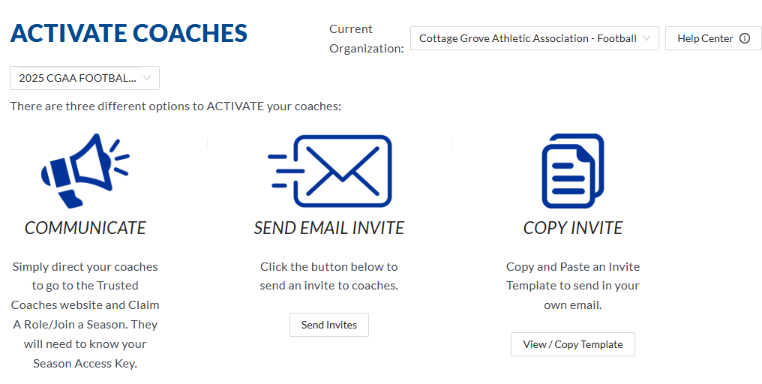
Below is what the template looks like when you invite coaches. This is the easy way to make sure they are getting all of the data they need. Much easier than just telling them to go to the website. You do not have to change any of the verbiage in the email. Just click on “Add Coach” and the coaches email address, first and last name fields appear. Then click on the plus sign to add another coach.
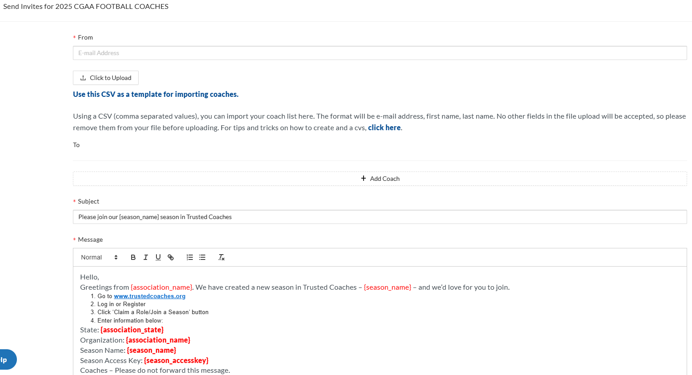
You can click on “Coaches” to sort and identify a specific coach/board member you are trying to find. Filter by seasons/role, tag or course.
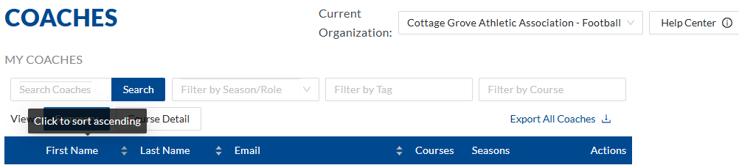
You can also click on “Course Detail” and it will show you the date they completed each requirement.
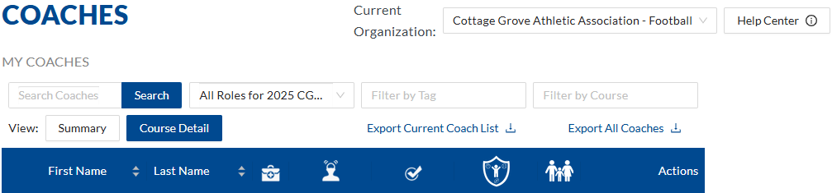
You can also go the Reports page and pull a report for the specific season to show the course status.
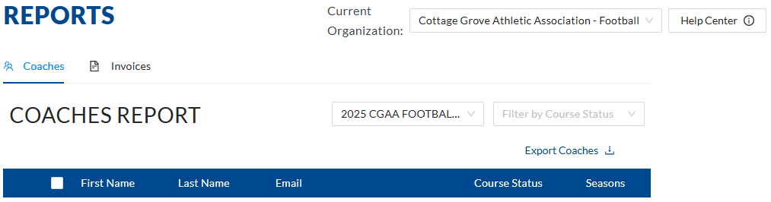

If you have any other questions regarding Trusted Coaches that you cannot figure out through the Help Center, you can also contact Adam Klinkhammer who manages this program.
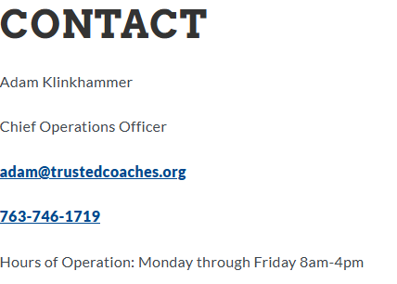

Please reach out to vicepresident@cgaa.us for questions as well!

