Team Reports Form for 2022-2023 ISWA Member Guide

Team: Team Indiana Freestyle Gold
Team Leaders & ISWA Title: Team Leader – Steven Livingston
Coaches: DJ Smith & Charles Taylor
Volunteers & Others You'd Like to Thank: Special thank you goes out to Warren Central Wrestling for hosting our Indiana based camp and Turks Head Wrestling Club for hosting our Pennsylvania based mini-camp.
Team Results: 4-3; 2nd place in the Green/Yellow Pool
California defeated Indiana 56-27
Florida defeated Indiana 42-40
Indiana defeated Colorado Blue 77-2
Indiana defeated Missouri Blue 59-24
Indiana defeated South Carolina 74-9
Indiana defeated Idaho 46-38
Washington defeated Indiana 46-31

Roster:
Name | Weight | Record
Van Stamper | 71 | 4-3
Cameron Schofield | 77 | 6-1
Jeremy Carver | 83 | 7-0
Tate St. Laurent | 87 | 4-3
Korbyn Woods | 87 | Team X
Dallas Rosenbarger | 92 | 6-1
Luke Merchant | 92 | Team X
Julius West | 97 | 3-4
Maddax Byrum | 102 | 1-6
Patrick Dowty | 106 | 7-0
Joseph Paun | 110 | 4-3
Lincoln Hinchman | 114 | 5-0
Abrum Swathwood | 114 | 2-0
Bo Jackson | 119 | 5-2
Max Benoit | 119 | Team X
Gabriel Myers | 119 | Team X
Tatumn Jones | 125 | 3-4
Ryan Hockaday | 125 | Team X
Donald Bowie | 130 | 5-2
Sebastian Jean | 130 | Team X
Sean Breedlove | 136 | 5-2
Clayton Miller | 149 | 3-4
Kale Shotts | 165 | injured
Thomas Minor | 187 | 1-6
Camden Williams | 250 | 5-2
Robert Harrell | 250 | Team X

Narrative: The Indiana Freestyle Gold team began the tournament in Pool B where we finished with a 1-2 record. The team then moved in to the Green/Yellow pool. The team finished 3-1 and placed second in the Green/Yellow pool. Statistically, the team finished fifth in the most pins in the least amount of time (18). Dallas Rosenbarger led the team in falls (3). Patrick Dowty scored the most dual meet points for the team (31) and also lead the team with most total points scored during matches (72). Three team members dominated the field and earned their way on to the prestigious ALL DUALS TEAM. Congratulations. JEREMY CARVER, PATRICK DOWTY, and CAMDEN WILLIAMS on a great showing! Remaining undefeated throughout both tournaments Jeremy Carver doubled up with two ALL DUALS TEAM honors.

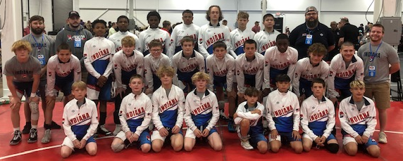
Back Row – (L to R) Coach Evan Smiley, Coach Austin Early, Donald Bowie, Thomas Minor, Robert Harrell, Camden Williams, Clayton Miller, Sean Breedlove, Coach Charles Taylor
Middle Row – (L to R) Abrum Swathwood, Patrick Dowty, Julius West, Gabriel Myers, Maddax Byrum, Joseph Paun, Lincoln Hinchman, Max Benoit, Sebastian Jean, Ryan Hockaday, Bo Jackson, Coach DJ Smith
Front Row – (L to R) Van Stamper, Jeremy Carver, Tatumn Jones, Tate St. Laurent, Cameron Schofield, Korbyn Woods, Luke Merchant, Dallas Rosenbarger

