Jacob  “You were born to be a player. You were meant to be here. This moment is yours.” – Herb Brooks |  | Ashton  “You were born to be a player. You were meant to be here. This moment is yours.” – Herb Brooks
Jackson  “You were born to be a player. You were meant to be here. This moment is yours.” – Herb Brooks |  | Ethan  “You were born to be a player. You were meant to be here. This moment is yours.” – Herb Brooks
Jack  “You were born to be a player. You were meant to be here. This moment is yours.” – Herb Brooks |  | Ben  “You were born to be a player. You were meant to be here. This moment is yours.” – Herb Brooks
Alex  “You were born to be a player. You were meant to be here. This moment is yours.” – Herb Brooks |  | Brody  “You were born to be a player. You were meant to be here. This moment is yours.” – Herb Brooks
Kaeden  “You were born to be a player. You were meant to be here. This moment is yours.” – Herb Brooks |  | Cole  “You were born to be a player. You were meant to be here. This moment is yours.” – Herb Brooks
Oakley  “You were born to be a player. You were meant to be here. This moment is yours.” – Herb Brooks |  | Tate  “You were born to be a player. You were meant to be here. This moment is yours.” – Herb Brooks
Jackson  “You were born to be a player. You were meant to be here. This moment is yours.” – Herb Brooks |  | Mason  “You were born to be a player. You were meant to be here. This moment is yours.” – Herb Brooks
You’re All That &…  [A Bag of Chips] |  | You’re All That &…  [A Bag of Chips]
You’re All That &…  [A Bag of Chips] |  | You’re All That &…  [A Bag of Chips]
You’re All That &…  [A Bag of Chips] |  | You’re All That &…  [A Bag of Chips]
You’re All That &…  [A Bag of Chips] |  | You’re All That &…  [A Bag of Chips]
You’re All That &…  [A Bag of Chips] |  | You’re All That &…  [A Bag of Chips]
You’re All That &…  [A Bag of Chips] |  | You’re All That &…  [A Bag of Chips]
You’re All That &…  [A Bag of Chips] |  | You’re All That &…  [A Bag of Chips]
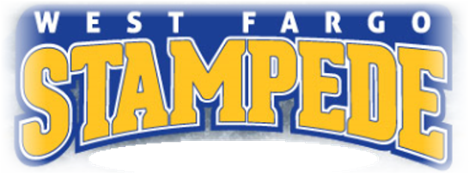
# 14

