Phase A - introduce the skill on air (1 on 0, 2 on 0 etc.)
Phase B - the coach guides the decision making of the players by providing reads
Phase C – the players use the skill in break down drills with live defence
Phase D – the players use the skill in game like situations (2 on 2, 3 on 3, 4 on 4 and 5 on 5)

Div ____ Practice #___ – Date – Time - Location
Skill | Time | Phase | Activity | Points of Emphasis
Intro | 10 Min |  | - Team Introductions  - Name, school  - Focus for today’s practice
Stretching | 5 Min |  | - 5 Minutes of Dynamic Stretching | - Ensure players are stretched to prevent injury
Shooting | 5 Min | A | - Drills focused on shooting | - Ensure players are using one had to shoot and one had to guide
Dribbling | 5 Min | A | - Drills focused on dribbling | - Ensure players are staying low with dribbling
Defense | 10 Min | B | - Drills focused on defense | - Ensure players are moving in good defensive posture
Rebounding | 10 Min | D | - Skills on how to rebound | - Ensure players are positioning themselves for rebounding
Scrimmage | 10 Min | C | - Game using thing you focused on in practice
Wrap-Up | 5 |  | - Next practice…..  - Next game….

Sr. Girls Practice #6 – Jan. 5 – 10:00 a.m. - 12:00 p.m. - Riverview
- Finishing at the rim
- Defending screens
- Contact on rebounding
- Working off screen and roll
  - How we roll to the rim
- Introduce Boston
- Press break
- Have to be patient on offense and do what’s best for the team
 | Time | Phase | Activity | P.O.E.
Intro | 10:00 |  | - Practice tomorrow @ 12:00pm  - I am being evaluated tomorrow  - First league game on Thursday, tournaments next 2 weekends  - We need to pay attention to detail and slow down a little during drills  - Today’s practice will probably be a little rocky
Shooting | 10:00 - 10:10 | A | Steve Nash Shooting  - how we start every practice  - 5 shots each around 3 spots in front and side of rim  - one handed only, hold extended arm and follow through each time  1-second advantages  - start on elbow, toss ball to yourself  - 1st - catch and sweep to outer hand, finish layup. Dribble with outside hand  - 2nd - catch and jab with outer foot then sweep towards middle of the key, finish layup  - ball should be dribbled with hand furthest away from defender
Warmup | 10:10 - 10:15 | A | 5-4-3 Flawless Weave  - Groups of 3, first time down and back with 5 passes, last pass must always be a bounce pass  - Then 4 passes only down and back. Finish with only 3  - No drops, no dribbling, final pass is always a bounce pass  - Team will count passes  - The little things like this matter, be focused and sharp
Stretching | 10:15 - 10:20 | A | Dynamic Stretching - Jess or Emily typically lead  - hamstring stretch . pull knee to chest  - high knees  - Quad stretch. Pull foot towards butt, opposite hand stretches up  - butt kicks . pump arms  - lunges. Reach up & twist across knee  - Frankenstein kicks. Straight leg with opposite arm  - hip stretch. Pull foot towards opposite hip  - hamstring stretch. Touch ground and extend leg  - karaoke. Twist hips and lift back leg across (both ways)  - progressive skips. Start low, finish high  - jog back and finish.
Transition | 10:20 - 10:30 | B | Michigan State Passing - Larry Krystkowiak - Part 1  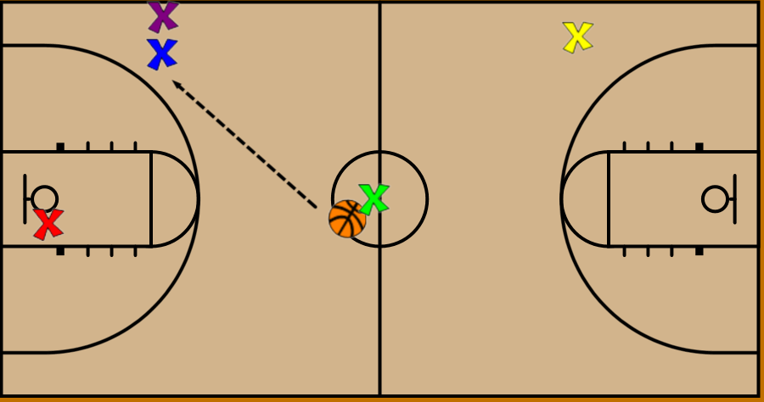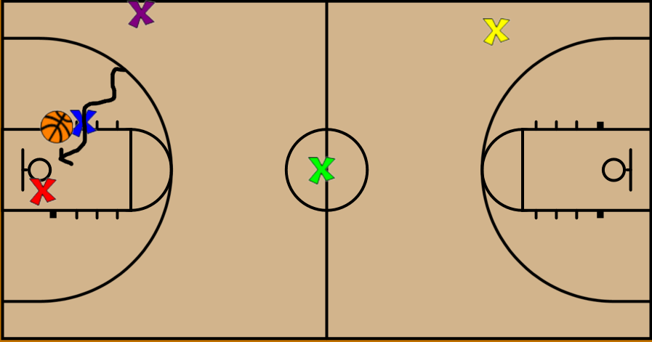  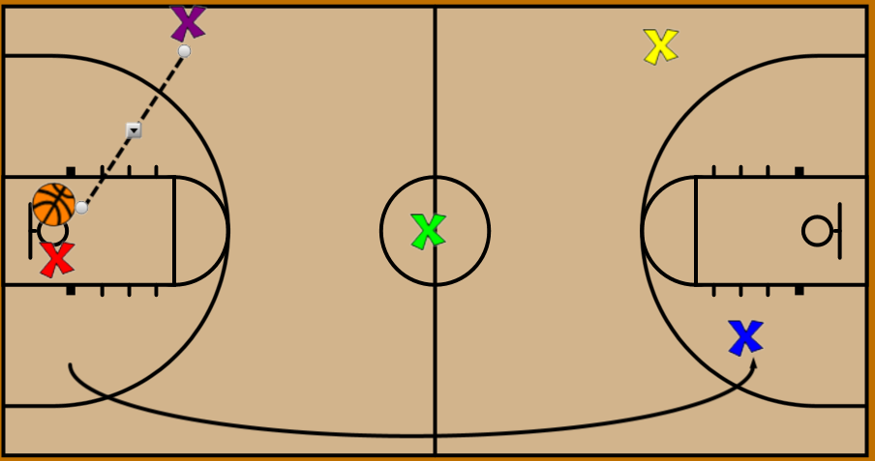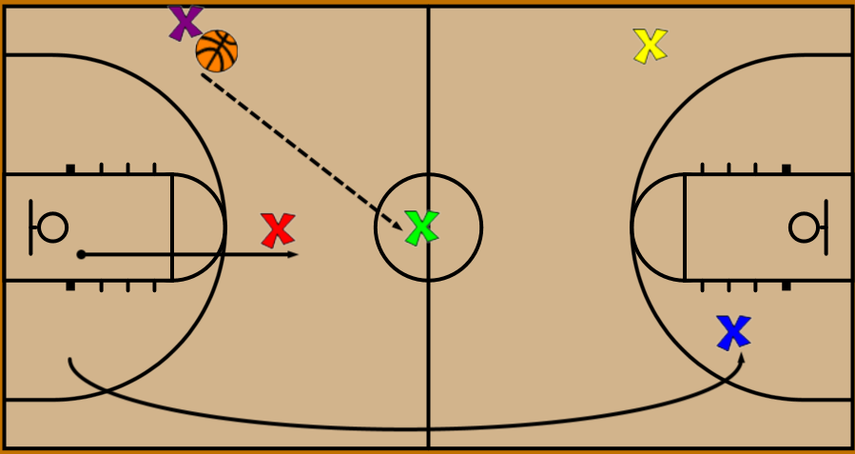  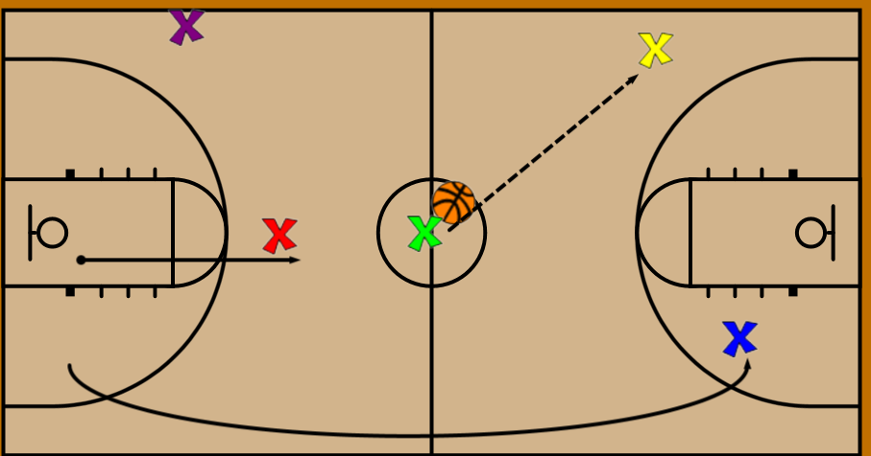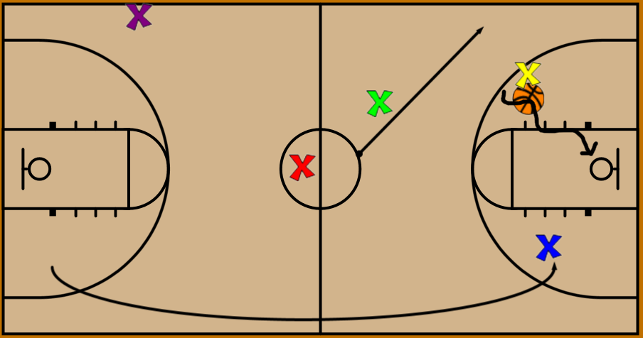  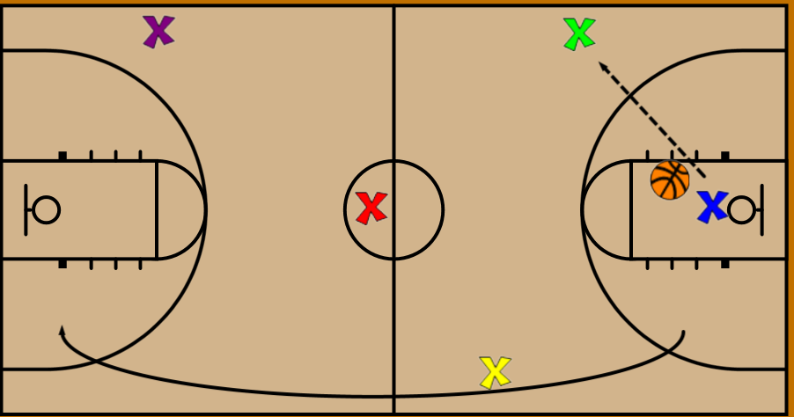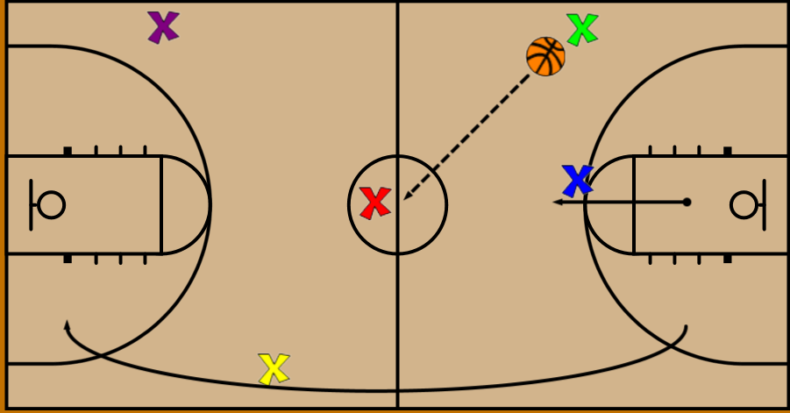  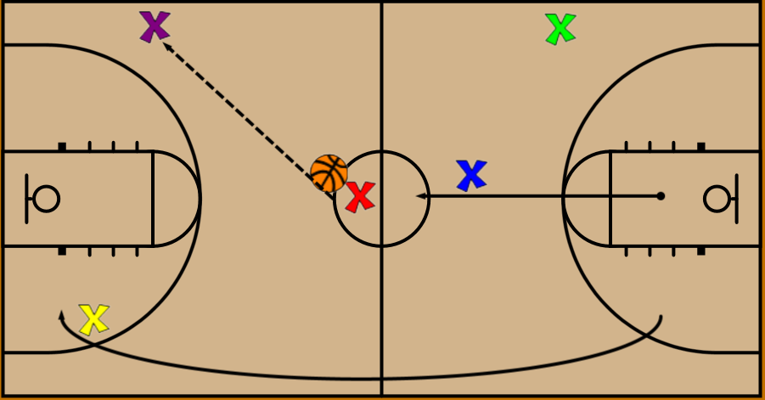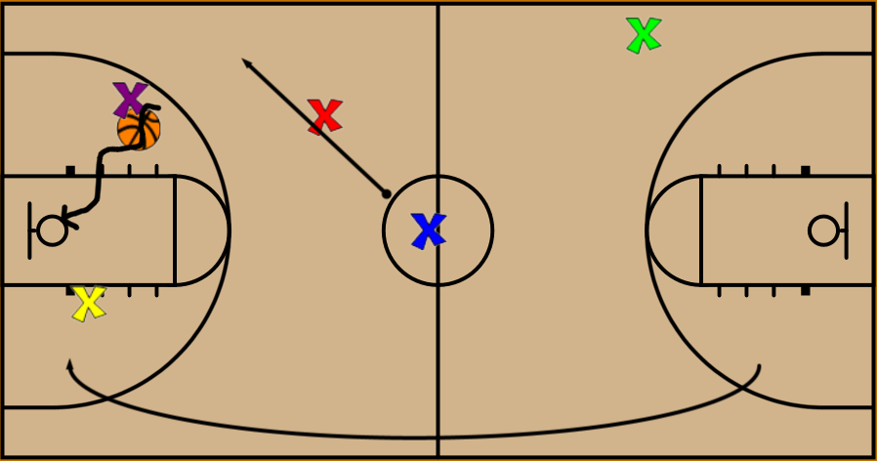  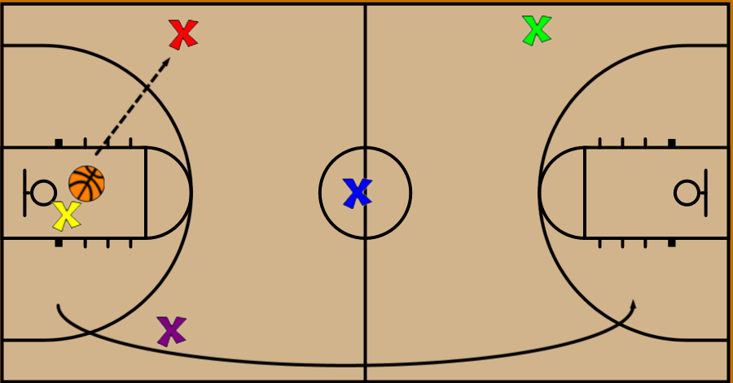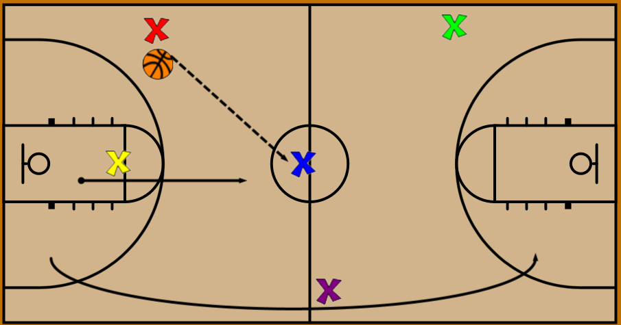  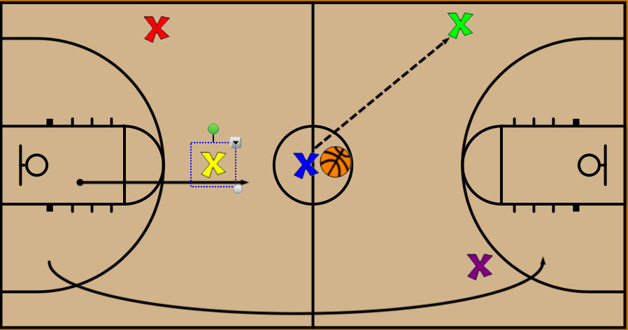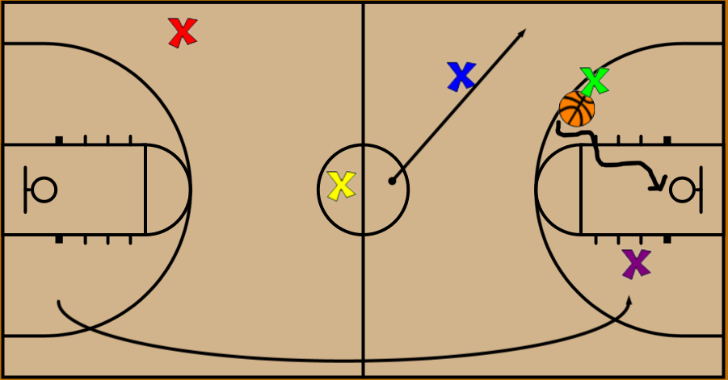
Defense | 10:30 - 10:40 | C | Gap Positioning Drill:  - 3on3, (build walls around and crowd the basketball, crowd the floor) Teach vision, jumping to the ball and communication.  - Drill starts with passing the ball 15-20secs, defense moves with the ball, in the gaps, communication. Drill moves to Offense dribbling the ball, top dribbles to wing,  - NOW the gaps need adjustment, offense drive into the gaps. NO baseline penetration on the wing, be active in the gaps, stunt and recover, being in the gap/positioning is your help!  - As your player moves you need to move into a good position. Discuss now screen away action on the wing, DON'T SWITCH...... top to Wing, top goes away to opposite wing, top goes under wing goes over so there in the gap quicker. Recover to your gap.  - Never run to your man then your gap....get to your GAP.
Finishing at rim | 10:40 - 10:50 | A & B | Dribble Drag Shooting - Tara VanDerveer  - 4 lines, 2 at centre with basketballs on either side of the circle, 2 at hash marks opposite top of 3 point line  - Player at centre dribbles towards wing while wing player cuts down to corner.  - Wing pivots & cuts back towards ball, accepts DHO, one dribble pull-ups  - Same as above but ballhandler will reject DHO & attack rim  - Wing player backcuts - use SKLZ & attacks rim. Use a bounce pass  - Screen and flash to rim, no roll
Ball Screens | 10:50 - 11:00 | A | Drill #2A: Pass and ball screen  - Need 2 three lines – 1 guard, 1 wing spots  - Defenders on both 3, pass to wing player who is open, set ball screen  - The ball starts at one of the top players and they pass across to the other top player. After the pass they set a ball screen for teammate  - Screener has to flash after the pick. 2 dribbles with OUTSIDE hand, bounce pass to teammate flashing to rim  - Make sure cutting off screener’s shoulder  - Cutting towards basket, Proper roll
 | 11:00 - 11:10 |  | Discuss Defending ball screens  - Going over the screen  - Calling the screen for your teammate  - You going to be the reason your teammate gets hurt if you don’t tell them the screen is coming  - Name, Screen, Right/Left  - Not being passive after a screen is set whether we go over or switch
Slice Offense | 11:10 - 11:13 | B | Slice - 3 minutes  Drill #1 - Pass to Wing  - Player 1 has the ball and passes to O3  - Passer ALWAYS moves first  - O1 cuts off O5 high side  - After O1 is past the free throw line, O2 also cuts high off O5 | 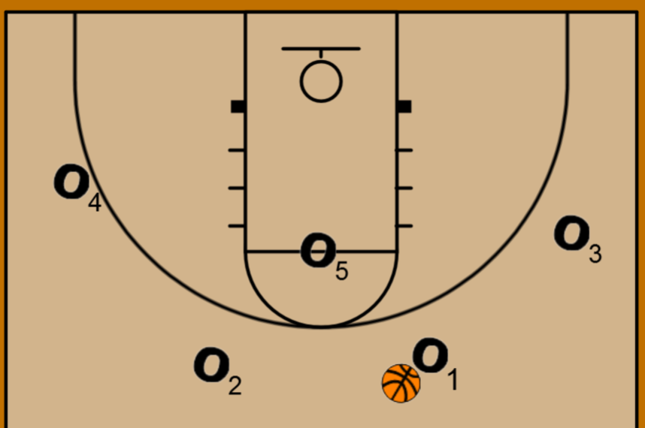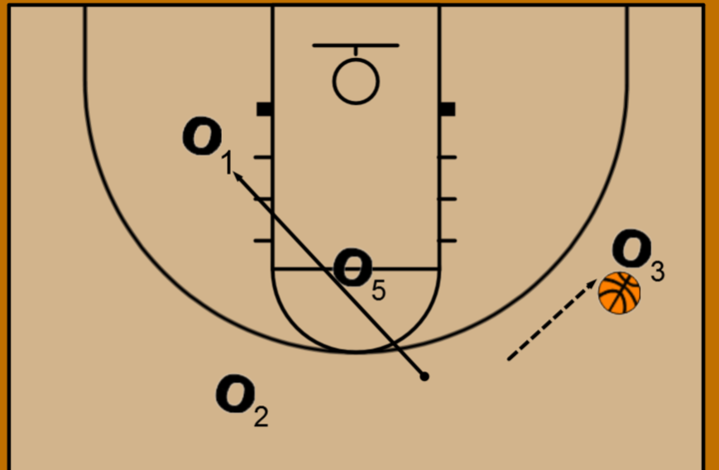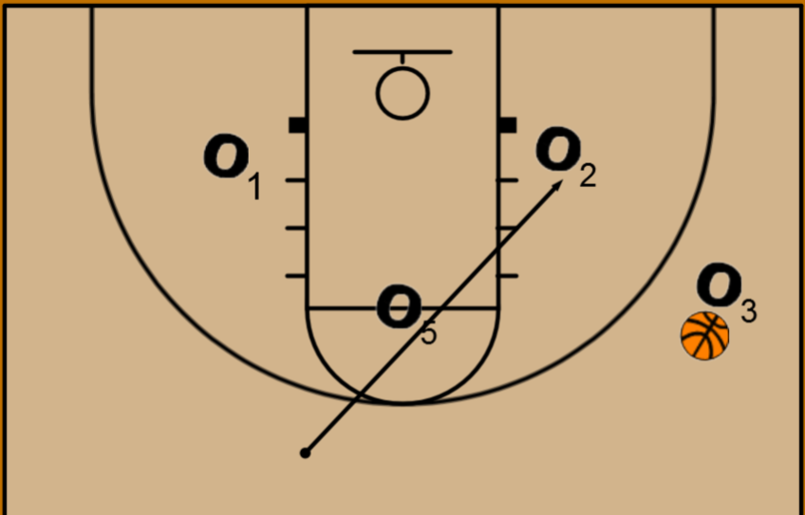
Slice Offense | 11:13 - 11:18 | B | Drill #2 - Pass to Post & down screen - 5 minutes  - O1 passes to O5 and down screens for O3  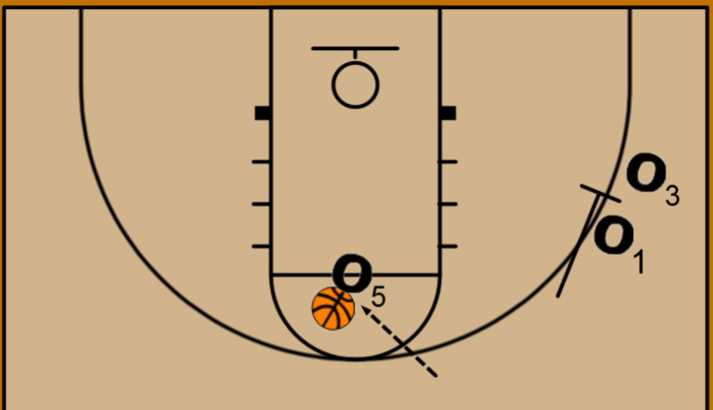  - O3 comes high off screen and cuts to rim looking for pass from O5 who has completed a reverse pivot to face the basket  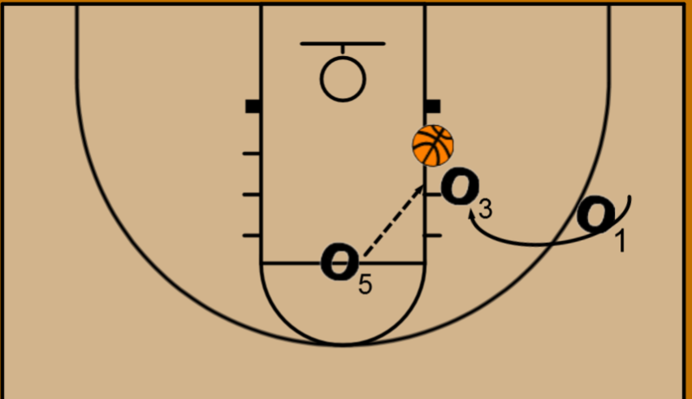
Slice Offense | 11:18 - 11:25 | C | Drill #3 - Pass to Post & Dribble Hand-Off - 7 minutes  - Make the correct read  - 1 passes to 5, then 2 down screens for 4  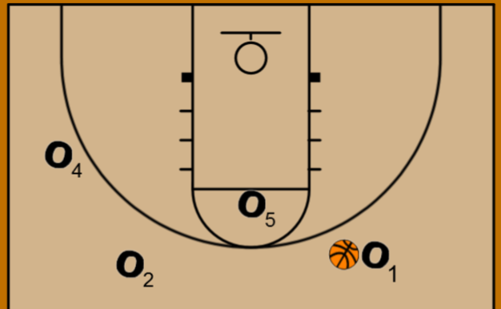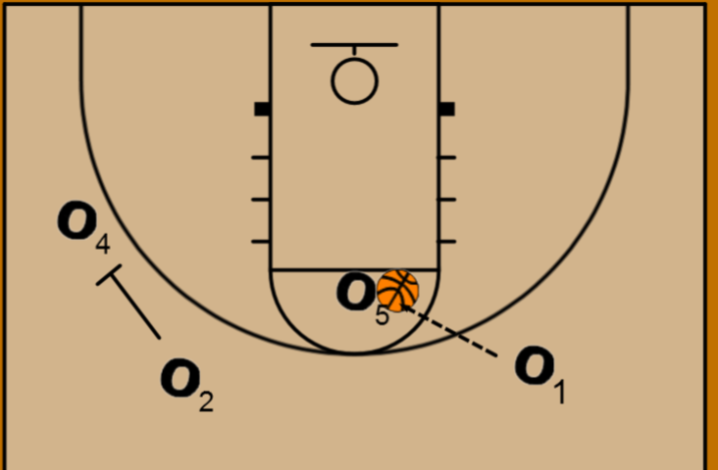  - 4 runs off 2’s shoulders and completes a dribble handoff (DHO) with 5  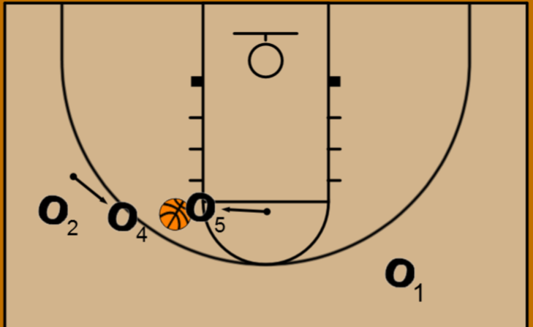  - 4 looks to attack the rim  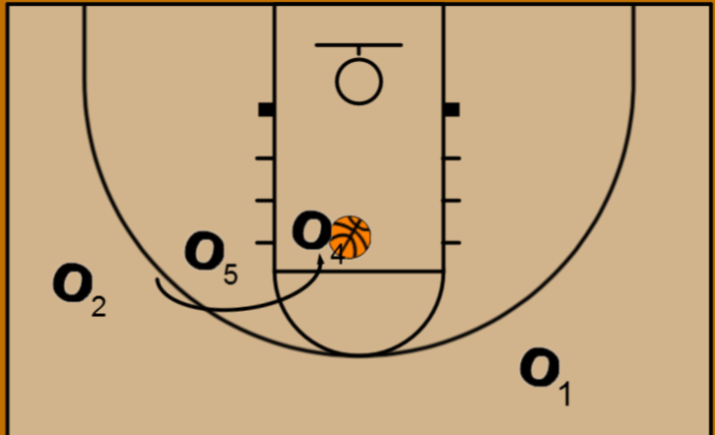  - Defenders on wings, post must make correct decision
Press Break | 11:25 - 11:35 | D | Press Break  - 5 on a dice, Line  - Go into Slice once press is broken
Boston Offense | 11:35 - 11:50 | A & B | Boston Series Drill #1  - For this 4-out set, we’ll have the 1 and 2 start on the left side, with the 3 & 4 on the right, and the 5 down low.  - The play will start off with 1 dribbling at 2, sending her along the baseline to the right side corner.  - From there, the 4 will come to 1 and set a ball screen, with 5 replacing her spot at the intersection of the arc and right lane line.  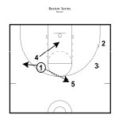 | 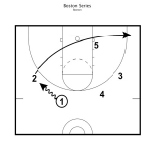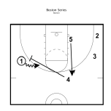
Wrap-Up | 12:00 |  | - Practice 12:00 - 2:00 pm tomorrow  - I’m being evaluated

Sr. Girls Practice #5 – Dec 13 – 3:15 - 4:45 p.m. - Robina
 | Time | Phase | Activity | P.O.E.
Intro | 3:15 |  | - Game tomorrow @ 4:00pm vs. JEL  - I don’t organize rides to games so make sure you have it figured out  - Playing time  - Starters  - Warmup  - Tap-19 (LCHS)  - 3 point (MMM)
Shooting | 3:15 - 3:30 | A | Steve Nash Shooting  - how we start every practice  - 5 shots each around 3 spots in front and side of rim  - one handed only, hold extended arm and follow through each time  1-second advantages  - start on elbow, toss ball to yourself  - 1st - catch and sweep to outer hand, finish layup. Dribble with outside hand  - 2nd - catch and jab with outer foot then sweep towards middle of the key, finish layup  - ball should be dribbled with hand furthest away from defender
Stretching | 3:30 - 3:35 |  | Dynamic Stretching - Jess or Emily typically lead  - hamstring stretch . pull knee to chest  - high knees  - Quad stretch. Pull foot towards butt, opposite hand stretches up  - butt kicks . pump arms  - lunges. Reach up & twist across knee  - Frankenstein kicks. Straight leg with opposite arm  - hip stretch. Pull foot towards opposite hip  - hamstring stretch. Touch ground and extend leg  - karaoke. Twist hips and lift back leg across (both ways)  - progressive skips. Start low, finish high  - jog back and finish.
Warmup | 3:35 - 3:50 | A | Game Warmup  - Scottish shooting warmup - move up after 3 shots from both sides  - Focus on footwork  - Wing closeouts  - Closeout hard  - Cut hard to basket whether face cut or back cut  - 3 man weave to centre, 2 v 1 back  - NEW - 4 player shell drill  - Must be done at speed, talking (help, gap, ball)  - This needs to bleed into our start of game energy, attitude  - Circle with 3 minutes left
 | 3:50 - 4:00 | C | Gap Positioning Drill:  - 3on3, (build walls around and crowd the basketball, crowd the floor) Teach vision, jumping to the ball and communication.  - Drill starts with passing the ball 15-20secs, defense moves with the ball, in the gaps, communication. Drill moves to Offense dribbling the ball, top dribbles to wing,  - NOW the gaps need adjustment, offense drive into the gaps. NO baseline penetration on the wing, be active in the gaps, stunt and recover, being in the gap/positioning is your help!  - As your player moves you need to move into a good position. Discuss now screen away action on the wing, DON'T SWITCH...... top to Wing, top goes away to opposite wing, top goes under wing goes over so there in the gap quicker. Recover to your gap.  - Never run to your man then your gap....get to your GAP.
Passing | 4:00 - 4:10 | A | Screen/Roll/Finish Warmup - Video  - Ball in swing, pass to teammate on wing  - Set a ball screen, flash to rim. Passer will take one dribble off screen and make bounce pass to teammate for finish  - 2 foot power layups  Load (~ 30 sec mark of the video) - Jess, Emily, Mylie & Cheyenne have done this before  - Same starting movement  - Off the catch, land on 2 feet facing rim  - Shot fake, dribble with outside hand (1 dribble only) get to other side of the rim to finish
Slice Offense | 4:10 - 4:13 | B | Slice - 3 minutes  Drill #1 - Pass to Wing  - Player 1 has the ball and passes to O3  - Passer ALWAYS moves first  - O1 cuts off O5 high side  - After O1 is past the free throw line, O2 also cuts high off O5
Slice Offense | 4:13 - 4:18 | B | Drill #2 - Pass to Post & down screen - 5 minutes  - O1 passes to O5 and down screens for O3  - O3 comes high off screen and cuts to rim looking for pass from O5 who has completed a reverse pivot to face the basket
Slice Offense | 4:18 - 4:25 | B | Drill #3 - Pass to Post & Dribble Hand-Off - 7 minutes  - 1 passes to 5, then 2 down screens for 4  - 4 runs off 2’s shoulders and completes a dribble handoff (DHO) with 5  - 4 looks to attack the rim
Press Break | 4:25 - 4:35 | D | Press Break  - 5 on a dice, Line  - They all know 5 on a dice. Line may be new for Kiara, Maddie, Zoey  - Go into Slice once press is broken
BLOBS | 4:35 - 4:45 | D | BLOBs  - Wall, Box, Stack

Sr. Girls Practice #4 – Dec 10 – 4:30 - 6:00 p.m. - Riverview
 | Time | Phase | Activity | P.O.E.
Intro | 4:30 |  | - Practice Thursday at Robina 3:15 - 4:45 p.m. at Robina  - You need to wait in my room until 3:00pm
Shooting | 4:30 - 4:40 | A | Steve Nash Shooting  - how we start every practice  - 5 shots each around 3 spots in front and side of rim  - one handed only, hold extended arm and follow through each time  1-second advantages  - start on elbow, toss ball to yourself  - 1st - catch and sweep to outer hand, finish layup. Dribble with outside hand  - 2nd - catch and jab with outer foot then sweep towards middle of the key, finish layup  - ball should be dribbled with hand furthest away from defender
Warmup | 4:40 - 4:45 | C | 3 on 2 on 1 - they’ve done this before but not yet this season  - Defenders waiting on the defending the far basket, 3 lines of offensive players on the opposite baseline. Basketballs on the right sideline  - 3 offensive players attack the far basket, this is not a 3 man weave in as few dribbles and passes as possible  - They should be spacing the floor, running DHO, ball screen, back cuts to get open  - The player who shoots the ball or causes a turnover sprints to defend the opposite basket while the original two defenders attack 2v1. The remaining 2 offensive players remain at the far basket to be the next 2 defenders.
Stretching | 4:45 - 4:50 |  | Dynamic Stretching - Jess or Emily typically lead  - hamstring stretch . pull knee to chest  - high knees  - Quad stretch. Pull foot towards butt, opposite hand stretches up  - butt kicks . pump arms  - lunges. Reach up & twist across knee  - Frankenstein kicks. Straight leg with opposite arm  - hip stretch. Pull foot towards opposite hip  - hamstring stretch. Touch ground and extend leg  - karaoke. Twist hips and lift back leg across (both ways)  - progressive skips. Start low, finish high  - jog back and finish.
Finishing at rim/ Passing | 4:50 - 5:00 | A | 5 Ball  - 150 points in 5 minutes or no more than 5 missed layups
 | 5:00 - 5:10 | B | Gap Positioning Drill:  - 3on3, (build walls around and crowd the basketball, crowd the floor) Teach vision, jumping to the ball and communication.  - Drill starts with passing the ball 15-20secs, defense moves with the ball, in the gaps, communication. Drill moves to Offense dribbling the ball, top dribbles to wing,  - NOW the gaps need adjustment, offense drive into the gaps. NO baseline penetration on the wing, be active in the gaps, stunt and recover, being in the gap/positioning is your help!  - This is new today. The offense takes 2 or 3 dribbles between defenders and the gap needs to close. Then the offense passes to their teammates and the defenders needs to recover to “Ball”, “Gap” and “Help”. Make them yell it out after every pass  - Never run to your man then your gap....get to your GAP.
Passing | 5:10 - 5:20 | A | Screen/Roll/Finish Warmup - Video  - Ball in swing, pass to teammate on wing  - Set a ball screen, flash to rim. Passer will take one dribble off screen and make bounce pass to teammate for finish  - 2 foot power layups  Load (~ 30 sec mark of the video) - Jess, Emily, Mylie & Cheyenne have done this before  - Same starting movement  - Off the catch, land on 2 feet facing rim  - Shot fake, dribble with outside hand (1 dribble only) get to other side of the rim to finish
Slice Offense | 5:20 - 5:23 | B | Slice - 3 minutes  Drill #1 - Pass to Wing  - Player 1 has the ball and passes to O3  - Passer ALWAYS moves first  - O1 cuts off O5 high side  - After O1 is past the free throw line, O2 also cuts high off O5
Slice Offense | 5:23 - 5:28 | B | Drill #2 - Pass to Post & down screen - 5 minutes  - O1 passes to O5 and down screens for O3  - O3 comes high off screen and cuts to rim looking for pass from O5 who has completed a reverse pivot to face the basket
Slice Offense | 5:28 - 5:35 |  | Drill #3 - Pass to Post & Dribble Hand-Off - 7 minutes  - 1 passes to 5, then 2 down screens for 4  - 4 runs off 2’s shoulders and completes a dribble handoff (DHO) with 5  - 4 looks to attack the rim
Press Break | 5:35 - 5:45 | B | Press Break  - 5 on a dice, Line  - They all know 5 on a dice. Line may be new for Kiara, Maddie, Zoey  - Go into Slice once press is broken
BLOB’s | 5:45 - 6:00 | B | BLOB - Wall & Stack  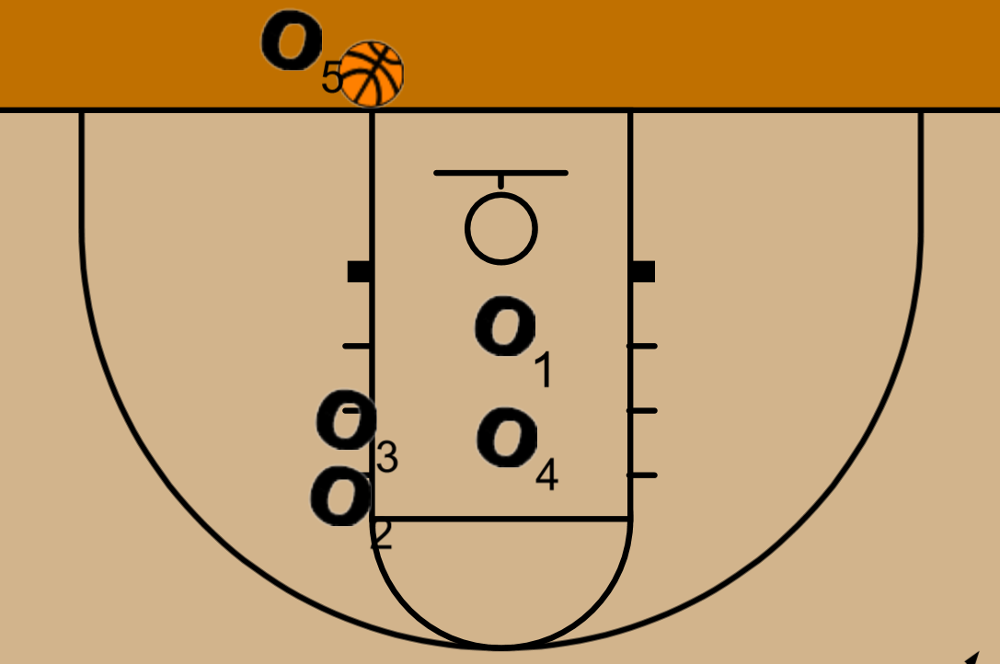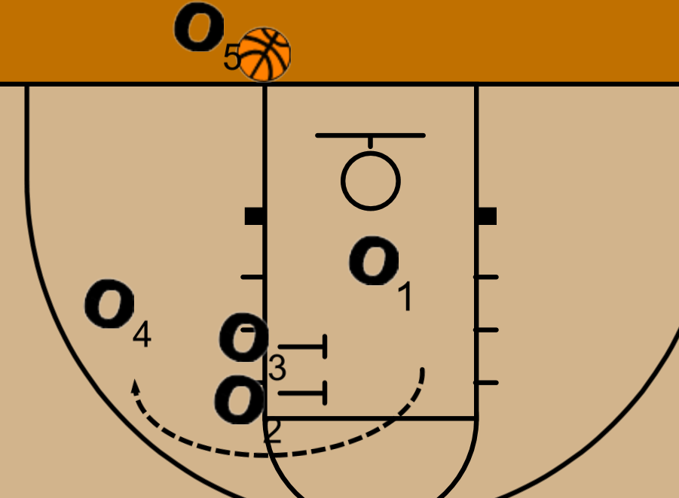  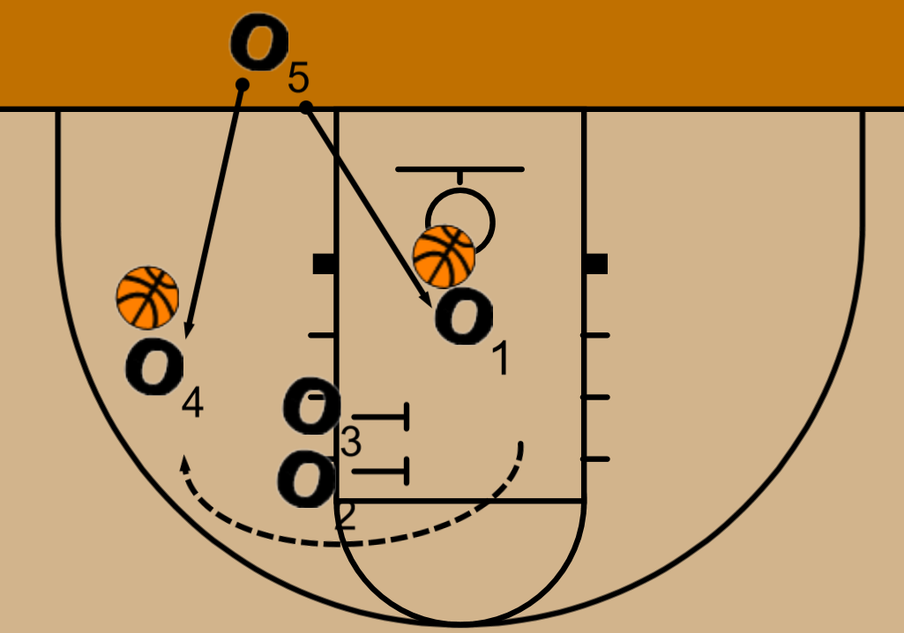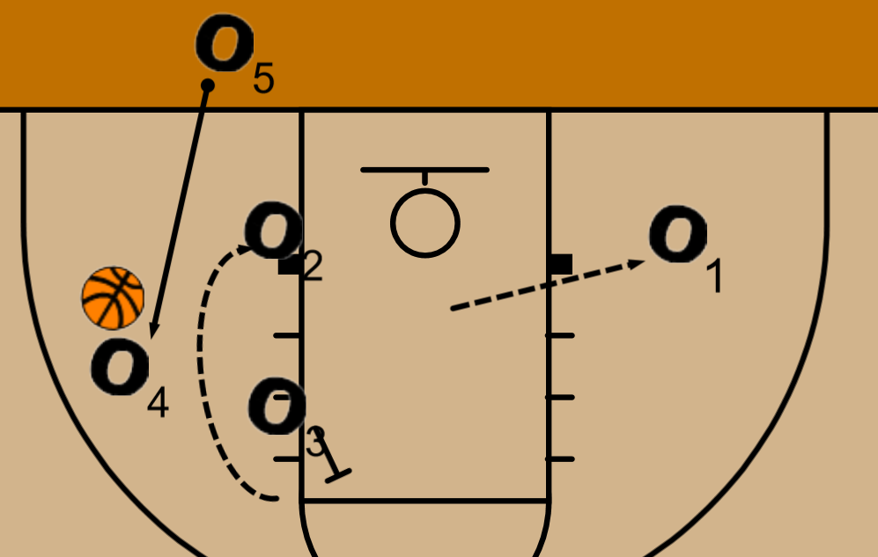  - After the inbound, play the half court set and go full court with the defending team on offense once. Then repeat on the far end of the court
Wrap-Up | 6:00 |  | - Practice Thursday (hopefully) 3:15 - 4:45 p.m. @ Robina  - Warmup, inbounds, 5v5

Sr. Girls Practice #3 – Dec 3rd – 3:00 - 5:00 p.m. - Riverview
 | Time | Phase | Activity | P.O.E.
Intro | 3:00 |  | - Practice Thursday at the high school 3:30 - 5:00pm. You need to wait in my room until 3:15  - Coaching clinic Friday
Shooting | 3:00 - 3:10 | A | Steve Nash Shooting  - how we start every practice  - 5 shots each around 3 spots in front and side of rim  - one handed only, hold extended arm and follow through each time  1-second advantages  - start on elbow, toss ball to yourself  - 1st - catch and sweep to outer hand, finish layup. Dribble with outside hand  - 2nd - catch and jab with outer foot then sweep towards middle of the key, finish layup  - ball should be dribbled with hand furthest away from defender
Warmup | 3:10 - 3:15 | A | Blind Catch Game
Stretching | 3:15 - 3:20 |  | Dynamic Stretching  - hamstring stretch . pull knee to chest  - high knees  - Quad stretch. Pull foot towards butt, opposite hand stretches up  - butt kicks . pump arms  - lunges. Reach up & twist across knee  - Frankenstein kicks. Straight leg with opposite arm  - hip stretch. Pull foot towards opposite hip  - hamstring stretch. Touch ground and extend leg  - karaoke. Twist hips and lift back leg across (both ways)  - progressive skips. Start low, finish high  - jog back and finish.
Finishing at rim/ Passing | 3:20 - 3:30 | A | 5 Ball  - 120 points in 5 minutes
Passing | 3:30 - 3:40 | B | Blackhawk drill:  - 3 offense/ 1 defender.  - Working on jumping to the ball when passed and not getting faced cut, ball to top wing.  - Defender jumps to GAP, denies cutter to bottom of circle in key  - Ball passed to new player at top of 3 pt line, defender closes out with short choppy feet with one hand up  - Ball passed to opposite wing  - Coach yells live attack from the top  - 3 dribbles to score. Offense scores 2pts, defense gets a stop 3 pts. Keep track of points.  - Video
 | 3:40 - 3:50 | B | Gap Positioning Drill:  - 3on3, (build walls around and crowd the basketball, crowd the floor) Teach vision, jumping to the ball and communication.  - Drill starts with passing the ball 15-20secs, defense moves with the ball, in the gaps, communication. Drill moves to Offense dribbling the ball, top dribbles to wing,  - NOW the gaps need adjustment, offense drive into the gaps. NO baseline penetration on the wing, be active in the gaps, stunt and recover, being in the gap/positioning is your help!  - As your player moves you need to move into a good position. Discuss now screen away action on the wing, DON'T SWITCH...... top to Wing, top goes away to opposite wing, top goes under wing goes over so there in the gap quicker. Recover to your gap.  - Never run to your man then your gap....get to your GAP.
Passing | 3:50 - 4:00 | A | Argentina Passing  - Half court, 6 spots, 2 basketballs  - Must pass with outside hand  - No travelling  - Run across after you pass
Finishing at Rim/ Dribbling | 4:00 - 4:10 | B | Screen/Roll/Finish Warmup  - Ball in swing, pass to teammate on wing  - Set a ball screen, flash to rim. Passer will take one dribble off screen and make bounce pass to teammate for finish  - 2 foot power layups  Load 1  - Same starting movement  - Off the catch, land on 2 feet facing rim  - Shot fake, dribble with outside hand (1 dribble only) get to other side of the rim to finish
Offense | 4:10 - 4:20 | B | Slice  Make this half-court competitive right away. Each team gets 3 possessions, first to 7 wins. We need to get them moving faster in practice if we want it to happen in games  Drill #1 - Pass to Wing  - Player 1 has the ball and passes to O3  - Passer ALWAYS moves first  - O1 cuts off O5 high side  - After O1 is past the free throw line, O2 also cuts high off O5
Press Break | 4:20 - 4:30 | B | Press Break  - 5 on a dice, Line  - Go into Slice once press is broken
BLOB’s | 4:30 - 4:40 | B | BLOB - Wall & Stack
5v5 | 4:40 - 4:55 | D | Switch  - Start in 5 on 5 shell drill (no offensive movement).  - When coach yells switch, defense becomes offense, and offense becomes defense.  - The team becoming defense cannot guard the same player that was guarding them.  - Offense is looking to score right away | - Spacing  - Opportunities to get open  - DHO, face cut, back cut, ball screens
Wrap-Up | 5:00 |  | - Practice Thursday (hopefully) 3:30 - 5:00 p.m.

Sr. Girls Practice #2 – Nov 29th – 4:30 - 6:00 p.m. - Riverview
 | Time | Phase | Activity | P.O.E.
Intro | 4:30 |  | - Practices next week - what time do you need to be here for the band concert on Thursday?
Warmup | 4:30 - 4:35 | A | - Pass/Clap/Catch  - 23 Cones  - Must shoot outside the key  - On every make by a team, the person who shoots must  - rebound the ball and pass it to the next person in line, then  - they are ‘rewarded’ by sprinting to the other end of the floor  - and get the opportunity to shoot a three-pointer to win a cone for their team.  - The player only gets one attempt. If they miss, they get nothing and return to their group. If they make it, they get to collect a cone for their group.
Stretching | 4:35 - 4:40 |  | Dynamic Stretching  - hamstring stretch . pull knee to chest  - high knees  - Quad stretch. Pull foot towards butt, opposite hand stretches up  - butt kicks . pump arms  - lunges. Reach up & twist across knee  - Frankenstein kicks. Straight leg with opposite arm  - hip stretch. Pull foot towards opposite hip  - hamstring stretch. Touch ground and extend leg  - karaoke. Twist hips and lift back leg across (both ways)  - progressive skips. Start low, finish high  - jog back and finish.
Finishing at rim/ Passing | 4:40 - 4:50 | A | - 5 Ball
Passing | 4:50 - 4:55 | A | Two-man Passing:  - Passes are: 1-handed chest pass, bounce pass, overhead pass all for finishes on the other end. Focus on finishing your lay-ups. *  - Working on passing because we still make bad passes at times, behind to late. Pass ahead; receiver getting the pass needs to show hands.  - Last one focus on two hard dribble out Low and out Front PASS back to the reversal. Be behind the pass. When you catch it sweep through hard, push out.
Passing | 4:55 - 5:00 | B | Argentina Passing  - Half court, 6 spots, 2 basketballs  - Must pass with outside hand  - No travelling  - Run across after you pass
Finishing at Rim/ Dribbling | 5:00 - 5:10 | B | Wing Drill Series  - Balls in the corner  - Dribble with outside hand to elbow, retreat dribble to 3 pt line  - Inside out with same hand, then crossover and attack the rim. Coach waiting underneath with a pad to hit on the finish  Load to Kobe Pivot Finish  - 2 foot jump stop in key, pivot away from rim, pivot back to rim, keeping ball high and finish  - Left side - right foot forward, front pivot 180°, front pivot to rim to score  - Right side - left foot forward, front pivot 180°, front pivot to rim to score  Load  - Between legs twice(scissor dribble)  - Inside out, Crossover attack middle of rim  - Outside hand pass to coach in corner  - Cut to dribble, catch pass from coach, catch & shoot
Finish at Rim | 5:10 - 5:20 | B | Drill #1a: Backcut from two lines  - This can be done from any 2 of the 4 spots in the perimeter. One ball needed.  - Begin with coach playing guided defense to imitate when to backcut  - Have wing player cut towards ball to get open. Coach will deny hard, playing up near wing player’s shoulder  - Identify this is your signal to backcut your defender  - Player with ball fakes high/low and passes low/high to backcut  - Complete step-through to finish  - Load to girls playing disrespectful defense
Passing/ Spacing | 5:20 - 5:30 | B | 3 Player Penetration Spacing  - 3 lines at centre line, middle line with basketballs  - Player in middle line will take jump shot with original ball. Players on wings will catch passes from coaches  - Player #1 in middle attacks 3 point line while Players #2 & 3 on wings run to the 45° on the 3pt line  - Player #1 passes to either teammate (Player 2)  - P2 rips and attacks baseline with outside hand. P3 drifts to corner and P1 (OG passer) fills in behind  - P1 must fill behind and not be lazy preparing for last part of drill  - P2 passes with outside hand to P3 in opposite corner. P2 then retreat cuts back to 3 point line to catch pass from coach for jumpshot  - P3 rips and attacks the elbow while P1 cuts to top and catches pass from P3. P1 catches and shoots while P3 catches a pass from the other coach and takes their own jump shot | - Attack baseline strong, 2 dribbles max.  - Rip low and fast  - Catching ready to shoot
Reverse Pivot | 5:30 - 5:40 | B | Skill Development - Post in Slice (off option #1)  - Passer in both swing positions, one wing and one post  - Pass is made to wing and both swing players slice off the post.  - Neither player is open so wing passes to post who reverse pivots & attacks the rim away from 2nd cutter  - Coach in key to player help defender. Post passes to 2nd cutter for layup
 | 5:40 - 5:50 | C | Press Break  - 5 on a dice, Line
4v4 | 5:50 - 6:00 | D | Switch  - Start in 4 on 4 shell drill (no offensive movement).  - When coach yells switch, defense becomes offense, and offense becomes defense.  - The team becoming defense cannot guard the same player that was guarding them.  - Offense is looking to score right away | - Spacing  - Opportunities to get open  - DHO, face cut, back cut, ball screens
Wrap-Up | 5:30 |  | - Practice tomorrow 4:30 - 6:00 p.m. large gym

Sr. Girls Practice #1 – Nov 28th – 4:00 - 5:30 p.m. - Riverview
 | Time | Phase | Activity | P.O.E.
Intro | 4:00 - 4:10 |  | - Commitments/tournaments/game days  - Responses to tryouts questions  - questions/concerns/nerves  - Practice tomorrow 4:30 - 6:00pm | Deleani - Dance
Questions to ask players

- Did you complete the drill at a level to have success against the best player you’ll play against?
- Are you motivated?
  - You can’t have a goal unless you’re motivated
- Did you improve 5-10% today towards your goal?
- Work on committing to grow on every repetition
- Practice makes permanent
- Improvement needs to be measurable
Warmup | 4:10 - 4:15 | A | - Everybody’s It  - Tag a shoulder, 5 jumping jacks  - Tag a knee, 5 pushups  - Can’t tag anywhere else
Stretching | 4:15 - 4:20 |  | Dynamic Stretching  - hamstring stretch . pull knee to chest  - high knees  - Quad stretch. Pull foot towards butt, opposite hand stretches up  - butt kicks . pump arms  - lunges. Reach up & twist across knee  - Frankenstein kicks. Straight leg with opposite arm  - hip stretch. Pull foot towards opposite hip  - hamstring stretch. Touch ground and extend leg  - karaoke. Twist hips and lift back leg across (both ways)  - progressive skips. Start low, finish high  - jog back and finish.
Finishing at rim/ Passing | 4:20 - 4:30 | A | Speed:  - Focus is on good passes and lay-ups. 3-players at a time, start with 1-under the rim, outlet and runner.  - Rebound> outlet--> lay-up.... This drill keeps it going. After you rebound go to outlet line, after you make the pass for the lay-up you become the person doing the lay-up opposite side.  - After you do the lay-up you become the rebounder. 2-pylons. Outlets are on the same side of the court. *good passes,  - Snap and then Work on speed.  - 20 in 2 minutes today
Shooting | 4:30 - 4:40 | B | Drill #1: Pass and cut from two lines  - This can be done from any 2 of the 4 spots in the perimeter. One ball needed. Player with the ball passes to the other line then cuts hard at the basket showing a target. Always fill a spot away from where you passed it to.  - Defender on the ball  - MUST FACE CUT
Finish at Rim | 4:40 - 4:50 | C | Finish on Break  - offense starts at centre sideline  - pass to coach (player) at top of 3 pt line while defender closes out from baseline  - receive pass back at the wing and attack  - Video
Footwork | 4:50 - 5:00 | A | One Cross step dribble  - Ball on right hip, sweep low, dribble with left hand, step with right leg, triple threat, pause  - Then repeat  - Baseline to centre or sideline to sideline
Transition | 5:00 - 5:10 | C | 6 vs 3 Full Court  - 6 defenders in 3 zones  - Baseline to 3 pt line, 3pt line to 3pt line, 3pt line to rim  - No dribbling, defenders cannot cross into another zone.  - If ball is turned over, offense starts again where they turned the ball over  - 3 attempts to score
Passing/ Spacing | 5:20 - 5:30 | B | 3 Player Penetration Spacing  - 3 lines at centre line, middle line with basketballs  - Player in middle line will take jump shot with original ball. Players on wings will catch passes from coaches  - Player #1 in middle attacks 3 point line while Players #2 & 3 on wings run to the 45° on the 3pt line  - Player #1 passes to either teammate (Player 2)  - P2 rips and attacks baseline with outside hand. P3 drifts to corner and P1 (OG passer) fills in behind  - P1 must fill behind and not be lazy preparing for last part of drill  - P2 passes with outside hand to P3 in opposite corner. P2 then retreat cuts back to 3 point line to catch pass from coach for jumpshot  - P3 rips and attacks the elbow while P1 cuts to top and catches pass from P3. P1 catches and shoots while P3 catches a pass from the other coach and takes their own jump shot | - Attack baseline strong, 2 dribbles max.  - Rip low and fast  - Catching ready to shoot
4v4 | 5:20 - 5:30 | D | Switch  - Start in 4 on 4 shell drill (no offensive movement).  - When coach yells switch, defense becomes offense, and offense becomes defense.  - The team becoming defense cannot guard the same player that was guarding them.  - Offense is looking to score right away | - Spacing  - Opportunities to get open  - DHO, face cut, back cut, ball screens
Wrap-Up | 5:30 |  | - Practice tomorrow 4:30 - 6:00 p.m. large gym

