Stretching & Yoga

This should be done along with strength training each day. It should coincide with the muscle group strengthened that day and should be done at the end of each workout.

For many people, stretching is just a necessary evil of fitness—one that you try to skimp on whenever you can. You know you're supposed to do it, but still, somehow it's the thing you always "forget" to do and decide you'll get to later (and then never do). All it takes, though, is a couple of minutes of stretching to reap the long-term benefits of increased mobility and range of motion, both of which will help you perform exercises properly and ultimately reduce your risk of injury.
Like many people, the only way I'll actually remember to stretch is if I do it immediately after I'm done exercising. I just know that I won't take the time to carve out a separate stretch session, so I tack it onto the end of my workouts. And there's some good reasons to do it then. For one, it simply feels good to stretch a muscle you've just been contracting during exercise. For another, it's better to stretch when your muscles are warm—increased blood flow in the muscle tissues makes them more flexible. Plus, stretching is an essential part of a cooldown session, which you should do after any cardiovascular workout because it helps your heart rate return to normal in a slow and controlled way.

Lower Body Stretch - Coincide with lower body Workout

Crossover Hamstring Stretch
- Stand with one leg crossed over the other.
- Bend forward at the hips and try to touch the floor with your hands. Try to keep your back knee straight.
- Hold for 30 seconds.

Pretzel Stretch
- Lie on your left side with your head resting on your arm.
- Bend your right hip and knee up toward your chest as far as you can, and then let it drop to the floor.
- Bend your left knee and grab your left foot (use a strap if you can’t reach it) with your right hand.
- Make sure your leg and torso remain in a straight line as you gently bring your top shoulder blade toward the floor.
- For more of a spinal twist, turn your head to look over your right shoulder.
- Hold for 30 seconds, then repeat on the opposite side.

Lunging Psoas Stretch
- Kneel on your right knee. Place your left foot flat on the floor in front of you, knee bent.
- Place your right hand on a foam roller for support.
- Squeeze your butt and tuck your hips, feeling the stretch in the front of your hips (where the psoas muscle is).
- Press down on the foam roller to deepen the stretch.
- Hold for 30 seconds, then repeat on the other side.

Heel Drops
- Stand up straight, holding onto the back of a chair for support. You can also do this in front of a wall.
- Lift your right toes so that you're standing on your heel and your toes are pressed against the back of the chair or the wall.
- Gently press your toes against the chair or wall. You'll feel a stretch in your Achilles tendon and your calf.
- Hold for 30 seconds. Repeat on the other side.

Figure Four Stretch
- Stand with your feet together, hands resting on a chair for support if needed.
- Cross your left foot over your right quad just above your knee.
- Bend your right knee slightly, hinge forward at your hips, and sit your butt back.
- You should feel the stretch primarily on the left side of your butt.
- Hold for 30 seconds, and then repeat with the other leg.

Standing Quad Stretch
- Stand with your feet together, hand resting on the back of a chair or against a wall for support if you need it.
- Bend your left knee and use your left hand to pull your left foot toward your butt. Keep your knees together.
- Squeeze your butt to increase the stretch in the front of your legs.
- Hold for 30 seconds, and then repeat on the other leg.

Downward Facing Dog
- Start in a high plank, hands directly under shoulders, legs out straight behind you, feet hip-width apart.
- Lift your butt toward the ceiling and press through your palms.
- Try to straighten your legs completely and lower your heels to the floor.
- Relax your head between your arms, and direct your gaze through your legs and toward your feet.
- Hold for 30 seconds.

Kneeling Hip Adductor Stretch
- Kneel on your left knee and extend your right leg straight out to the side.
- Place your hands on the floor in front of you, and put your weight into your hands as you press your right hip down gently.
- To target different muscles, rock your hips slightly forward and backward.
- Hold for 30 seconds. Repeat on the other leg.

Straddle
- Sit on the floor with both legs extended out to the sides so that you're in a V.
- Open your legs as wide as possible and flex your feet.
- Take a few deep breaths and try to inch your body forward and open your legs wider. If it feels comfortable to you, fold forward and reach your arms out on the floor in front of you as far as you can.
- Hold for 30 seconds.

Double Pigeon Pose
- Sit up straight with both legs bent in front of you. Rest your right leg over your left, trying to stack your opposite knees and toes.
- Walk your hands out in front of your body, folding forward at your hips, as far as you can.
- Hold for 30 seconds.

Upper Body Stretch - Coincide with upper body Workout

Upper Trapezius (Neck) Stretch
- Start standing or sitting tall and place one hand on your lower back, the other hand on the opposite side of your head.
- Pull your head toward your shoulder, looking straight ahead, until you feel a stretch in your neck.
- Hold for at least 30 seconds and then repeat on the other side.

Cross-Body Shoulder Stretch
- Start standing or sitting tall. Grab one arm above your elbow with your opposite hand, and pull it across your body toward your chest until you feel a stretch in your shoulder.
- Make sure to keep your elbow below shoulder height.
- Hold for at least 30 seconds and then repeat on the other side.

Overhead Triceps and Shoulder Stretch
- Start standing or sitting tall. Bring one arm overhead and drop your forearm behind you, resting it on your back between your shoulder blades.
- With your other hand, grab right above your bent elbow and pull gently, until you feel a stretch in your shoulder and the back of your arm. “You never want to pull on your elbow,” Giordano says.
- Try to keep your bicep close to your ear, and don’t force it past.
- Hold for at least 30 seconds and then repeat on the other side.

Reclined Spinal Twist
- Lie faceup with your arms out to your sides, either straight or bent into the shape of a goal post (pictured above).
- Hug your knees into your chest. Then drop both knees over to one side as you twist your torso in the opposite direction. Try to keep your knees and hips in line with each other as you draw them toward the floor, and keep your chest as square to the ceiling as you can.
- Keep your shoulders flat on the floor as you feel a stretch in your back.
- Hold for at least 30 seconds, and then repeat on the other side.

Biceps Stretch
- Sit on the floor with your feet flat and knees bent.
- Place your palms on the floor behind you with your fingers pointing away from your body.
- Keeping your hands in place, slowly slide your butt away from your hands until you feel a stretch in your biceps.
- Hold for at least 30 seconds.

Chest Stretch
- Start standing tall, fingers interlocked behind you near your butt.
- Keeping your back straight and shoulder blades together, push your arms up until you feel the stretch in your pecs.
- Hold for at least 30 seconds.

World's Greatest Stretch
- Start by standing with your feet together.
- Take a big step forward with your right foot, so that you are in a staggered stance.
- Bend your right knee and drop into a lunge, keeping your left leg straight behind you with your toes on the ground, so you feel a stretch at the front of your left thigh.
- Place your left hand on the floor and twist your upper body to the right as you extend your right arm toward the ceiling.
- Hold for at least 30 seconds.
- Repeat on the other side
Core Stretch - Childs Pose, Cobra Pose, Cat/Cow Pose, Obliques Stretch
Yoga - Should be done on Fridays after the full week
I have attached two videos. You pick your favorite or rotate them.
https://www.youtube.com/watch?v=WmpYhGn8o2k
https://www.youtube.com/watch?v=dC2vj42luko

Agility Training
Should be done on Mondays!
Agility Training
- “Jump” Drills
  - Jump rope 3x1-minute
  - Line hops 3x30 seconds each way (forward/back & side/side; double leg & single leg)
  - Vertical jumps:
-Double leg 3x5-stick the landing
-Single leg 1x5-stick the landing; 2x5-rapid fire
  - Standing broad jumps 5x10 jumps-stick the landing; 5x10 jumps-rapid fire
  - Finisher! “skaters” (Rapid fire) 3x1-min, 20 seconds rest

- T-Drill x20 reps (10 Left, 10 Right) Full recovery
  - Start, finish and numbers represent cones
  - Follow numbered pattern from start, return to 1 then finish
  - Athlete should keep back to start/finish throughout drill
  - Sprint up to center cone, shuffle left, shuffle right past center cone, shuffle back to center, backpedal through the starting line.

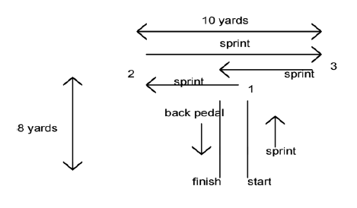
- “Square of Joy”/Box Drill
  - Make a 10x10-yard box; Begin in an athletic stance (knees bent, on the balls of your feet)
  - Go around the box changing speed and method of movement (shuffle, backpedal, carioca, broad jump, etc.); any time you change direction, squat down and touch the ground with both hands.
  - This is for time: 3x1-minute rounds with 30-seconds rest to begin; work up to 5x2 minute rounds
  - “Circle of Joy” can be done using center circle.

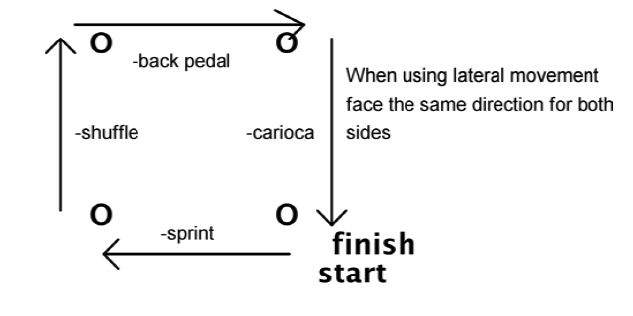

- Figure 8 (x8-15 total reps; full recovery)
  - Drop the hips at the corners
  - Keep the feet moving at the corners
  - Break down at each corner
  - Full acceleration out of each corner

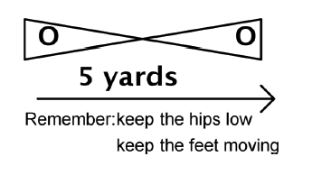
- M-W Drill
  - Set up the drill as represented by the diagram (use 10x10-yards)
  - Emphasize cuts; Keep feet moving
  - Drop the hips at the corners
  - Slow down going into the corner and full acceleration out of the corner; push off hard when changing direction.
  - Complete 5 reps each direction for 10 total. Add 2 reps each time you do this drill until you can successfully complete 10 reps each direction with maximum efficiency.
