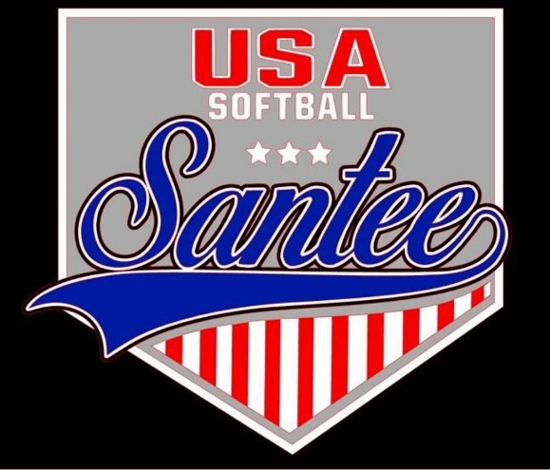
MINUTES TO BE APPROVED AT THE NEXT BOARD MEETING. THESE MINUTES ARE NOT CURRENTLY POSTED AND SHOULD NOT BE DISTRIBUTED UNTIL APPROVED BY USASSCS BOARD.
Board Meeting Minutes May 13, 2024
Location: Santee City Hall
Attendees Shown with Marked Box
President | Jay Strandberg | x | Field Prep | Kevin Hopkins
1st VP/ Field Prep/Uniforms | Erik Ruiz | x | Field Prep | Trevor Henton
2nd VP | Kelli Timanus | x | Field Prep | James Timanus | x
Treasurer | Tiffany Lynch | x | Field Prep | Nate Anderson
Secretary/Safety Coordinator/Head Scorekeeper | Bryan Scholar | x | Field Prep | Brad Allen | x
Tax Advisor | Lori Britt |  | Field Prep/Equipment | Shane Frary | x
Player Agent | Lance Craw | x
UIC/Parliamentarian | Felicia Leca |  | Head Team Parent Coordinator | Dana Hisaw | x
Field Scheduler/Fall Ball Coordinator | Chris Klima
Webmaster/Social Media/All-Star Coordinator | Alexis Ruiz | x | Picnic Coordinator/Pictures | Kat Vecchione | x
BOTH Tournament Coordinator | Kayleigh Ponciano-Ahue | x | Snackbar #1 | Amy Ramirez | x
Sponsorships | Kylee Scholar |  | Snackbar #2
Awards | Janis Aiello | x | Social Media Coordinator | Sophia Vigil | x

Meeting called to order: 7:10PM
Meeting Minutes
Brad Allen motioned to approve minutes from April 2024. Dana Hisaw seconded the motion.
Meeting rule – One Topic at a Time
Financial Update (Tiffany L)
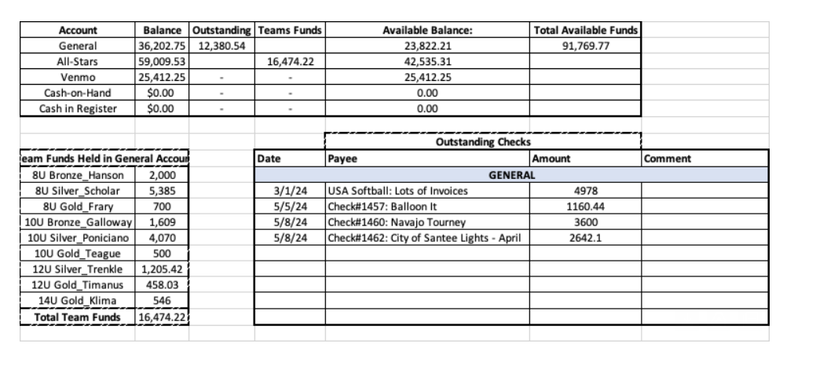
Bring on the Heat Tournament
- Committee meeting soon to discuss details

Fields
- Field crew to check all locks on fields
- Need to purchase new field bin on field 1
Rules Committee – meet before June meeting
- Bryan Scholar
- James Timanus
- Kayleigh Ponciano-Ahue
- Brad Allen
- Felicia Leca

Meeting Adjourned: 8:21 pm
Next Meeting: June 10

