GIRLS HOCKEY
“SNAP SHOTS”
The girls’ hockey season is in full swing keeping coaches, players and their parents very busy. A few reminders for all head and assistant coaches. First, if you haven’t done so already, please sign up for the MGHCA Coaches Newsletter. We will be using this forum to communicate information regarding girls’ high school hockey to our membership including info about programs, membership, awards, nomination deadlines, etc. The registration link is below. It takes only a minute to register and it is free to all coaches.
https://mghca1.sportngin.com/register/form/078850663
The link below is for the nominating one of your players for the Hobey Baker High School Character Award. Deadline for submission for your player’s name to be included in the state tournament program ad is February 9th. Allow ten days for the award to be processed in advance of your team year end banquet.
https://hobeybakermemorialaward.sportngin.com/register/form/286219248
Dates to remember:
- January 27, 2018 – Scholarship application deadline
- February 21-24, 2018 – MSHSL Girls Hockey State Tournament, Xcel Energy Center & Ridder Arena
- February 22, 2018 – Hall of Fame Awards Banquet
- March 2-4, 2018 – Senior Classic and U18 Festival at the Schwan’s Super Rink in Blaine
- April 19-22, 2018 – Final 54’s & High School National Invitational Tournament, Vadnais Ice Center

The Premier Prep League is proud and honored to be sending two teams off to additional competition next spring! Our playoff champion, Premier Prep Red, will be representing Minnesota at the 19U Tier 2 USA Hockey National Championships next spring in Marlborough, Massachusetts. Congratulations to the following players:

#1 Goalie Camryn Salmonsen Faribault HS
#2 Defense Annika Swanson Wayzata HS
#3 Forward Emily Elias Maple Grove HS
#5 Defense Gigi Jacobson Eden Prairie HS
#6 Forward Alexa Ocel Wayzata HS
#7 Forward Izzy Radley Eden Prairie HS
#8 Forward Emily Roder Shakopee HS
#9 Forward Hannah Vitelli Benilde St. Margaret’s HS
#12 Forward Kaylyn Forliti Saint Francis HS
#14 Defense Mayson Toft Alexandria HS
#15 Forward Kady Mill Eden Prairie HS
#16 Forward Brielle Arzdorf Saint Francis HS
#18 Forward Payton Putrah Cretin Derham Hall HS
#19 Forward Anna Laugen Wayzata HS
#20 Defense Grace Halvorson Andover HS
#25 Defense Kennedy Spiering Cretin Derham Hall HS
#26 Forward Erin O’Kane Alexandria HS
#27 Forward Sophia Zebro Saint Francis HS
#28 Defense Holly Eckers Shakopee HS
#30 Goalie Carly Greene Benilde St. Margaret’s HS
#36 Defense Allison O’Kane Alexandria HS

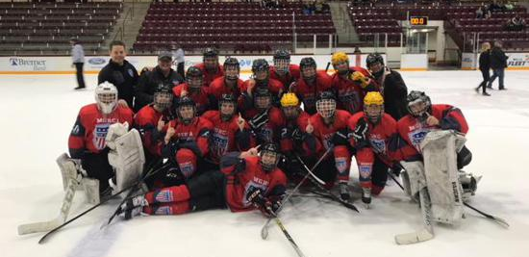

Premier Prep Yellow, along with a few substitutions, will also be representing Minnesota at the America’s Showcase event in St. Louis, Missouri. Congratulations!

For information on these events or any other activities and awards provided by the MGHCA, go to www.mghca.com. Information regarding all programs can be found there or by emailing any of the Section Reps or Executive Council staff. Submitted by Tim Morris, Executive Director MGHCA

