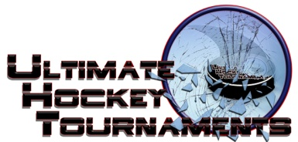
Ice Blast Tournament, St. Louis, November 2- 4, 2018
Peewee B Division

Tournament Format

Four teams, with each team playing three preliminary round games. At the conclusion of preliminary round, 1st plays 2nd for Championship. 3rd plays 4th for the consolation.

Standings
Team | Points Gm1 | Points Gm2 | Points Gm3 | Total Points | Tiebreakers
Twin Bridges Lightning | 0 | 0 | 0 | 0
Midwest Blackbirds | 2 | 2 | 2 | 6
Southern Illinois Ice Hawks | 0 | 0 | 2 | 2
St. Peters Spirit (Dyck) | 0 | 2 | 2 | 4
Game Results
Fri | 5:00 |  | Pm |  | Fenton Forum |  |  | Spirit |  | 0 |  | vs. |  | Blackbirds |  | 5
Sat | 12:10 |  | Pm |  | All American Rink |  |  | Lightning |  | 2 |  | vs. |  | Spirit |  |  | 6
Sat | 1:20 |  | Pm |  | All American Rink |  |  | Blackbirds |  | 7 |  | vs. |  | Icehawks |  |  | 0
Sat | 5:40 |  | Pm |  | Fenton Forum |  |  | Blackbirds |  | 7 |  | vs. |  | Lightning |  |  | 0
Sat | 6:00 |  | Pm |  | All American Rink |  |  | Icehawks |  | 1 |  | vs. |  | Spirit |  |  | 5
Sun | 8:00 |  | Am |  | McKendree RecPlex |  |  | Icehawks |  | 5 |  | vs. |  | Lightning |  |  | 2
 |  |  |  |  |  |  |  |  | HOME |  |  |  |  |  | AWAY
Sunday |  | 1:10 |  | Pm |  | All American Rink | 3rd |  | Icehawks |  |  |  | 4th |  | Lightning Consolation
Sunday |  | 1:10 |  | Pm |  | Affton Rink | 1st |  | Blackbirds |  |  |  | 2nd |  | Spirit Championship

