
Emergency Action Plan
N North County Coastal Friday Night Lights
EMERGENCY ACTION PLAN
(Poinsettia Community Park)
(6600 Hidden Valley Rd.)

Emergency Contacts Phone Numbers
- Mario Moore Director of Operations 760-912-8244
- Paul Publico Commissioner 619-616-8272
- Thadd MacNeal Commissioner 562-254-3201
- Paul Packard Head Referee 760-492-4255

Activation of the EAP:
- The individual with the highest qualifications (AT, coach, etc.) will:
  - 1) Activate the EAP
  - 2) Provide care during a medical emergency or delegate it to a higher medical authority
- Retrieve Emergency Equipment
- If necessary, summon EMS via cellular phone or facility on site phone. Be prepared to answer the following:
1.) Address of the emergency and location relative to the street address
3.) Approximate age and gender of the sick/injured individual
4.) Are they alert and breathing normally
5.) Best access point for the responding EMS unit(s)
6.) Your name and phone number
- Locate AED if necessary. Contact 911 dispatch for AED code
- Contact FNL representative (Head Referee, Commissioner MacNeal or Publico) and retrieve Player Emergency Contact Card if no parent or guardian is present.
- Provide the appropriate medical care needed until the EMS arrives and takes over

Directions
In the event 911 is activated, one FNL staff member located at the snack bar will assist with traffic control by directing any vehicle that may be stopped waiting for parking to move along and vacate the parking area temporarily. Once EMS arrives the same staff member will direct EMS to the patient’s location. While EMS is treating the patient FNL staff should clear a path of travel to the ambulance. Play on adjacent field may need to be stopped depending on the location of the patient.

IN AN EMERGENCY SITUATION, PERFORM THE FOLLOWING STEPS:

1) DIAL 911, GET AED (if warranted), REQUEST AED CODE FROM DISPATCHER, NOTIFY FNL STAFF

AED is located at the restrooms just to the east of the turf fields

2) DO NOT HANG UP UNTIL INSTRUCTED TO DO SO BY DISPATCHER

3) GIVE THE FOLLOWING INFORMATION TO DISPATCH
Exact Location of the Incident
Example- Poinsettia Turf (soccer field), Poinsettia Baseball Field
What has happened?
Example- Possible broken leg
Are they alert and/or breathing? Patient Male or Female?
From what Phone Number are you calling?
Best Access for EMS Services

4) ADDITIONAL DUTIES
Retrieve Emergency Contact Card (if parent or guardian is not present)
Retrieve first-aid equipment
Provide first-aid care (to extent of training)
Open, unlock, and/or prop open access gates and doors
Meet and direct ambulance/police/fire services
Provide scene control

MAP

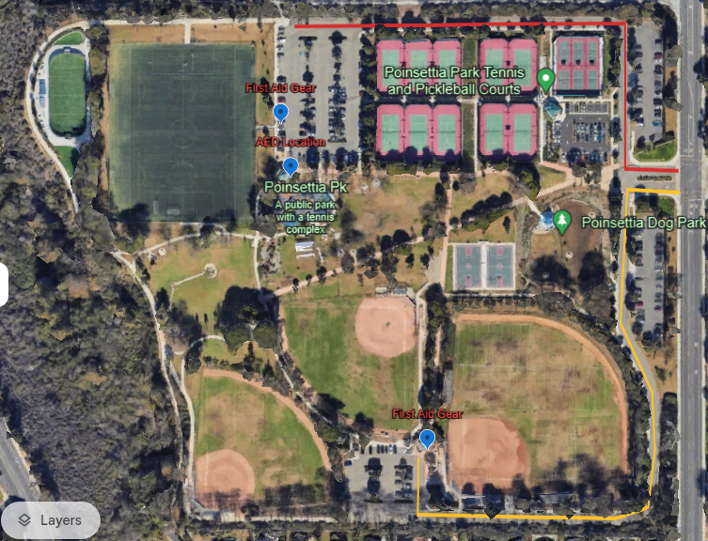

EMS Routes shown in red and yellow.

AED and First Aid Gear locations shown with blue icon

