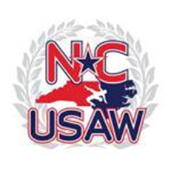
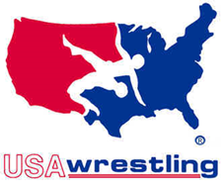
Tar River Wrestling Club
Presents the
Lorenzo “LO” Carmon clash

Date: Saturday, March 30, 2019

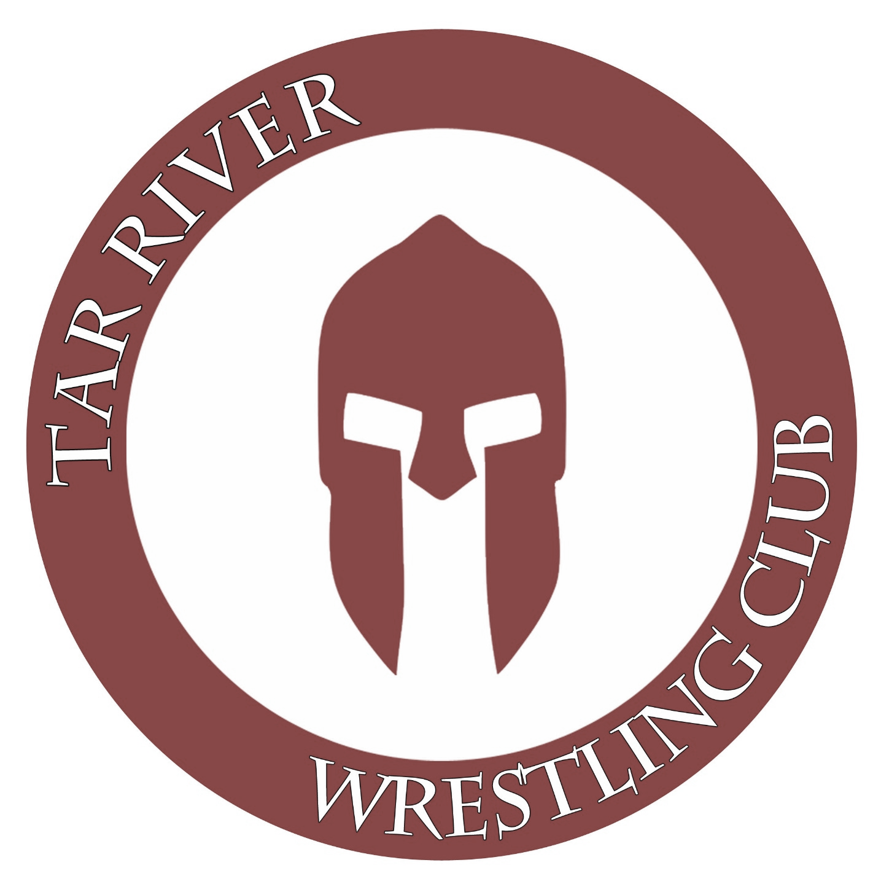
Location: Tarboro High School
1400 Howard Avenue
Tarboro, NC 27886

Time: Weigh-ins 8:00 AM - 9:00 AM
Wrestling Starts @ 10:00 AM

Pre-Registration (required) @ www.ncwrestling.org

USA Wrestling Cards are required: www.themat.com

Styles: All Ages Greco-Roman/Freestyle

Entry Fee: $25 (both styles included)
Awards will be given to the top 3 individual finishers in each weight class.

For More Information, contact Tournament Director Rick Mann: (252) 544-0760

