Mount Washington Valley Youth Hockey Association
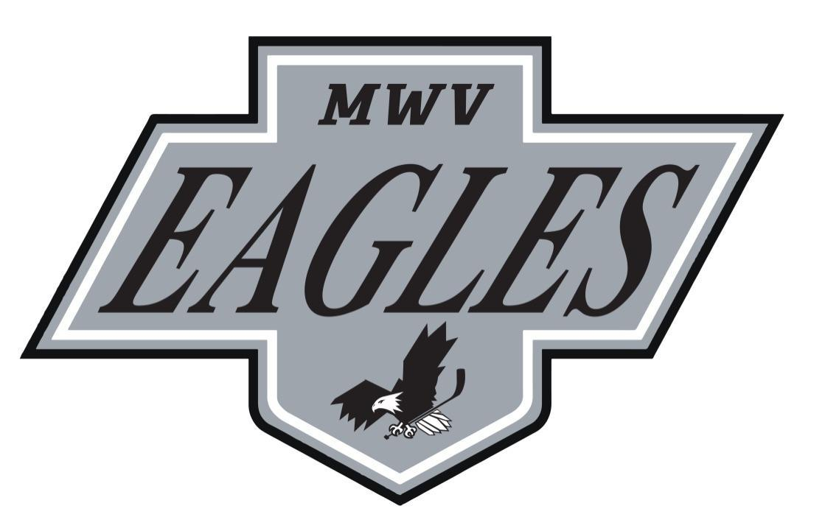
2025-2026 Code of Conduct
The Mount Washington Valley Youth Hockey Association Board of Directors has adopted USA Hockey’s Code of Conduct for the 2025-2026 season. All parents & players are required to go over this document together, sign and return to their head coach prior to the first game. Players will not be allowed to participate in any Granite State contests until the Code of Conduct is signed and returned to the head coach. Per the MWVYHA Board of Directors, any parent or player who fails to adhere to all aspects of the following Code of Conduct may/will be removed from their team and the Mount Washington Valley Youth Hockey Association.
Parent's Code of Conduct
Do not force your children to participate in sports, but support their desires to play their chosen sports. Children are involved in organized sports for their enjoyment. Make it fun.
- Encourage your child to play by the rules. Remember, children learn best by example, so applaud the good plays of both teams.
- Do not embarrass your child by yelling at players, coaches or officials. By showing a positive attitude toward the game and all of its participants, your child will benefit.
- Emphasize skill development and practices and how they benefit your young athlete. De-emphasize games and competition in the lower age groups.
- Know and study the rules of the game and support the officials on and off the ice. This approach will help in the development and support of the game. Any criticism of the officials only hurts the game.
- Applaud a good effort in both victory and defeat, and enforce the positive points of the game. Never yell or physically abuse your child after a game or practice – it is destructive. Work toward removing the physical and verbal abuse in youth sports.
- Recognize the importance of volunteer coaches. They are important to the development of your child and the sport. Never approach a coach regarding a player issue inside the locker room or the arena. Always allow up to 24 hours before expressing your concern.
- Communicate with the coaches and support them.
- If you enjoy the game, learn all you can about hockey – and volunteer.
Player's Code of Conduct
- Play for fun.
- Work hard to improve your skills.
- Be a team player – get along with your teammates.
- Learn teamwork, sportsmanship and discipline.
- Be on time.
- Learn the rules and play by them. Always be a good sport.
- Respect your coach, your teammates, your parents, opponents, officials & the rink you are playing in.
- Never argue with an official’s decision.
Spectator's Code of Conduct
- Display good sportsmanship. Always respect players, coaches and officials.
- Act appropriately; do not taunt or disturb other fans; enjoy the game together.
- Cheer good plays of all participants; avoid booing opponents.
- Cheer in a positive manner and encourage fair play; profanity and objectionable cheers or gestures are offensive.
- Help provide a safe and fun environment; throwing any items on the ice surface can cause injury to players and officials.
- Do not lean over or pound on the glass; the glass surrounding the ice surface is part of the playing area.
- Support the referees and coaches by trusting their judgment and integrity.
- Be responsible for your own safety – be alert to prevent accidents from flying pucks and other avoidable situations.
- Respect locker rooms as private areas for players, coaches and officials.
- Be supportive after the game – win or lose. Recognize good effort, teamwork and sportsmanship.

I have read the above; I agree to abide by the Code of Conduct established by USA Hockey and Mount Washington Valley Youth Hockey Association. I am fully aware that failure to abide by the agreement may/will result in disciplinary action that may/will include suspension/removal of my child/family in activities associated with Mount Washington Valley Youth Hockey.

Player Name (printed) _________________________________________ Team ________________________

Players Signature ______________________________________________ Date ___________
Parent/Guardian Signature ____________________________________ Date ___________

Parent/Guardian Signature ____________________________________ Date ___________

“The greatest thing about hockey is the people you meet, the people I’ve met, the friendships I have, the memories and there’s nothing like it. It’s the greatest game in the world.” ~Wayne Gretzky

