How to: Print Tournament Program in Booklet Form

Step 1: Open the Program in Adobe Reader. If you are using another PDF reader consult the documentation for that program.
Step 2: Go to ‘File’, found in the Menu Bar at the top of the page, and left click. You will see something exactly like or very similar to this:

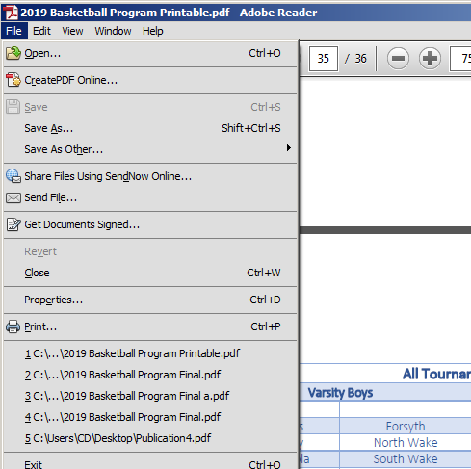
Step 3: Select ‘Print’ with a left click and you will see this:
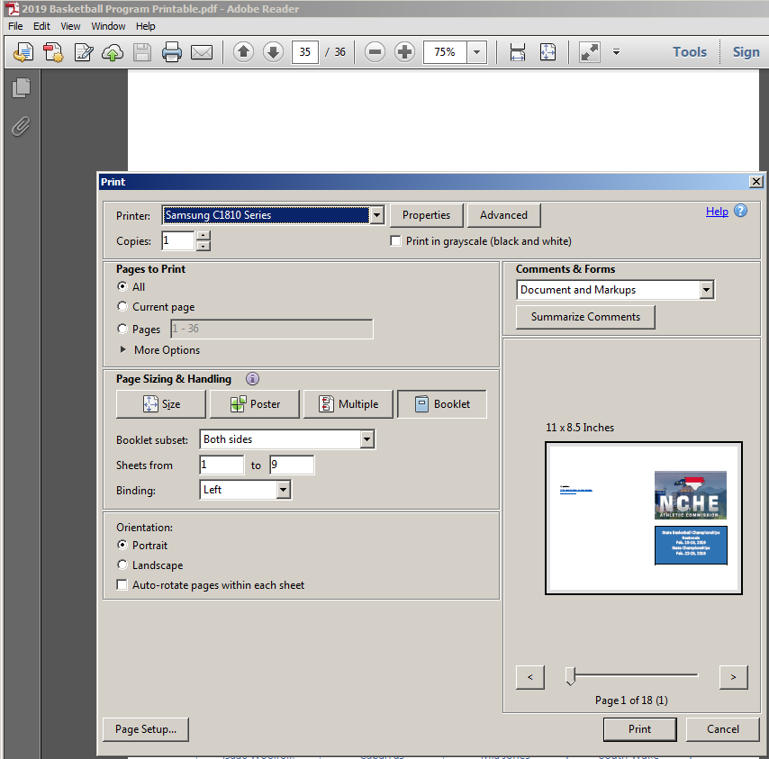

Step 4: In the ‘Printer’ drop down menu, select your printer. In the ‘Page Sizing and Handling’ dialog select ‘Booklet’.
Step 5: Left click on Print. If you have a printer capable of automatically printing both sides of a sheet of paper, then just wait until the printer is done, and then fold the pages accordingly to create the Program. If not, then follow the directions generated by your printer on how to proceed printing the backside of the paper. There may be additional settings required by your printer to accomplish this. Consult your printer documentation if necessary.

