

Hilton Sparks Athletic Event Emergency Action Plan

This Emergency Action Plan shall be adhered to at any and all of our events and locations, in the event of a medical emergency. All coaches and staff members should be familiar with this document and their role and responsibility in an emergency. Any questions should be directed to the program director. An emergency is defined as the need for Emergency Medical Services (EMS) to give further medical attention and/or transport an individual to the hospital. It is important in these situations that coordination between all parties concerned be effective. This guide is intended to delineate roles and outline the protocol to be followed should an emergency occur.
Situations when 911 should be called, for any individual present are:
- not breathing
- loss of consciousness
- suspected neck or back injury
- open fracture (bone has punctured through the skin)
- severe heat exhaustion or suspected heat stroke
- severe bleeding that cannot be stopped

Emergency Personnel
This team of individuals will carry out various roles in the event of an emergency.
- Coaches
- Program Director
- Security (if applicable)
The highest person in the chain of command who is present at a scene will be the designated person in charge, or leader. That person is responsible for deciding whether or not to call 911, instructing others how they may be of help and will be the person who stays with the athlete until EMS arrives.

Immediate Care of Injured/Ill Individual
At all home contests, the home team Head Coach will be in charge of the direct care of the involved individual.
He/she will act as the First Responder and fulfill the role of immediate care. Whatever the situation, he/she will dictate all other duties to those assisting.

Once it has been decided that EMS should be called, the following protocol should be followed:

Activation of EMS
The First Responder will determine whether or not to activate EMS. When this determination is made, he/she will assign the duty to call EMS to another individual (assistant coach, parent, etc).

When making the call:
- Remain calm
- Speak clearly: Identify yourself and the location (be specific and give them the address)
- Relay all details of the injury/illness as given to you by the First Responder. If it is a cardiac emergency, be sure to specify this to the operator.
- Remain on the line until the operator instructs otherwise

The parents or guardians MUST be notified if not present at the contest. This may be performed by the same individual making the EMS call or another depending on availability of personnel. If it is a life-threatening situation, the parents may be called after activating EMS. If it is not life- threatening, the parents will be contacted prior to activating EMS.
EMERGENCY ACTION PLAN
- The highest person on the chain of command will be deemed the leader, and will stay with the individual to monitor their condition and administer necessary first aid. If possible, someone else on the chain of command should also stay and assist. The front office or an administrator should be notified that there is an emergency situation on campus.
- The highest person on the chain of command will make the call to EMS or will designate another person to make the call. (911 from a cell phone) EMS should be told what the emergency is, the condition of the individual and how to get to their actual location. Also, tell EMS that someone will meet them at the closest intersection to aid in directing the ambulance. DO NOT HANG UP UNTIL EMS HANGS UP FIRST.
- The leader will send runners to all intersections between where the individual is located and to direct EMS personnel into the scene. The runners should stay in their positions and wave the ambulance through the proper turns to get to the athlete.
- The leader will designate another person to attempt contact with the individual’s next of kin- Emergency contact information must be available in the coach's bag for all athletes. If an athlete’s parent is not present, the leader should accompany the athlete to the hospital.
- If transport is deemed necessary by EMS, the athlete will be taken to Strong West ER, 16 West Ave. Brockport NY, unless the parent requests otherwise.

Venues:
Hilton Community Center (Hilton Parma Recreation)- 59 Henry St for all 8U & 10U home games

Village Elementary School - 100 School Lane for all 4 & 6 U games

Merton Williams Middle School - 200 School Lane for all 13 & 17U home games

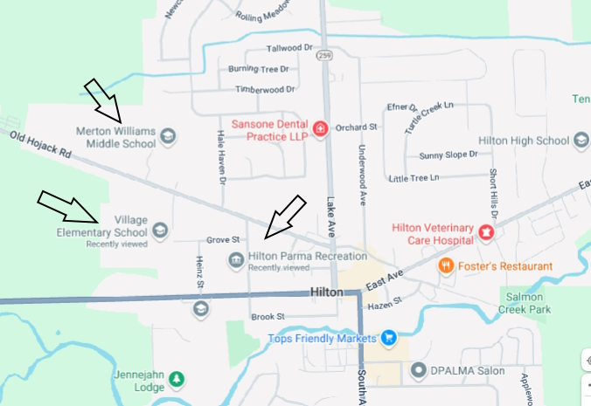

Location of AEDs: - on field, designated with a corner flag

*Coaches should take note of the closest AED to their practice and game locations.

IMPORTANT PHONE NUMBERS:
EMS: 911
Club President: Bob Rosso 629-7459 c(t)
Club VP: Steve Reiter 313-7815 c(t)
4U Program Director: Amanda Gallina 794-0935 c(t)
6U Program Director: TBD
8U Program Director: Matt Strong 303-3583 c(t)
MURSL Program Director: TBD

