Soccer Stars Fall 2023

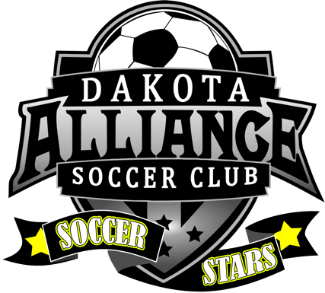

6 total sessions that you can come to and enjoy. We are very much looking forward to hosting our Soccer Stars friends again.

- Wednesday September 20th, 6pm at the Mini-pitch (Nusier-Salem Field) at Terrace Park
- Sunday September 24th, 6pm at the Sanford Crossing, Field 1
- Wednesday September 27th, 6pm at the Mini-pitch (Nusier-Salem Field) at Terrace Par
- Sunday October 1st, 6pm at the Sanford Crossing, Field
- Wednesday 4th, 6pm at the Mini-pitch (Nusier-Salem Field) at Terrace Park
- Sunday October 8th, 6pm at the Sanford Crossing, Field 1

Please help us grow this program by spreading the good word about how much fun we have and how much each player connects with the buddies and the coaches.

Thank you

