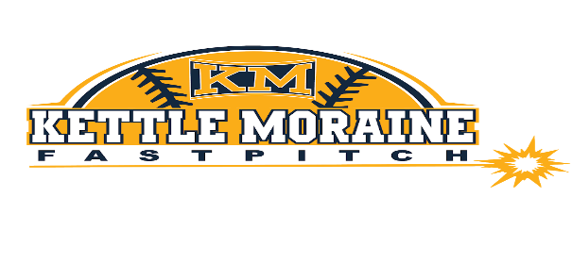
TEAM SPONSORSHIP ORDER FORM
Platinum Sponsorship: 1 per team ($400)
- Company Name and Logo on Team Banner and KMLFC website
- 2021 All American Tournament Sponsorship
- Framed Thank You photo of sponsored team

Gold Sponsorship: 2 per team ($250)
- Company Name and Logo on Team Banner and KMLFC website
- 2021 All American Tournament Sponsorship
- Framed Thank You photo of sponsored team

Silver Sponsorship: 8 per team ($100)
- Company Name on Team Banner and KMLFC website
- Framed Thank You photo of sponsored team

Business Name: ________________________________________________________________________

Address: ______________________________________________________________________________

City: _______________________________________________________ Zip: _________________

Phone: ________________________________________________________________________________

E-mail: ________________________________________________________________________________

Team: U8 / U10 / U12 / U14 Gold / U14 Navy / U16

Sponsorship Level: Platinum($400) Gold($250) Silver($100)

Please make checks to KM Community Education
Please send completed form with payment by 3/1/21 to Leslie Staver, N30W22048 Woodfield Ct E
Waukesha, WI 53186

We will send a link to your email address to provide your artwork for the Platinum and Gold level sponsorships.
Thank you for your support!
Kettle Moraine Lasers Fastpitch Club

