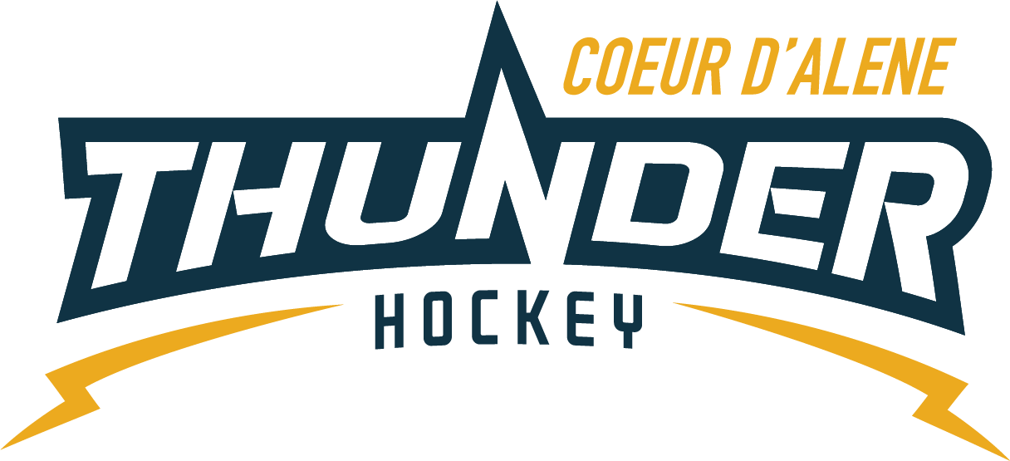

Meeting minutes

Location: Frontier
Date: January 24, 2023
Attendees: Meghan Smith, Katie Lovitt, Matt Fisher, Elliot Taub Jackie Peterson, ,April Hocking, Josh Leppert (phone),
Absent: Will Higgins, Matt Peltz, Matt Creighton( on state call),
Guest: John Perkins

- Call to order
Meghan Smith, Vice President called meeting to order at – 6: 05PM
- Roll call
As stated above
- Approval of minutes from last meeting
Motion to approve minutes – Katie Lovitt
Second by – Matt Fisher
Passes unanimous
- Treasurers Update
  - See separate sheet
  - Raffle has been great for players
  - Had to write a second check for state and a girls tourney due to getting lost
  - 500 donation from photographer as a donation back and will add him to the website sponsor
  - Motion to approve the line item in the budget per head coach per team (mites 1 only) – Elliot Motions – Jackie seconded – all in favor passes unanimously
  - 12 x 12 from 2021-2022 current 5.00
- Committee Updates
  - Coaching Committee update (5) –Joe – Josh
    - Josh sent a document on how to handle tough situations when traveling or in general how to handle the right way should go to coaches – review and provide feedback by Friday to blast to coaches
    - Have a big parent meeting about the expectations – and have a fan captain.
    - Print a copy of code of conduct for board
    - Meeting will be the 31st and will be blasted
  - Gear Committee update (5) – Sean Meyer – NA
    - Clean up purchase process for how to sell the gear – Matt will own the process and decide what the plan is for the LTP and gear process
  - Discipline committee update (5) – Meghan
    - 2 meetings and Megan is taking care of the issues and sorting out the issues and addressing them
  - Safe sport Committee update (5) – Matt P
    - State update from USA hockey on annual safe sport now must be done every year, locker room monitor is the biggest issue so far across the board with cell phones being concerns, use the boxes for phones – policy audited annually can make policy more strict not less strict, mandatory reporter must be done in 24 hours they will hold you accountable.
  - Scheduler update (5) – Jackie

- New Business
  - Jon Perkins is really impressed by the goalie only practices, LTP, mites and our coaching mentality is changing so we are working as a team – girls teams are growing – I would like to propose a coaching position of goalie coach in chief – directly under coach in chief would like to be considered to that role. Needs to be added to the by laws in our April meeting – could help coordinate goalies – could be a board appointed position
  - Spring planning – coordinate a program with Darin and other coaches for weekly development for Mites – Bantam plus girls on weekends will have 8 week plan
  - Player coaches needs bylaws revision examples having PWs running stations on the ice for SQ doesn’t thinks it’s appropriate need permission from coach possible 2yrs older than one year division coaching. Kids should only be there to demonstrate not goofing around but engaged not a big issue but others may see it as a big issue. Student Coaching minimum age is 12 years old. Coaches need to be aware of and brought up in the Coaches Meeting next week and rules tightened up.
  - Graduation status pushed to next meeting
  - Survey results will be pushed to the next meeting so we can see the results after payment made.
  - Visiting players from out of state – Matias is 12u that moved away and will be in town and wants to practice with us. USA registered but may be frowned upon but others don’t have a problem with it they will find out if he is for sure USA registered and will decide when gets here and in good standings with his association.

- Business.
No updates on old business
- Any other Business
Next Meeting Date: Next meeting Tentatively scheduled for 1/17/23 at 6pm at the rink

- Meeting Adjourned
Josh Motioned to adjourn at 800, second by Matt – all approved

