Rookie Rugby Cleveland Flag Rules (3rd – 6th Grade)
Playing Area
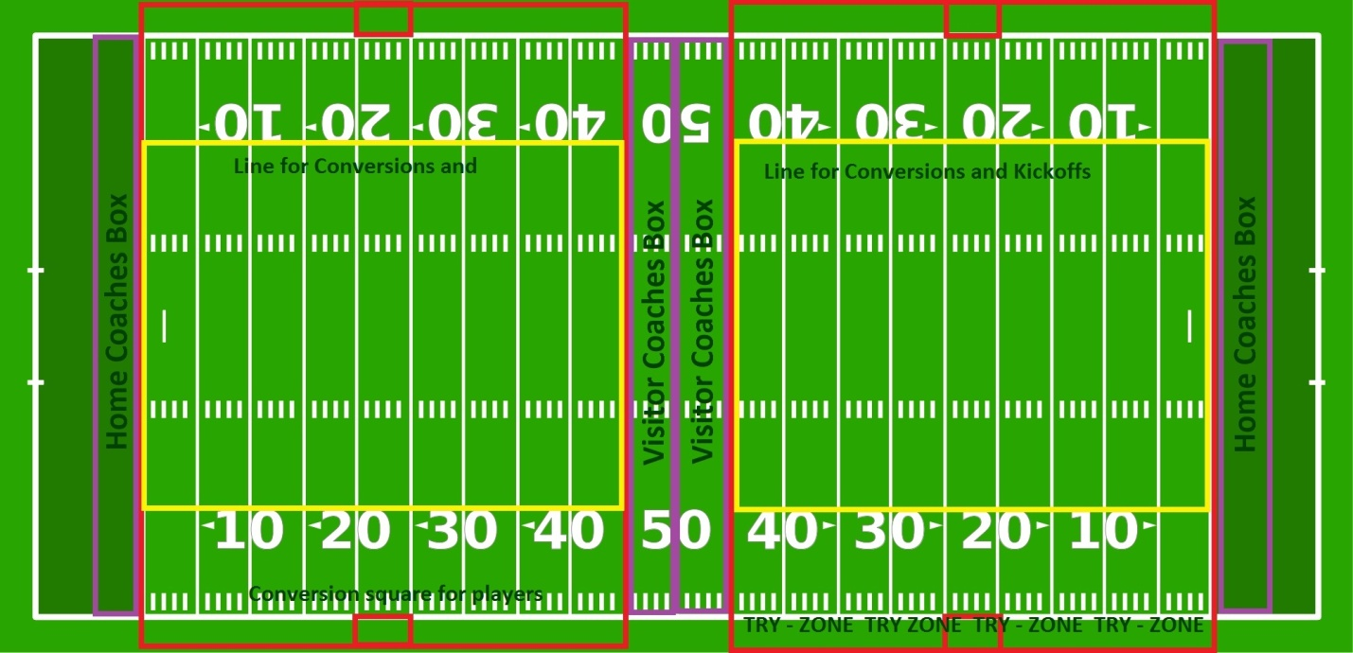
On Wasmer Field, home coaches are to be on the sidelines on the far sides of the fields. Visiting coaches are to be in the middle of the field. Coaches must remain on their-own sideline for the duration of the match. They are NOT permitted to be on both sidelines.

The width of the field will be from the line in the middle of the football endzone to the 45 yard line (approximately 50 yards in width). The length of the field is from the football out-of bounds line to the other out of bounds line (approximately 54 yards in length). The back of the try-zone is marked by a gold-line before the track.
All conversions AND kick-offs are taken from the top of the numbers. During conversions, players must stand in the "conversion box" located between the 20 and 25 yard lines.
The try-zone is the area extending from the line on the football out-of-bounds line up until the gold-line in the back of the try-zone.

Ball Size
We will use a size 3 ball for all players grades 2 and below. We will use a size 4 ball for all players in 3rd – 6th grade division.

Ages
Flag rugby is possible for all players in the 6th grade and younger.

Starting the Match
The match begins with a kick-off from the top of the numbers (the 22). Players may punt or dropkick the ball to start play. If the ball goes into touch on the fly or out of the side or back of the try zone, the receiving team starts with a free pass at midfield and starts with a tackle count of "ZERO." If the ball bounces inbounds and then goes out, the receiving team gets a free pass at the place where the ball went out. The kicking team CANNOT recover the ball on a kick-off. If a player knocks on the kick, play will start at the point of the knock-on for the receiving team with a 'tackle 1.'

General Game Play
Offense
The goal of the offense is to score. This is done by touching the ball to the ground in the opponent's try-zone. Players can run forward with the ball. Players can also throw the ball laterally or backward to their teammates. Players may also kick the ball at any point in open play. Teams may not kick to touch on penalties at this level. The offense has seven possessions to score. The following infringements result in a turnover and a free pass for the other team:
- Failure to score after seven possessions (the referee will call-out the tackle count)
- Pass/Drop the ball forward
- ACTIVELY block another player from making a tackle
- Guard their flag from being ripped
- Tied flags: turnover with play beginning at midfield
- Shirts not tucked-in in such a way as to prevent flags from being pulled by defense

Defense
The goal of the defense is to prevent the offense from scoring. The defense attempts to rip the flag of the offensive player off of his/her waist. Each time this happens, it is considered one possession. Defenders must do this seven times in order to create a turnover. The defense can also commit infringements that will result in a new set of seven possessions for the offense. These infringements include:
- Pushing a player out of bounds
- Making a tackle without your flag
- Impeding the ball carrier with no intent to rip the flag
- Throwing the ball carrier's flag
- Player dangerously leaving his feet
- Offsides (set by official at 5 yards from tackle)

Tackle
A tackle is made when the ball carrier's flag is ripped-off. The tackle exists wherever the flag was pulled. A tackle only happens when the referee verbally signals "Tackle." Sometimes the referee will deem that the flag was pulled after/during the ball had been released. Play until the referee announces "TACKLE." The referee will count out the tackles each time this occurs "Tackle 1," "Tackle 2," etc. If the referee does not signal a tackle, then play continues.
After each 'tackle' play restarts with a free pass. The previous ball carrier cannot restart play. It must be one of his teammates. The teammate will pass the ball from the point where the last flag was pulled. If this does not happen, the referee will bring the ball back to the spot of the tackle and penalize the offense 1 'tackle.' (Exception: If the last tackle was within 5 yards of the opponents goal-line, players may restart anywhere behind that spot in order to gain more space.

The defense must be 5 meters back from the tackle. The referee will mark the 5 meters for each tackle. The defense does not need to retreat farther than their own try-line. The defense may advance after the free pass has been made. Players who are not back 5 meters are offsides.
Any offensive player who receives/recovers the ball on the ground is automatically 'tackled.'
If an offensive player's flags accidentally fall-off either in the course of running or they did not realize it, it is necessary to 'tackle' that person simply with 1-hand 'touch.'

Scoring
The purpose of the game is to score more points than the other team. You can score points in two ways.
A try is scored when a player touches the ball down in the try zone. He/she must apply downward pressure to the ball. A try is awarded 5 points.
A conversion is scored when a player kicks the ball to his/her awaiting teammates in the try zone in the conversion box. If any of his/her teammates catch the ball with two feet in the box, the conversion is awarded. A conversion is worth 2 points. A conversion kick is a punt taken from any spot perpendicular to the try line from the spot where the try was scored. It must be taken from behind the 22. This is represented as the top of the numbers on the football field. The conversion is good if any of the kicker's teammates catch the ball in the try zone with two feet in. Kicks must be taken within 20 seconds of the scoring of the try.

Time
Play consists of two 7-minute halves. Half time is 1 minute. Play does not stop at the end of either half until there is a dead ball. A tackle is not a dead ball. Dead balls include turnovers and scores. Passes that are intercepted would not end the game. 7 tackles for a turn-over would end the game. If the offense knocks the ball on and it is picked-up live by the defense, the game does not immediately end (as advantage is being played). If a team knocks on their ball and picks it up with time expired, the game is over. Penalties do not end the game. Time will stop during injury time. There is no over-time except during the City Championships. Overtime in tournament play is sudden-death. The first possession is determined by a coin flip.

Substitutions
Substitutions may enter ONLY during injury time or after a try has been scored. Players may exit or enter as many times as they wish during these appointed times.

Discipline
Rookie Rugby Cleveland K - 6th flag division is Flag and contact is discouraged. Defensive players have a right to the ground that they are holding. If an offensive player is running hard in their direction, they may choose to move and attack the flag from the side. It is understood that incidental contact will occur. However if the referee deems that a player must leave the pitch for dangerous play, he/she may award a yellow-card (2 minutes off) or a red-card (remainder of the match off). That team must play down a player during this period. If a referee gives a yellow-card to a coach for behavior, the coach must pull 1 player off (of his her/choosing) for a 2 minute period. If a coach receives a red-card, he/she must pull a player and play down for the remainder of the match. Coaches receiving “Yellow” and “Red” cards will also be reported to the League Disciplinary Review Board and will receive appropriate discipline. This includes (but is not limited) to suspension and expulsion from the league. Only certified coaches are permitted on the sidelines during matches. Parents who are not coaches should be in the "FAN" area.

Rookie Rugby Cleveland Tackle Rules

The 6th – 8th Grade League will follow the World Rugby Laws for 7's. However, there are a few differences in gameplay. These games take place on Kyle and McLaughlin Field. The width of each pitch is 54 yards. The length of each pitch is 60 yards from try-line to try-line.
- The conversion is a drop kick taken perpendicular from where the try was scored. Kicks must be taken within 20 seconds of the scoring of the try.
- Drop kicks at the beginning of each half and after any scores are taken from the midfield (30 yard-line on a football field). Drop kicks must go 10 yards before they are playable. On the soccer field, this is represented by the extreme edge of the mid-field circle. If they do not reach a full 10, then the receiving team will have the choice of a re-kick or a free-pass at the half-way line.

5th - 6th Grade Modified Tackle League

1) Numbers: 7 players per side
2) FIVE tackles is a turnover
3) Knock on’s, throw forwards, ball in touch are turnovers
4) A high tackle/dangerous tackle/whip tackle/no arm tackle is a penalty (which resets the tackle count); Referees will be instructed to refrain from using cards in the first week of the process. Beyond weeks 1 and 2 referees will begin to issue yellow (2 minutes in bin) and red cards (elimination from that game).
5) There are no mauls. If the ball is not produced, the referee will verbally instruct the players to let the ball carrier go to ground. This counts as a ‘tackle.’
6) On penalties, players must retreat 7 yards before they can continue to play. The tackle count is reset to “ZERO.”
7) At a tackle (ball carrier brought to ground*)
* one knee in contact with the ground is considered “brought to ground” and momentum stopped
- Tackler must release ball carrier and roll away in such a manner as not to interfere with the recycling of the ball for the offensive team (not rolling away quickly enough is a penalty/tackle count reset)
- Tackler must retreat 1 YARD beyond (not next to or in line with) the last person that is on the ground at the breakdown before they can resume play. Referee will make this mark.
- Ball carrier must set the ball OR pop the ball to an arriving player.
** no rucking in the modified tackle league.
- Ball carrier must remain on the ground until such time as the ball has moved off/away from where it was set by the tackled player
- ALL players of the defending team must retreat 1 YARDS BEHIND (not next to or in line with) the last person on the ground at the breakdown before they can resume play. If they do not the player is considered “offside.” Referees will penalize “MATERIAL” off-sides
- Only 1 quick-tap on penalties. The ball must leave the hands of the ball carrier.
- The ‘scrum-half’ MAY pick up and run with the ball if he so chooses. Defenders may come up as soon as the ball is lifted.

8) Open play resumes when the scrum-half picks the ball off of the ground
9) If a defensive player in an offside position moves forward and interferes with the ball carrier’s
ability to freely play the ball, ADVANTAGE will be played.
10) Advantage = being able to move 7 yard upfield (towards oppositions goal line) without being
obstructed by the defensive team. If no advantage occurs play restarts at the mark where the offense occurred. The defense must retreat 7yards!
11) No Lineouts
No Rucks
No Scrums
12) The ball may not be ripped away from the offensive player. A ball ripped away results in play continuing with a free pass from the point of losing the ball. A ball lost forward by the player is a knock-on.
13) Knock-ons on the kick-off results in “Tackle 1” … not a turnover
14) Open field kicking is permitted. Onside rules apply.

The goal of this league is to create a bridge between flag and 7th - 8th grade tackle.
The focus is on introducing how to tackle, how to be tackled, how to fall, how to roll away without having to also introduce scrums, rucks, and lineouts all at the same time.

The aim is that this will then facilitate a smoother and safer transition into 7th-8th grade tackle.

Referee Discretion
The referee is the sole arbiter of the laws of the game.
His judgment includes, but is not limited to:
- Awarding 10 meters to the offense on significant penalties (unsportsmanlike conduct, habitual offsides, etc.) (7 yards for the modified league)
- Playing advantage when it is beneficial to the offense
- Issuing a yellow card to a player or coach (Player is out for 2 minutes. Player cannot be replaced during this period)
- Issuing a red card to a player/coach (Player is out for the rest of the game. Player cannot be replaced during that game.)
The location manager and commissioners of Rookie Rugby Cleveland will decide if further disciplinary action must be taken against players, coaches, or spectators. The commissioners of Rookie Rugby Cleveland have the power to remove players/coaches from the league if necessary. All complaints should be made in writing and should cite the element of the coaches’ code of conduct that is violated. These complaints should be submitted to Dan Arbeznik who will refer them to a disciplinary panel of 5 coaches from within the league chosen before the league begins. All complaints will be resolved within 7 days of their receipt.

A-Side and B-Sides
Teams who field both an A-side and a B-side may not mingle their players. B-side players may "play-up" and sub for A-side matches. However, the "top 7" players of an A-side program may not "play-down" in the B-side league. These players will be marked by scorekeepers at the site. All ‘B-side’ matches in which an “A-side” player participates will be deemed an automatic forfeit by the offending side. This will result in the forfeiture of the match and a bonus point scoreline awarded to the opposition by means of a 20-0 score.

When a team is short on players, they have a choice to either play the match down players (for full credit) or to borrow players from another team, including a higher side of their own club (as a forfeit).

