BGYHA Meeting Minutes

May 16, 2022 7:00pm, Beckett’s Burger Bar

Attendees Present: Jamie Webb, Adam Maidment, Brandy Best (taking minutes), Nick Snyder, Leah Pekarik, Tony Burt*,

Absent: Tony Lake, Tony Kramp, Kirk Maxey

Prior Meeting Minutes: Leah motioned to approve previous minutes, Adam 2nd, JW abstained, 4 approved.

JW: 1. Discussion on goalie training options. BB motion to form sub-committee of NS, TB, BB and JW to provide proposed option of goalie training to be presented and voted on by board at June meeting, LP 2nd, Unanimous approval. 2. Start planning welcome back day. Get some welcome back training for refs.

AM: 1. Prelim ice contract from Jamie was received. Cost is the same for ice time, requested to be approved by 6/15/22.

NS: 1. AS coaches, a couple people have reached out

LP: NA

BB: 1. Bank Balance $106k - All ice paid for, includes about $12k for travel commitment fees for next season. 2. Redeemed $1,150 in cash back credit card rewards 3. Received Rally Up payment for YHD - $7,838 4. Submitted accounting records to William Vaughn to complete July 1 2020-June 30 2021 tax return that was on extension (due date 5/15) 5. Waiting on BOGO from Hockey Time to close prior season budgets

TL: 1. Absent

KM: 1. Absent.

TK: 1. Absent

TB*: 1. Ice schedule, can we do clinics or ice time during holiday off time for club to run some clinics or stick and pucks/games. We will schedule a couple of ice times during day and decide how to offer.

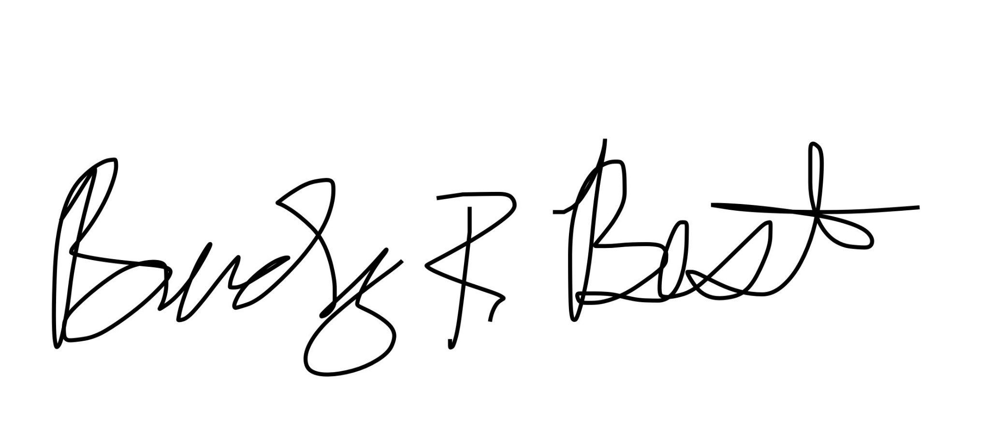
Other items: 1.Visit from Josh Chatfield from Champion Athletics to discuss off ice training - train the trainer program - write multiple 30 mins programs for coaches to use. He will prepare some plans to provide to the board and come to Coach’s meeting

Closing - Meeting adjourned at 8:57PM

Signed: ________________________________ Signed: ____________________________
President, Tony Lake Secretary, Brandy Best (Treasurer)

