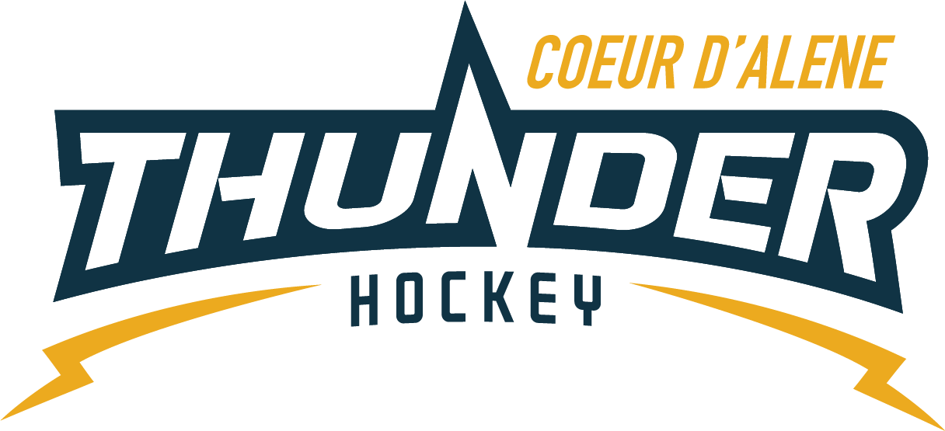

CDAHA

Meeting minutes
Location: ZOOM/Frontier Date: February 4, 2021
Attendees: Bob Nelson, Elliot Taub, April Hocking, Meghan Smith, Bart Barrett, Jarrod Hansen, Matt Fisher, Josh Leppert, Matt Creighton, Torsten Langley, Matt Crieghton
Time: 7:00PM
- Call to order
Bob Nelson, President called meeting to order 2/04/21 7:03PM
- Roll call
Guests Jackie G, Jackie P, Derek Kosanke, Kami Winfrey
- Approval of minutes from last meeting
Elliot Motions Bart 2nd approved.
- Open issues
  - TRESURER UPDATE
    - Looking good going to be up for the season, no estimation on how much due to the unknowns. Should be in green.
    - Spent money on grants last weekend & sponsorship money (mite goalie sticks, quick change goalie gear) so families don’t have extra cost. Now have 3 quick change sets for Association, plus 5 large player kits, rings, pucks, wheels and & honing kits, LTP nets and tutors.
    - Really cool stuff for grants next year to help volunteers. Find on IAHA website under grants to find what’s available.
  - Spring/Summer Ice
    - Survey had overwhelming yes but there was a cap on how many results you could see before charging a $100 a month. Let’s look at poll on SE for future polls.
    - Start April 5, times 5:15, 6:15, 7:30PM
      - Looking to different clinics throughout summer once a week. Thew will have to pay one lump sum & drop in if available. Fill pay 1st priority.
      - LTP right before season and already have coaches lined up for it
      - Next season want to look for try out and practice jerseys.
  - Mite Pictures
    - Go with Dorian
    - Jackie P will schedule
  - 10U SQUIRTS
    - Wanting to have BOD members for Mite-Squirt meetings, Bob and Matt C will be available
    - Disciplinary Actions, request to notify the Team Managers and Head Coach of what’s coming down the pipe & add that to disciplinary process. USA says all lies on head coach to then communicate. Matt C will send email to amend process
    - Games and practices depends on the violations depends on the severity & going to State.
    - End of Season status on funds for Squirts, do they have any left. Meghan will let them know.
    - Patches – are they still a thing this year? Yes turn them in and Elliot will get them handled by the end of March.
  - Website
    - Updated with the correct wording for COVID
  - Graduating Midgets
    - 5 seniors, need 5 stickers, want to keep up a tradition of what Stacy started
    - $20 per player for a swag gift – Elliot made a motion Josh 2nd approved unanimously
  - IAHA Winter Meeting
    - Trying to get future rules changed for border issues for PDC players as well as State, etc.
      - USA Hockey rules they are trying to access may not work for smaller Associations like us but geared towards bigger areas.
  - Elections
    - Zero letters at this point, need to keep blasting, even if you plan to reup your term you still need to turn in a letter of intent.

- Adjournment
8 PM
Minutes submitted by: April Hocking
Minutes approved by: CDAHA BOD
- Next Meeting
  - March 4, 2021 7PM

