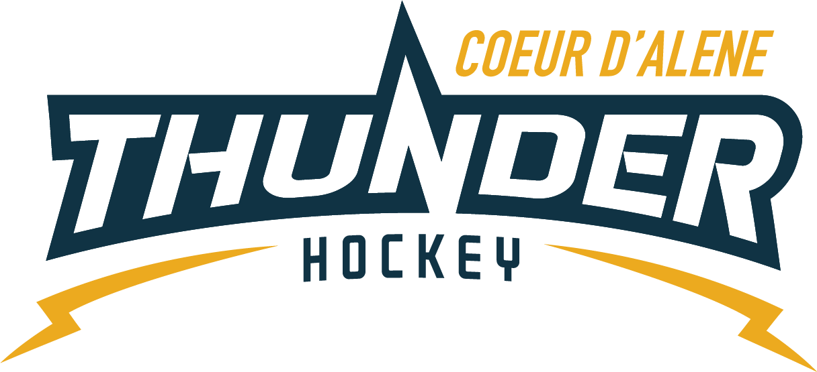

CDAHA

Meeting minutes
Location: Frontier Ice Rink Parking Lot
Date: September 3, 2020
Attendees: Bob Nelson, Elliot Taub, April Hocking, Meghan Smith, Torsten Langley, Matt Creighton, Bart Barrett, Jarrod Hansen, Matt Fisher, Jeremy & Jackie Guerrin, Jackie Petterson, Stacy Veach, Kami Winfrey, Cam Peterson
Time: 6:00pm
- Call to order
Bob Nelson, President called meeting to order 9/3/20 @ 6:01pm
- Roll call
As stated above, Josh Leppert absent
- Approval of minutes from last meeting
Motioned by Bart to approve minutes Meghan 2nd – passed
- Open issues
  - Financial Update
31,400 has come in since registration has opened
One outstanding invoice from last season being tackle
  - Practice Jerseys
    - Asking for approx. $492 to get them all numbered
  - Meghan made a motion to approve and passed unanimously
  - Leasing Program
    - Wanting to purchase game jerseys for a leasing commitment
    - 15 jerseys as a stockpile
    - $1240
    - Finance committee approved
  - Bart motioned to approve this Torsten 2nd no discussion
  - Registrar Update
      - 11 LTP
      - 46 Mites
      - 26 SQ
      - 33 PW
      - 23 BAN
      - 12 MID
      - GIRLS 12
      - PWTryout 16
      - TOTAL registration 151
    - Need Covid guidelines
    - Will get with Jarrod for this
  - Schedulers
    - No MT, no WA will reevaluate in January
    - Idaho has nothing scheduled yet but will contact Sarah Benson for further follow up
    - INW scheduling will not happen
    - Need managers to be willing to look and be on top of this
    - Salmon, McCall, Moscow, Frontier will be open
  - State Meeting
    - Approx $57000 in state fund
    - They are at 80% capacity CDAHA is 20% of that
    - USA Hockey rates will go up, $125
    - PDC Regionals in Dallas
      - Feb 26-28 Idaho Falls-State
      - March 12-14 Sun Valley – HS State
      - Feb 19-21 Boise PDC
    - Out of State players must know Covid Rules
      - It will now be Affiliate to Affiliate
    - Need to know Covid rules at each rink before scheduling
    - Are Registrars being notified of monthly meetings – not ours
    - No coaching clinics
      - Washington has a wait list
    - Want to nominate Darren Shoemaker for our N Idaho ADM
    - Blast the State Committee for volunteers
    - We’ll have to vote on P&P overhaul
    - Team Hockey and Team Idaho
      - We are not longer connected
      - 25 girls tried out and it fell apart shortly after
      - We have Washington girls that have played here all their lives that were not going to be able to play per new rules
      - Brought up to the State President
      - Parameters need to be reevaluated for our Northern part due to our situations and logistics
    - Committees for the State
      - Bob will sign up and pick
  - Coaches Meeting
    - Went well until end
    - Need another meeting with just Mites
    - Have made many calls to may ADMs
    - Must work with Vince to maintain our relationship with for the ice
    - PWs looking good on numbers
    - TryOuts in one week
    - Some may be waiting to pay to see outcome
    - Bart & Meghan both agreed meeting went well
    - People in association just need to be educated on our dynamics
  - Tryouts
    - Elliot, Matt C, Darren Shoemaker will be there for evaluating
    - 3 coaches will be there for the team per P&P
    - Need pins and #s
    - Future wishlist of 25 numbered black jerseys and 25 numbered white jerseys
    - There will be evaluation mtg following each tryout
    - Decisions will be made within a week of last tryout
    - Emails will be sent
    - Will be ran by a point system to hopefully post on website for future tryouts and uniformity
  - Mite Meeting
    - Scheduled for 2 weeks
    - Capping will be removed from all website/registration notices
    - Revisit capping in the future and after Covid
    - Not big enough to cap numbers
    - Want to keep Mite to Coach ratio and need to work together to find that magic number
    - Have 27 coaches signed up and ready to help
  - Travel Policy
    - Meghan made a great outline
  - Matt C motioned to approve Bart 2nd unanimous
  - Midget Update
    - Undetermined it those boys/coaches are coming at this time – tabled
  - Fundraising
    - Sold 80 masks so far
    - Still handing out tickets

- Adjournment
Bob adjourned the meeting at 7:46pm.
Minutes submitted by: April Hocking
Minutes approved by: CDAHA BOD
- Next Meeting
  - September 16, 2020 LIVE 6 PM changed to a Wed.

