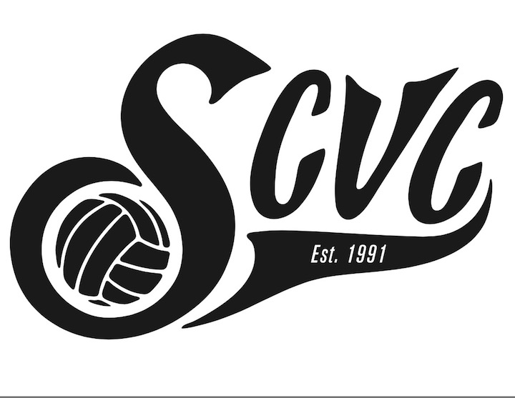

2020 Girl’s Junior Volleyball

Program Fees & Player Agreement

“SCVC Roxy Girls”

Ages 8 to 11

Name of Participant:_________________________________(print clearly)

2020 SCVC Program:

Program includes:
The parent/guardian understands that participation in Southern California Volleyball Club includes a membership for the participant from November 2019 through April 2020.
Program fees include:
- Program instructors/coaches.
- Uniform, sweatshirt and backpack.
- Participate in 4/5 SCVA league tournaments, per SCVA schedule: January / February / March / April
- Practices and training November 1, 2019 through April, 2020

Roxy Girls Fees:
As this is a program, all fees due in full upon acceptance.
The following payment schedule is available to you as a convenience; Credit Card payments available.

Practices: Saturday’s @ Dana Middle School

Option 1: $1,650.00

Option 2: Payment Plan

- $450.00 Due Upon Acceptance
- $400.00 Due October 1, 2019
- $400.00 Due November 1, 2019
- $400.00 Due December 1, 2019

SCVC Secure Online Bill Pay:
https://www.goscvc.com/page/show/3644732-make-a-payment

By my signature below I accept the financial responsibilities stated above. All fees are non-refundable.

Parent’s Signature:_____________________________________________________Date:____________

Relationship to Player: _______________________________

Telephone:__________________________ Email: _____________________________________________

SCVC: 806 So. Juanita Ave., Redondo Beach, Ca 90277

FAX: (310) 316-5515 …. Tel: (310) 316-4264 …. Email: scvcinfo@verizon.net

