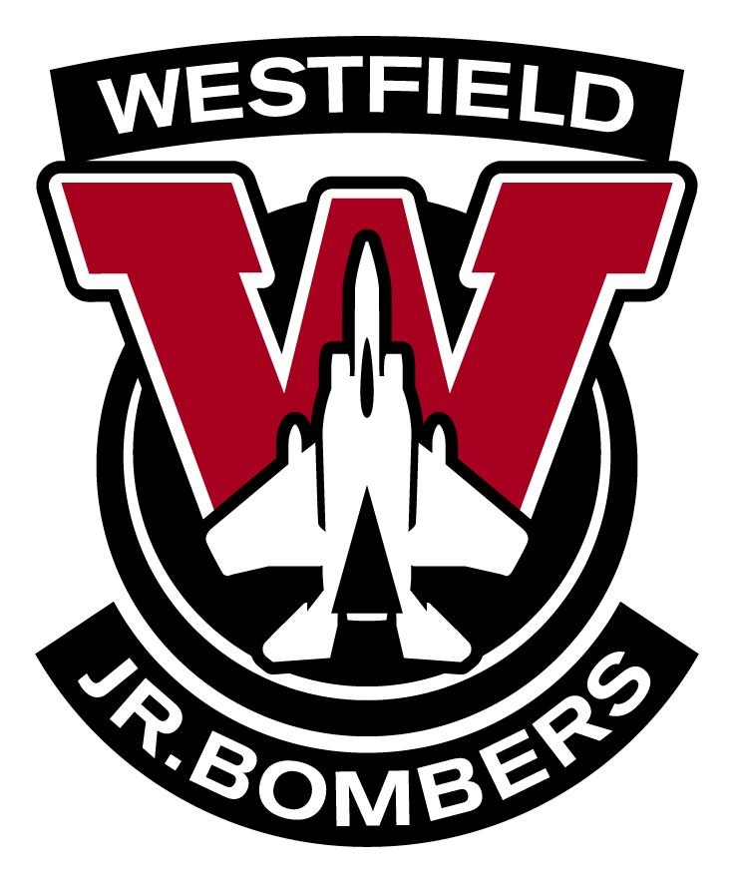
WESTFIELD YOUTH HOCKEY
OCTOBER 10, 2023 BOARD MEETING

ATTENDANCE: Caitlin Sadowski, Lauren Naworski, Phil Naworski, Mike Shea, Dave St. Lawrence, Kaylee Orluk, Nick Orluk, Neal Byrne, Jim Blascak, Todd Duso, Marissa Horan, Heidi Quigley, Keith Richards, Nick Galarneau, Joe Mancino, Mark Denoncourt, Russ Lepage, Felicity Stasiak

Meeting Started at 7:02pm

PRESIDENT REPORT: MIKE SHEA
- Expected behavior at tournaments, hotels & rinks
  - Please remember that you are representing our organization!
  - Watch your children!
  - Have fun but be respectful!
- Purchasing of WYH merchandise
  - Any WYHA merchandise should be purchased at Gateway Hardware located in the Olympia.
  - Pretty much anything can be ordered and if he can’t do something then you can look elsewhere.
- Methods of dealing with inter team issues
  - Try to deal with any team issues internally. If that cannot be done please reach out to Phil Naworski.
- New communications director
  - Leanna Pezzini has decided to step down as Communications Director. Thank you Leanna for all the time & effort you have put into this organization!
  - As a board we have appointed Lauren Naworski as the new Communications Director. There will be an election held at the end of the season should anyone want to run.
- Board incentives
  - A proposal was made for board members to have 1 of their children skate for ½ price. A vote was taken and it was unanimous that we would move forward with this incentive starting next season.
- Mike Shea will be stepping down as President at the end of this season. If anyone is interested please let him know so you can start to shadow him. An election will take place if multiple people are interested.
- The Amherst Girls Team is looking to form a mite girls team- reach out if interested. It would consist of tournaments and independent games.
- A representative from each team is expected at board meetings moving forward.

1ST VICE PRESIDENT REPORT: PHIL NAWORSKI
- LTS/LTP update
  - Great turnout- we are up to 38 skaters
- Novice update
  - 2 teams
- Coaching CEP’s
  - Please make sure you are registered. These expire 12/31/23 and THERE ARE NO EXCEPTIONS!
- Pucks
  - Each team has been given a certain amount of pucks- THEY NEED TO BE RETURNED AT THE END OF THE SEASON.
- Code of conduct for players & parents
  - Please review this- it is located on the website under the Home tab

2ND VICE PRESIDENT: DAVE ST. LAWRENCE
- Game Schedule
  - The schedule is out until mid November- the rest will be out once they make the high school schedules
  - Should be loaded into sports engine soon!
- Practice Schedule
  - Practices are scheduled up until Thanksgiving
  - Please be aware that after Thanksgiving practices may change due to us sharing the ice with several high school teams and the college. Thank you for your understanding!
- Check your schedules often for changes!!
- Open ice
  - There are a few sheets left. Please reach out to Dave if you are interested.
  - If you use this ice for independent games please let us know so we can schedule refs & timekeepers. Payment will be your responsibility.
- Mite Teams
  - Please remember that you need to put the boards up and take them down. Games are scheduled for a 60 minute sheet- 5 minutes to the boards up, 50 min game, 5 minutes to take the boards down. Please help to do this at other rinks too!
  - We are also responsible for time keeping these games. A parent or coach will need to volunteer.

FINANCIAL REPORT: PAUL BRACCIALARGHE
- Fire & Ice
  - Squirt A- 3 teams so far
  - Squirt B- 4 teams (possible 6 team division)
  - Squirt C- 3 teams

COMMUNICATION REPORT: LAUREN NAWORSKI
- Managers
  - Checks have been handed out as well as reimbursements for evals. Please reach out with any questions
- Med Bags
  - Please reach out if your team does not have one. THESE ARE TO BE RETURNED AT THE END OF THE SEASON.

SECRETARY REPORT: CAITLIN SADOWSKI
- Pictures
  - Oct 24 & 25- flyer is on the website
    - Players show up to your scheduled practice early, dressed in black jersey and socks
    - Coaches- please wear your WYH jacket or pullover. WYH hats are ok.
  - Novice can come to either night between 5-6
- Fire & Ice
  - We will hold a meeting soon.
  - Everyone is expected to volunteer in some way
  - Every team in the organization is to donate a raffle prize worth $100

GSL REPORT: RUSS LEPAGE
- Once the high school schedules are out we will get the rest of our game schedule.
- The 10U A&B division will be combined- best 6 records move up to playoffs
- The ref shortages are worse than last year. Expect to see young refs- they can make calls but trainers can also step in to make calls.

USA HOCKEY REPORT: MARISSA HORAN
- Rosters
  - Still waiting on a few

UNIFORM UPDATE:
- Jersey order
  - We need 6 sets in order to place a jersey order. Right now we have 5- if you are interested in new jerseys please reach out to Mike Shea by the end of this week!

FUNDRAISING REPORT:
- Calendar raffles
  - They have been handed out!
  - Only obligated to sell your 10 per player- keep the money.
  - If you need more- please reach out to Lauren Naworski.
    - Any extra that you sell- that money will go back to the organization.

Meeting ended at 7:37pm

