Unsubscribing –or- Changing the email address from which you receive communication from the North Stars is a “USER FUNCTION” on the SportsEngine website. The HNS webmaster cannot do this. Follow these simple instructions and you can update your email preferences.

1: Click your Sportsengine name: A drop down box will appear.
2. Click on ACCOUNT SETTTINGS
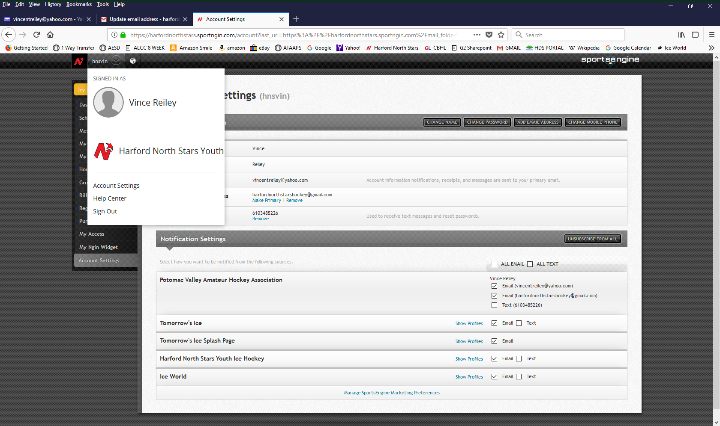
4
3
2
1
3. You can also change your email address by adding a new email.
4. And then making that new one Primary.

3. You can also UNSUBSCRIBE FROM ALL
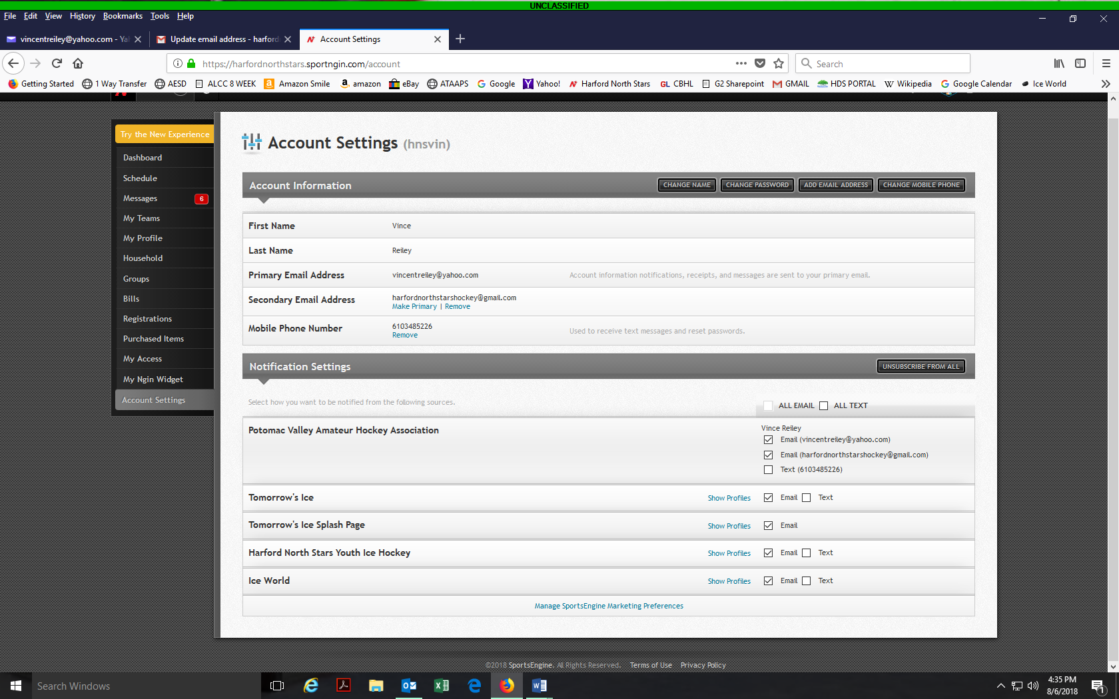
4
3

4. Or Uncheck the HARFORD NORTH STARS YOUTH ICE HOCKEY box.

