U5, U6&U7 COACHING CLINIC
Player’s turn up at different times. Get them involved in something constructive right away. Have them dribbling in an area and trying to touch the ball as many time as possible. Get them to use the laces (toe pointing down) we want to try and get them to touch the ball 500 times per session.

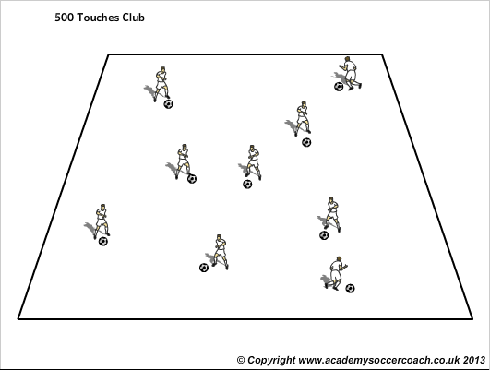
Progression: As players progress, get them to use different areas of the foot (inside, outside, sole). You can also use cones to get them to think about avoiding them. See diagram below.

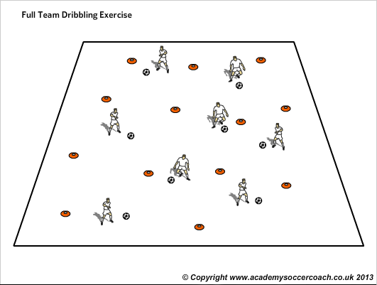

Warm up games.
Make this fun and vary them each session. Again it’s about them having as many touches on the ball.
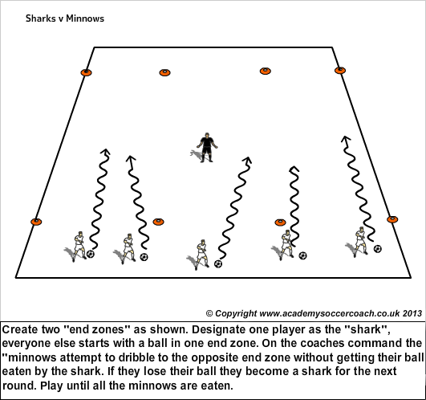
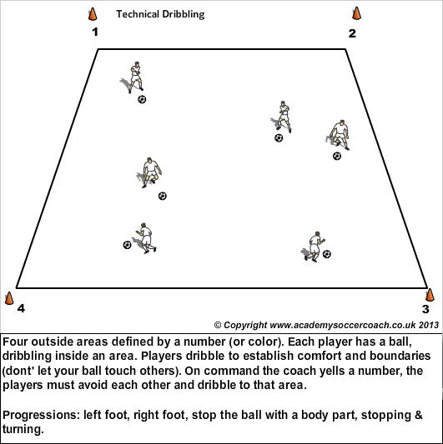
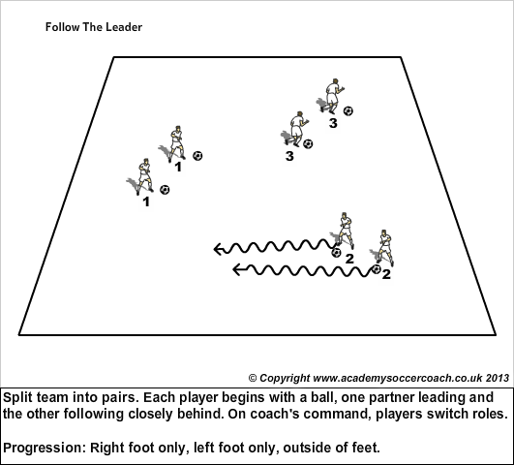

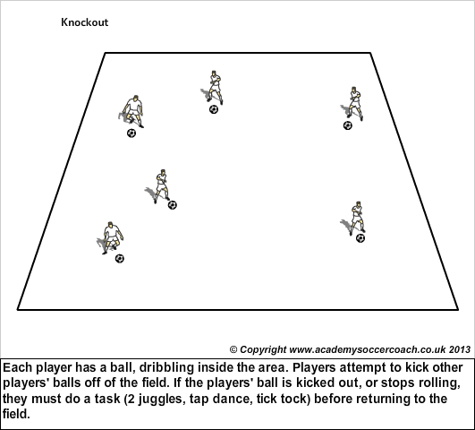

Main Content of session: It might be passing, dribbling, shooting. Have some key points for your session to help players improve technique.
Passing: Use inside of the foot (arch or where the logo is on the shoe) and hit the middle of the ball. Non kicking foot should be next to ball. NEVER USE THE TOE!
Receiving the pass: Heel down toe up.
Dribbling: Keep the ball close to feet (knees should be over the ball).
Head up as much as possible so they can see where they are going.
Soft touches.
Shooting: Placement over power. Don’t lean back.
Look at the ball, the goal doesn’t move!

3V1 (U5/U6), 2V1, 1v1 and 2v2 should be included in to as many sessions as possible. Make pitches 15x15 yards. It can be tournament. Winners move up, if you didn’t win, players go down a pitch. Never use the word loser!
Always finish with a game. You may want to implement your own rules depending on what you want to get out of the session. Example: To score you have to dribble through the goal.
NOTES:

