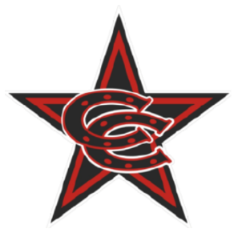

Spring 2026 11U Select Team Roster

Coppell Cowboys
Coach Taves
- Andrew Hay
- Augustus Braucksieker
- Caleb Sarmiento
- Davis Chi
- Easton Taves
- Eli Cho
- Harrison Myers
- Jayden Mohapatra
- Luke Mancuso
- Titus Robinson

