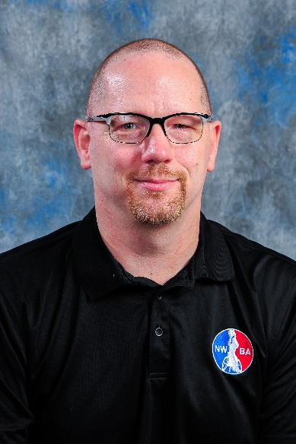 |  | Curtis “Gus” Lease  Adaptive Sports Athlete & Advocate
Profile  Curtis “Gus” Lease, originally from Jacksonville, Illinois, graduated in 1994 from the University of Illinois-Champaign. While there, Lease was a four-time All-American, and awarded the Sportsmanship and MVP Award for the Intercollegiate Division. Lease was also a three-time MVP for U of I.  Gus is a two-time Paralympian on the US National Sitting Volleyball Team.  Lease continues to play wheelchair basketball as a member of the Chicago Hornets in the NWBA Adult Division I, coaches the Synergy Junior Bulls youth wheelchair basketball team, plays wheelchair softball with the Wheelchair Cubs, and is a current member of the NWBA Board of Directors.  Contact  PHONE:  630-926-1385  EMAIL:  gusgus71@gmail.com |  | Wheelchair Basketball (1990-current)  - University of Illinois - 4 time collegiate All-American  - 3-time member of US National Team  - 2001 National Championship (Golden State)  - Head Coach - Synergy Jr Bulls  - NWBA Board Member (Treasurer)  - 2018 NWBA Collegiate Hall of Fame  sitting volleyball (1999-2007)  - US National Team 2000 - 2007  - 2-time Paralympian (00, 04)  - 2-time Para Pan Am Medalist  (Gold in 03, Silver in 07)  wheelchair softball (2008-Current)  - Wheelchair Cubs Wheelchair  Softball Team

