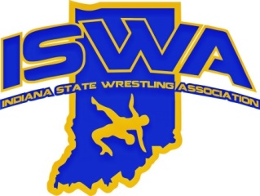
INDIANA STATE WRESTLING ASSOCIATION, INC.

P.O. Box 157, Beech Grove, IN. 46197 Phone 317-780-1885

2025 Olympic Style Mat Officials Annual Report

- Numbers for officials rose again, we are getting a bit more conversion of folkstyle officials
- We had 2 officials get awards at national tournaments
  - Central Regional Tom Clark Award- Keith Halbig
  - Fargo Greco official of the tournament- Cam Diep
  - Mark McNicholl as well got his lifetime achievement award
- Looking to get things more organized for officials to better track and streamline event coverage
  - We had all duals covered but were down about half the number of officials at Fargo
  - Trying to work better in the region to cover the state events and provide more opportunities for growth

Respectively submitted,
Dalton Halbig

