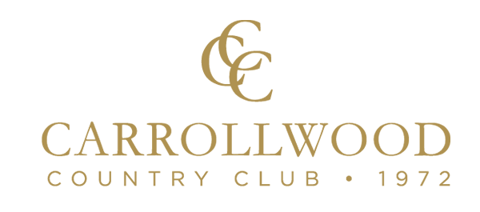
Blue Sponsor- Sign at Tee Box, Team Photo,
Mention at champions event
White Sponsor- Sign at Tee Box,
Team Photo,
Sponsor material in welcome bags,
Mini Game Sponsors
Advertisement in Banquet room
Name: _____________________________________________________
Company Name: _______________________________________________
Email: _______________________________________________________
Phone: _______________________________________________________
Address: _____________________________________________________
City/Stater/Zip: _________________________________________________

Completed Form and Check Are Due by December 1st, 2020.
Team Name: _________________________________________
Player 2 Name: _________________________________________
Email: _________________________________________
Player 3 Name: _________________________________________
Email: _________________________________________
Player 4 Name: _________________________________________
Email: _________________________________________
Please provide an email address for each player.
This will be the main contact method used.

Individual $100.00
Team $400.00
Donation $______
Sponsorship(s) $______
Mulligans $10 each limit 4 per person & 16 per team ___ x $5 = $_____
Grand Total $______
Make Checks payable to (Clearwater Ice Storm).
Mail form with check to 2015 S Carolina Ave Tampa FL 33629.
Cash will be taken at time of entry Registration.
Email to confirm spot and for 501C3 form

fees include:
green fee, cart fee, breakfast and lunch, range balls,
and chances to win GREAT prizes!
Closest to Pin
Longest Drive
Individual Contests
Spectator Games & Contest
50/50 Drawing
Raffle
- Hole-In-One $2500
- Blue Sponsor $150
- White Sponsor $250
- CTP Sponsor $500
- Long Drive Sponsor $500

Check the sponsorship(s) of
your choice:
Phone: 585-957-5434
Email: icestormhockey@yahoo.com

Carrollwood Country Club
13903 Clubhouse Drive
Tampa, FL 33618
9 am
8 am
Monday December 14th,2020

