Annandale Baseball/Softball Agenda

August 10, 2025

7:00 PM @ Billy D’s
- Call to order @7:00
  - Roll call- Jerpseth, Allerson, Hamberger, Schramel, Eakins, Bronder, Gagnon,
  - Guests Present: Macalena, Wittrock, Miller
- Reading and Review of July Board Meeting Minutes
- Updates to the Agenda-
- Treasurer’s Report –

- Old Business
  - Update on Concession Stand construction- Taping
  - Update on By-Law Amendments- No update

- New business
  - Board Nominations and voting-
    - 6 nominees. Send email out to nominees, confirmation deadline 8/17. Form/Vote Deadline 8/24.
    - Concession Stand-Nick Allerson volunteered to take over the position. Jean will help with the transition, motion made to waive registration fees for whoever runs the stand.
  - Season Re-Cap, lessons learned, and off-season goals
    - 10U uniforms- Collect sizes, no names, order a few extra common sizes to cover late registrations. Sublimated.
    - Review Tournament registration process-Consider ABBSB Coaches coordinators registering teams for consistency.
    - Make a note to discuss 10U Softball philosophy.
    - Need to add Ag Lime to all fields-may need volunteers to help move piles to areas of easier access
    - Consider Turfing AHS JV Field-
    - YE Survey-Nick will compile and discuss next meeting.
    - YE Survey-For coaches, equipment,
    - Concession Stand Coordinator- Nick A.
    - Consider hosting 12A and 12U C/Rec tournaments-possibly have some of the older teams work the tournament, they can earn ¨swag¨
    - BOD Role Job Descriptions with a task list

  - Recap 2025 Tournaments-
    - We hosted 71 teams over 3 weekends (6 days) and earned expected Gate Fees income of $10,650 and estimated Concession Profit of $8,000. $20,000 for 5 full days and one Friday evening. The 1 day 8U tournament was the most profitable.
    - Went through each member and recapped the year and any changes that we would like to address moving forward.

- Next Mtg. Sunday, September 14, 2025
- Adjournment-

12AA, 13AA,AA
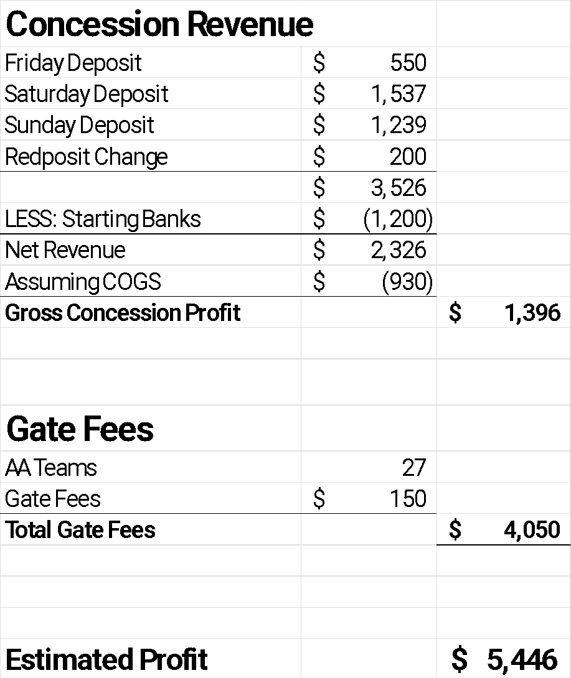

10A
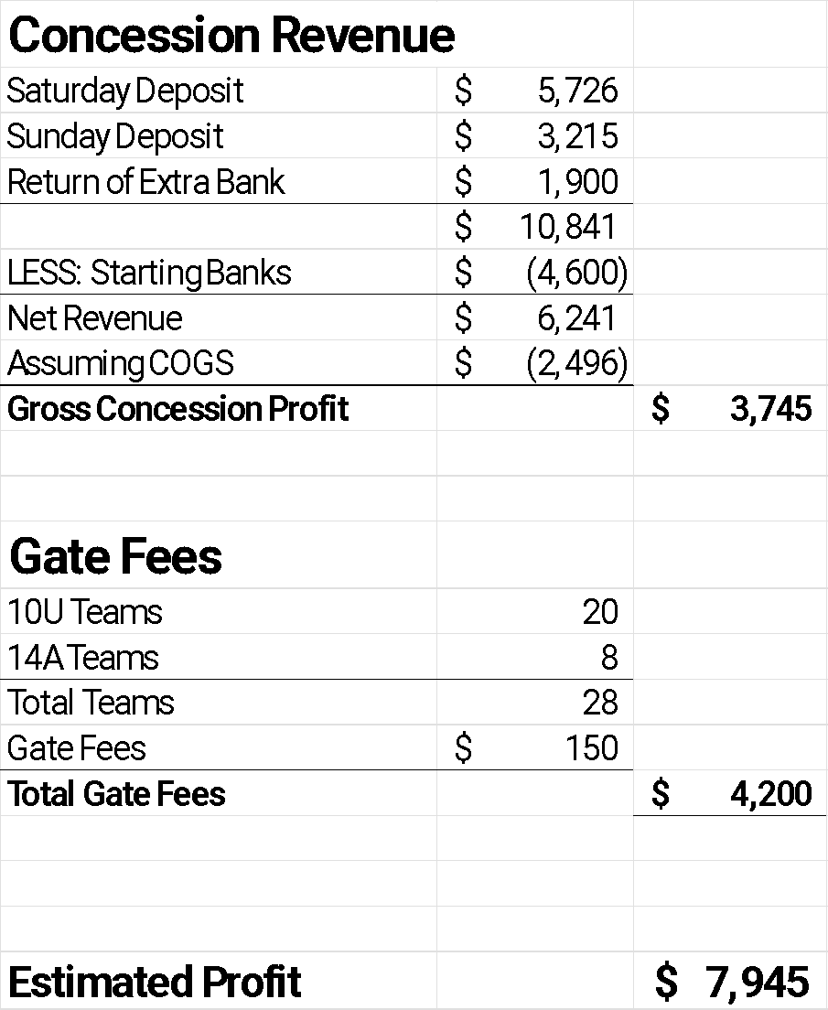
8U
