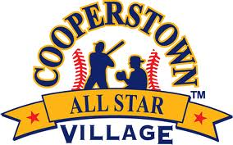
Cooperstown All-Star Village
Home Run Derby 16-33
All teams on Field 32
August 7th- 13th
Week 10

# | Team Name | Player Name | Outs | Homeruns
16 | CJB All Stars, NY | Cole Harris | 5 | 1
17 | Dirt Dawgs Sports, MA | Steven Gonsalves | 5 | 3
18 | Clarksburg Keys, MD | Andrew Giacalone | 5 | 2
19 | Mohawk Valley Vipers, NY | Jamison Young | 5 | 0
20 | Rolling Hills Renegades, CA | Zachary Shen | 5 | 0
21 | FB Braves, NJ | Dominick Condo | 5 | 0
22 | Lou Gehrig Red 12u, NY | Aiden Graesser | 5 | 0
23 | Holbrook Hitmen, MA | AJ Clark | 5 | 0
24 | Visalia Hammers, CA | Tyson Chavez | 5 | 2
25 | Oil City Bandits, NY | Jalen Josey | 5 | 1
26 | So Cal Yard Goats, CA | Zachary Gergurich | 5 | 1
27 | Central MA Minutemen, MA | Colby Wall | 5 | 0
28 | Generals Baseball Academy, NY | Anthony Duffy | 5 | 6
29 | Chicago Warriors, IL | Matthew Saliers | 5 | 2
30 | Belmont Blasters, CA | Elliot Sternke | 5 | 0
31 | Carmel Cubs, NY | Alex Amore | 5 | 2
32 | Liberty All Stars, PA | Anthony Barthol | 5 | 0
33 | Lynnfield Pioneers, MA | Coley Walsh | 5 | 0

