How to add a guest player from a different club.
Follow the steps below to add a guest player to your event roster. Player's must go through their individual player account and register for the event as a guest before you will be able to add them.

Step One:
Once logged into your team account click on the name of the event you are looking to add the guest player for.
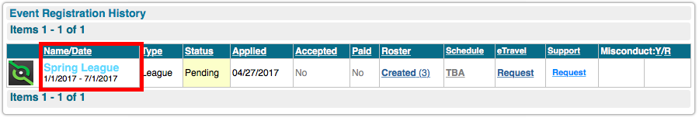
Step Two:
Click on the "guests" tab, and then click on the player's name you are looking to add.
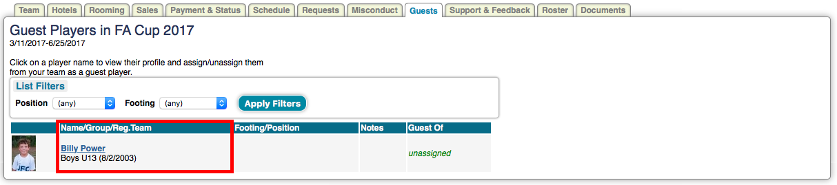

Step Three:
Click the dropdown next to "Guests Of" and select your team. Then click update.
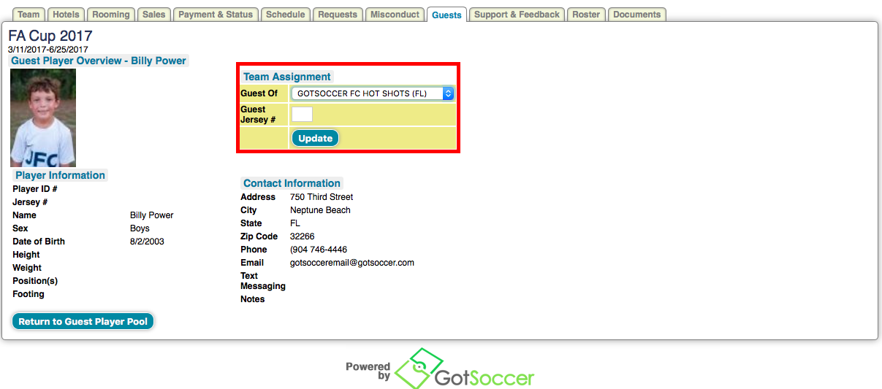
Step Four:
Go to your event roster and hit the add guest button at the bottom of the page.
